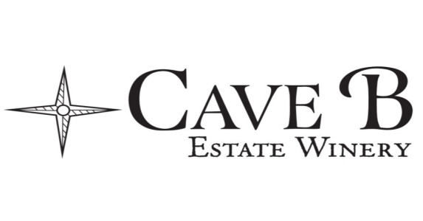WINE CLUB TERMS & CONDITIONS:

If you have opted to pick up your Wine Club fulfillment and have not picked up your fulfillment within 30 days, we will automatically charge your card and ship it to your shipping address on file. If you have unusual circumstances and cannot pick up your fulfillment within 30 days and do not want it shipped it is your responsibility to contact our Wine Club Manager Kirsten at wineclub@caveb.com and request a pick-up extension. This should be used only in exceptional circumstances.
If you have opted for shipping the shipping & handling are dependent upon weight (i.e. number of bottles in the shipment) and location; costs typically run between $15 and $30 for in-state shipments. UPS will make a minimum of three attempts to deliver. Returned shipments may be picked up at the winery for no additional charge within the 30-day window or at your request we will resend the shipment and charge your credit card again for shipping. Please note that all wine shipments must be signed for at time of drop off per federal law.
Discover and Explore Wine Club fulfillments (winemaker choice level) cannot be voided and processed with different wines in place of the initial order. For Ambassador and Inspire members (our customer choice levels), changes can be made to wine club orders if requested prior to processing for all shipping members. Changes can be made at the time of pick up at one of our tasting rooms for all pick up members. We always send an e-blast with the processing dates, but keeping your email address current in our files and marking them to stay out of your junk mail is your responsibility.
Wine Club pick up fulfillments not picked up within the 30 day window, and orders that have been shipped but were returned will be held at our Quincy tasting room. At that point we will make 3 attempts on 3 different days to reach you either by phone (voicemail or text) or by email. We understand that at time unusual circumstances occur and we might need to work with you one on one to get your wine to you. We will do our best to help if we can. If we do not here back from you by the next wine club shipment your wine club fulfillment will be donated to a non-profit organization. Please email wineclub@caveb.com or call 509-785-3500, ext 2. Please do not leave messages with the tasting room staff.
Membership benefits are included for the member and their “named” spouse or partner. Legal ID may be required to verify membership.
All credit cards submitted with membership application must have an expiration date that is at least six (6) months after the date of the first scheduled shipment. Please keep your address and credit card information up to date by logging into your wine club account at www.caveb.com.
Our Inspire, Ambassador and (grandfathered in) Indulge Wine Club levels have the opportunity to reserve 1 annual free 3-hour rental use of the back Cave at our Quincy location based on availability. A wine minimum of $300 is required. All other club levels can reserve the back cave for $350 (plus the $300 wine minimum) for a 3 hour rental by emailing events@caveb.com.
After your first year of membership, you may cancel at any time via email notification at wineclub@caveb.com. If you do not receive an email confirming your cancellation please email again as we will always respond via email to any cancellation requests received. Early cancellation (before your 1 year commitment is over) will result in a $50 early termination fee. If you would like to continue after a year, do nothing and your wine club shipments will continue with your valid credit card number on file. Indulge members will be notified before renewal. Terms and conditions are subject to change without notice.
Thank you for being a Cave B Wine Club member! 1-30-2022

