Houston City Council OKs 'Walkable Places' programs for Midtown, Third Ward, Near Northside

By Chris Mathews – Reporter, Houston Business Journal
Aug 5, 2020, 3:35pm EDT

Certain areas of the Bayou City could become more pedestrian-friendly under new measures approved by Houston City Council.
City Council on Aug. 5 unanimously approved the "Walkable Places" and "Transit-Oriented Development" programs "to encourage pedestrian-friendly, mixed-use development with an enhanced, walkable public realm," according to the agenda item. The programs are a result of three years of work by the city's Walkable Places Committee.
The rules will apply to new development and redevelopment along designated primary "Walkable Places" streets in Midtown, the Third Ward and the Near Northside. These ordinances include bringing building facades closer to the road, expanding sidewalks to benefit pedestrians, moving parking lots to the side or rear of buildings and including additional bike parking standards.
For example, previous building regulations in the city of Houston required buildings along major thoroughfares to be set back from the street at least 25 feet, offering less buildable space for property owners and often resulting in street-facing parking lots.
Under the new rules, building facades on primary streets in Midtown would be set back 20 feet from the curbside, with off-street parking options moved behind or to the side of the building. Sidewalks would be expanded to include more unobstructed pedestrian space and 4-foot safety "buffers" from the curbside to protect pedestrians and cyclists from traffic. Property owners along secondary Walkable Places streets may opt in to the applicable standards.
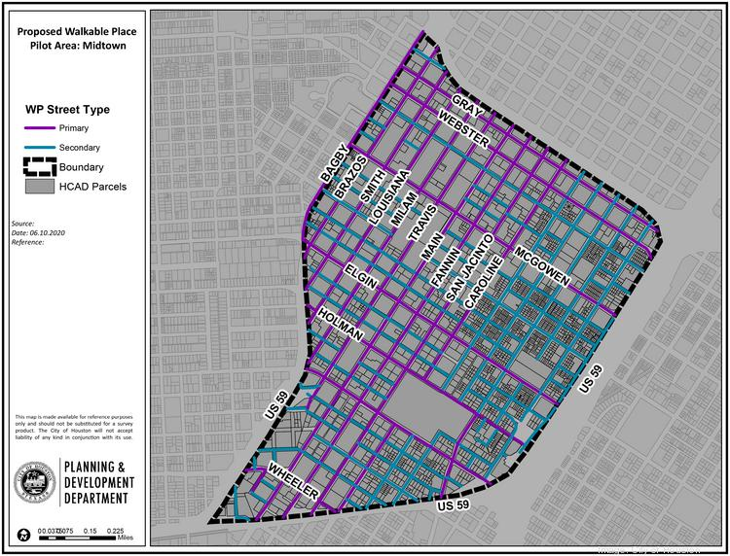
Similar ordinances will be required for new development and redevelopment along portions of Emancipation Ave. in the Third Ward as well as along Hogan Street and Lorraine Street in the Near Northside area.
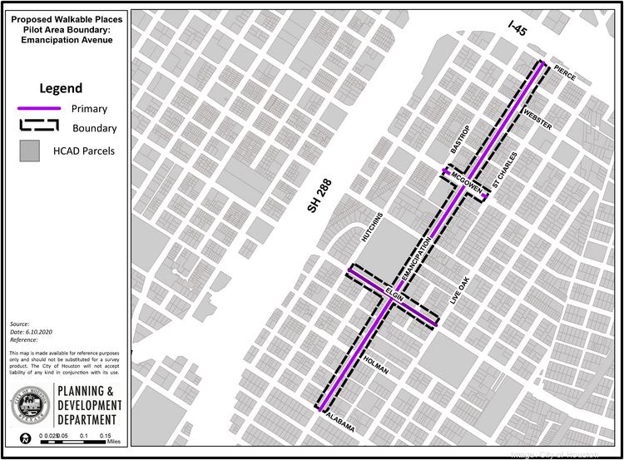
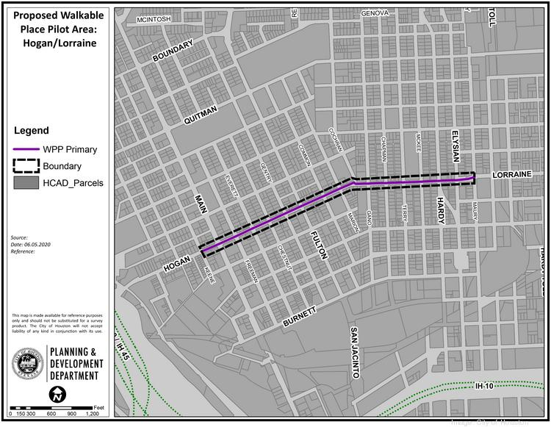
The Transit-Oriented Development program ordinances apply to streets within a half-mile walking distance from Metro transit station platforms. New development and redevelopment along TOD streets would be required to expand sidewalks with additional unobstructed sidewalk space and safety buffers. The program also eliminates parking requirements on TOD primary streets and allows property owners to decide the amount of parking spaces needed. Property owners along TOD secondary streets would be eligible to opt in to the program.
The ordinances will take effect Oct. 1, the Houston Chronicle reported.
The programs garnered support from organizations including the Houston Real Estate Council, the Metropolitan Transit Authority of Harris County, and the Center for Civic and Public Policy Improvement, among other organizations.
Houston Mayor Sylvester Turner called the approval of the walkability programs a "paradigm shift" that will change how people move about in the city of Houston.
The city has attempted to make portions of Houston more pedestrian-friendly in recent years. In July 2019, City Council voted to eliminate minimum parking requirements in East Downtown and parts of Midtown. Previously, only downtown was exempt from rules requiring property owners to build off-street parking spots.

