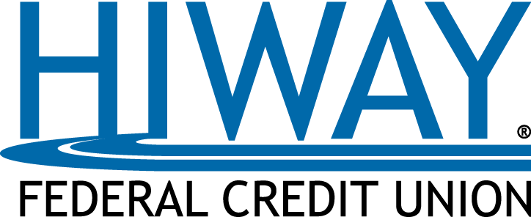

Contact: Deb Cariveau-Rogers, Marketing Manager
651.291.1515 ext. 8294 | drogers@hiway.org
hiway.org

FOR IMMEDIATE RELEASE:
HIWAY HONORED AS EAST SIDE AREA BUSINESS OF THE YEAR
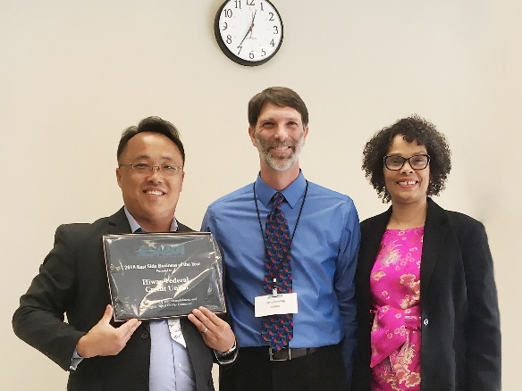
(St. Paul, Minnesota) January 31, 2019 – Hiway Federal Credit Union® (Hiway) was recognized by the East Side Area Business Association (ESABA) as the East Side Area Business of the Year at ESABA’s annual awards event Jan. 24.

ESABA works to connect local businesses with resources and tools that create business growth, and its members are dedicated to the development of St. Paul’s East Side. Hiway’s corporate headquarters, as well as one of its branches, call the East Side home, and Hiway supports many organizations and events in the surrounding area.

“We’re honored to be recognized by our neighbors on St. Paul’s diverse East Side,” said Hiway President/CEO Dave Boden. “We are longtime supporters of the work of ESABA and are proud to be a part of the growing East Side business community.”

Photo Caption: Khue Yang, Hiway Business Lending Officer and East Side Area Business Association Treasurer, accepts the Business of the Year Award at the ESABA awards dinner
Jan. 24.
###

ABOUT HIWAY FEDERAL CREDIT UNION
Hiway Federal Credit Union was founded in 1931 to serve the employees of the Minnesota Highway Department. Today, Hiway serves over 74,000 members in Minnesota and around the country, registers $1.1 billion in assets and welcomes new membership from individuals and small businesses. Hiway offers its members unparalleled member service and a lifetime of savings through lower loan rates, higher savings rates and fewer and lower fees. For more information about Hiway, visit hiway.org.

