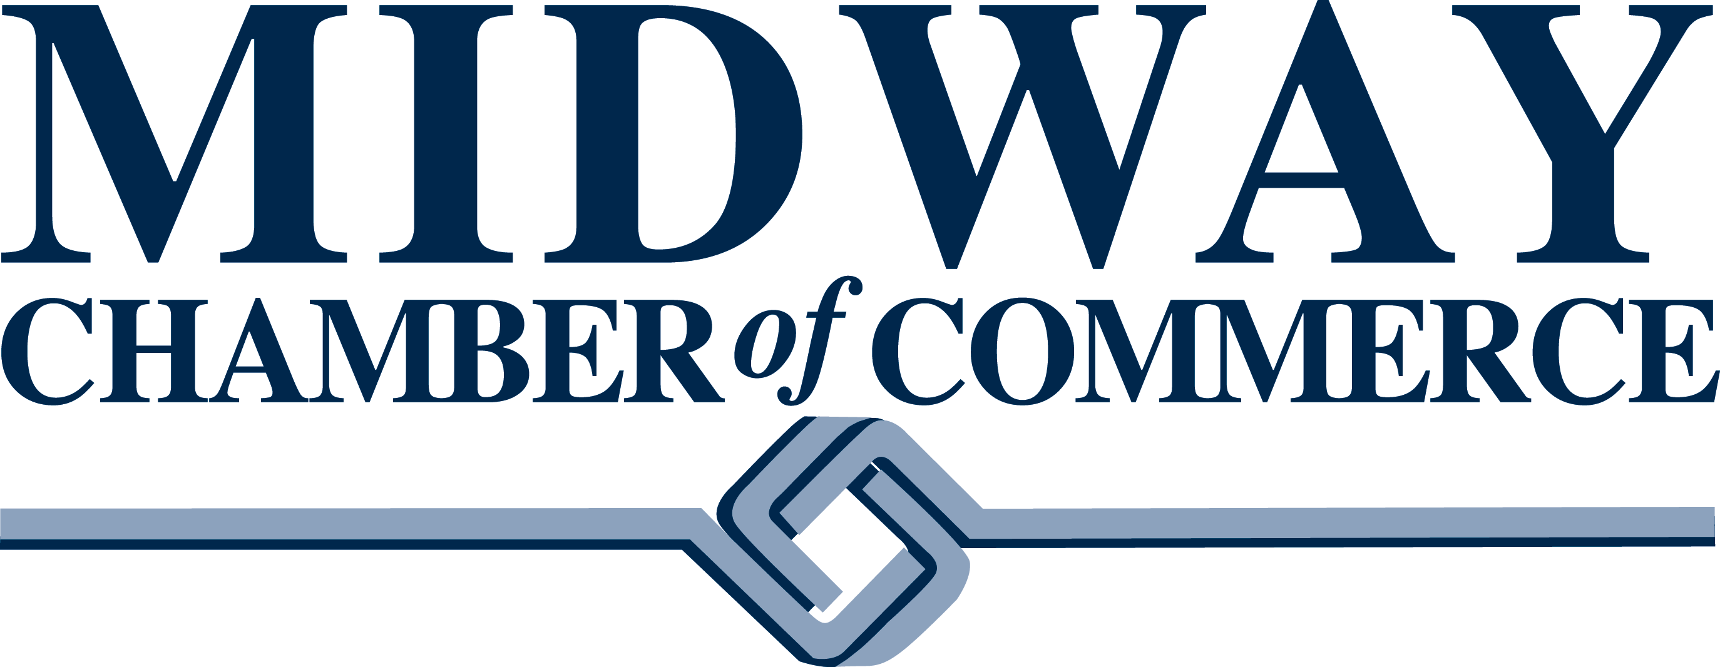
Leadership Awards History

Large Business of the Year
2022-Mortenson
2021- Xcel Energy
2020- SPIRE Credit Union
2019- Warners’ Stellian
2018- Sunrise Banks
2017- Hiway Federal Credit Union
2016- Grand Casino Mille Lacs & Hinkley
2015- American Engineering Testing, Inc.
2014- St. Paul Saints Baseball Club
2013: Loucks

Small Business of the Year:
2022-Elsa’s House of Sleep
2021- The Lab, LLC
2020- Mendoza Law
2019- Urban Growler Brewing Company
2018- Davis Communications Management
2017- Midpointe Event Center
2016- Bywater Business Solutions
2015- Fenske Law Office
2014- O’Gara’s Bar & Grill
2013- Visual Communications, Inc.

Rookie of the Year:
2022-NDC (Neighborhood Development Center)
2021- Open Cities Health Center
2020- 21st Century Bank
2019- Riverland Bank
2018- Deneen Pottery
2017- Half Time Rec
2016- Hiway Federal Credit Union
2015- Turf Club

Nonprofit of the Year:
2022-WomenVenture
2021- Ujamaa Place
2020- Keystone Community Services
2019- Jennings Community School
2018- Ally People Solutions
2017- Tech Dump
2016- Twin Cities Jazz Festival
2015- Episcopal Homes
2014-Saint Paul Police Department
2013- Midway YMCA

Volunteer of the Year:
2022-Matt Meyers
2021- Christine Noonan
2020- Russ Peterson
2019- Dan Leggett
2018- Sabrina Fay
2017- John Young
2016- Cheryl O’Donnell
2015- Jamison Randall
2014 – Terri Banaszewski
2013- John Hoffman
2011- John Bennett
2010- John Schweitz

Business of the Year 2000-2012
2012: McDonald’s
2010: Latuff Brothers Auto Body
2009: Hubbard Broadcasting
2008: Warners’ Stellian
2007: JB Realty
2006: TDS Metrocom
2005: Rock-Tenn Company
2004: Whitaker Buick- Jeep
2003: Mintahoe Hospitality Group
2002: Episcopal Homes
2001: Wellington Management, Inc.
2000: St. Anthony Park Bank (Sunrise Banks)

Resiliency Award 2021
(one-time only COVID):
Bole Ethiopian

