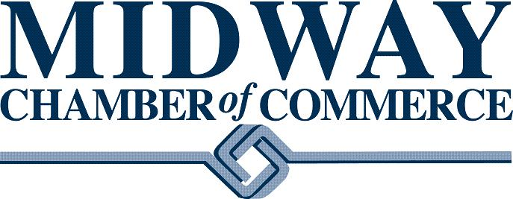
Indicate for which Leadership Award you are nominating this person or group for:
- Large Business of the Year Award (20 or more employees)
The Large Business of the Year Award is presented to a company that plays an active role in the local business community, business associations and volunteer groups. Recipients have demonstrated growth in sales, employees and/or service since inception. This award is given to a business of 20 or more employees and is a member of the Midway Chamber of Commerce.

- Small Business of the Year (20 or less employees)
The Small Business of the Year Award recognizes a business with outstanding business practices in the Midway community. This award honors the entrepreneurship, sustainability, productivity and effort put forth in a small business. This award is given to a business of 20 employees or less and is a member of the Midway Chamber of Commerce.

- Nonprofit of the Year (any Section 501(c)(3) public charity/foundation)
As defined by the Midway Chamber, the Nonprofit category recognizes any Section 501(c)(3) public charity or private foundation that is tirelessly focused on serving the community and the partnerships they have built with for-profit organizations. The award will recognize a Midway Chamber member who is a section 501(c)(3) charity or private foundation member.

- Volunteer of the Year (individual)
The Volunteer of the Year award recognizes a Midway Chamber member for their commitment, dedication, leadership, and exceptional volunteer service on behalf of the Midway Chamber of Commerce.

- Rookie of the Year (new member in their first 2 yrs)
The Rookie of the Year award recognizes a Midway Chamber of Commerce member for their enthusiasm and can-do attitude in their first 2 years as a Midway Chamber Member. Their excitement for the chamber is infectious and inspires other members and their commitment to the chamber.
Nomination Form

Nominator Information
Provide the following information about you so that we may contact you about your submission
Your Name:
Your Connection to Nominee:
Phone Number:
Email address:

Nominee Information
Provide the following information so we may contact the nominee
Name/Organization:
Phone Number:
Email address:

Nomination Questionnaire
Please complete the following questions to the best of your ability in support of your nomination

- Identify the specific actions demonstrated by the nominee that embodied excellence in leadership.

- Describe the current or potential outcomes and/or impact of the nominee’s contributions.

- What ways did the nominee demonstrate leadership attributes you would like us to consider?

Thank you for taking the time to complete this submission form!
Please return form to the Midway Chamber of Commerce by Monday, January 14, 2026!
Email to ana@midwaychamber.com or drop it in the mail to: 1600 University Avenue West, Suite 301 St. Paul, MN 55104

