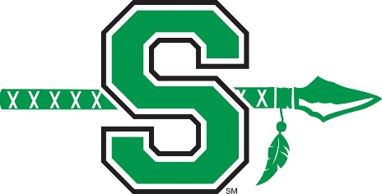
WARRIOR BASEBALL
Spring Youth Baseball Camp 2019
Hosted by the Smithville High School Baseball Staff and Players

When: Saturday, March 23, 2019
Times: Grades 1-3 9:00am – 11:00pm
Grades 4-6 11:30pm – 1:30pm
Grades 7-8 2:00pm – 4:00pm

Where: Smithville High School Baseball Field (HS Gymnasium if raining)
Cost: $30 per child

Bring baseball equipment and cleats, tennis shoes |camp t-shirt will be given to each child.

Registration begins 30 minutes prior to start of camp.
To register early, send the completed registration form below with your payment to:
Smithville High School: Josh Speer
645 South Commercial
Smithville, MO 64089
Please make checks payable to Smithville Baseball Booster Club

PLAYER’S NAME: ___________________________________________________
AGE/GRADE: ___________ TSHIRT SIZE(Youth and Adult Availible): _____________
CONTACT NAME: _______________________________ ____________________
PHONE#: ____________________ EMAIL: _______________________________

Emergency Medical Authorization and Waiver:
Should (Child's Name) ____________________________________ DOB_________________
suffer an injury or illness while in attendance at the SHS Youth Baseball Camp and the association and or person in charge is unable to contact me immediately, it shall be authorized to secure such medical attention and care for the child as may be necessary. I shall assume responsibility for payment for services. SHS does not assume any responsibility beyond that of normal supervision and safety practice.

Signature of Parent/Guardian Date: ____________________________________________

