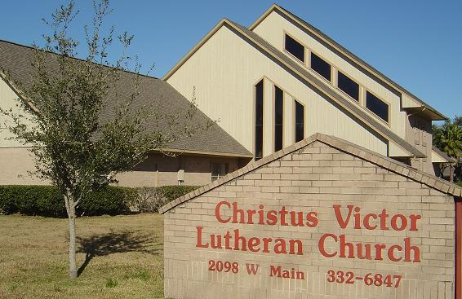

**SEARCHING FOR PIANIST/ORGANIST—MUSIC DIRECTOR**

**TAKING APPLICATIONS UNTIL POSITION IS FILLED**

Christus Victor Lutheran Church (ELCA), an open and affirming congregation located in League City, Texas, is searching for a part-time Pianist/Organist-Music Director. As the Pianist/Organist, the applicant will be responsible for providing leadership with hymns and liturgy for one service on Sunday morning as well as evening services during Advent and Lent, Christmas Eve and Holy Week. Applicants should be able to confidently play a wide range of styles including liturgical music. As Music Director, the candidate will be conducting a choir of volunteer singers including one practice per week, preparing them to sing two anthems per month in worship. Applicant will also assist with leadership of the Praise Choir which leads the music in worship once per month, and support the volunteer led Bell Choir. Christus Victor understands the importance of music in worship and ministry, and we look forward to having someone who will encourage and guide the continuation and further development of a vital music ministry. If interested, please contact Pastor Tammy Sharp at pastortammy@comcast.net, or call 281-924-1667. A more complete Job Description can be found on [our website](https://christusvictor.us/church-pianist-organist-music-director/).

**Christus Victor Lutheran Church**

2098 W. Main

League City, Texas 77573

Phone: 281-332-6947

Fax: 281-316-1930

E-mail: pastortammy@comcast.net

Website: christusvictor.us