Concrete Council
Quality Concrete Awards
2021 ENTRY FORM AND RULES

The annual Quality Concrete Awards program recognizes member firms and others who have demonstrated outstanding concrete work in the St. Louis area, and it reinforces the Council’s long-range commitment to quality concrete construction.

We invite you to participate in this year’s competition. We hope you will take the time to submit one or more entries and will attend the awards ceremony in November.

ELIGIBILITY
All member firms of the Concrete Council, along with local architects and engineers, are eligible to enter this competition. Projects to be nominated must have been completed within the last 5 years and a member firm must have been involved on the project. A current list of Concrete Council members may be found on our website: www.concretecouncil.com.

AWARD ENTRY DEADLINE
All award entries must be received no later than 5:00 PM on Friday, September 10, 2021. NO LATE ENTRIES WILL BE ACCEPTED. Award entry form and photos can be emailed to gina@concretecouncil.com or can be sent via DropBox.

AWARD ENTRY FORM
Entry in the awards competition requires a completed award entry form (see below) received on time. The submittal information, narratives, and photographs play a vital role in project selection, because the submittal is the only input available to the judges. Please do not stray from the format of the entry form. All entry forms need to be submitted as a Microsoft Word Document.

DIGITAL PHOTOGRAPHS
In addition to the completed form, entrants must submit a minimum of 5 and no more than 10 “high resolution” jpeg photos taken during all stages of construction as well as of the finished project (if applicable). Photos should, where possible, illustrate points made in your project narrative. Please include at least one “sunny day” photo of the completed project. The file name of all jpegs must include the project name and the sequence number in which the image should be viewed. For example, “Concrete Parking Lot 1” and “Concrete Parking Lot 2” etc. Please include a brief description to be put under each picture in the Judging Packet. If the images are too large to be emailed, please send them via DropBox.

JUDGING
Winners will be selected by a panel of prominent experts in the concrete-construction industry. All entries will be evaluated solely upon information in the submittal, following the provided entry form and rules. No on-site judging will take place. Winners will be announced during the second week of October, 2021.

AWARDS PRESENTATION
Winners will be recognized at the 2021 Concrete Council Quality Concrete Awards Dinner on Thursday, November 18, 2021 at the Missouri Athletic Club in Downtown St. Louis.

ASSISTANCE
The Concrete Council will provide professional assistance if requested to complete the entry form or assist in taking pictures. If you require assistance, please contact the Concrete Council office at 314.862.0324 so that time can be scheduled.

FOR FURTHER INFORMATION OR QUESTIONS
Please contact Gina Loddeke at 314.862.0324 or Gina@concretecouncil.com for questions or to request an entry form.

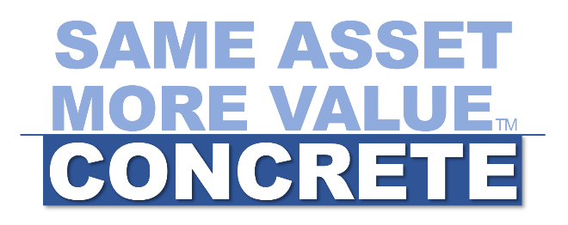

Concrete Council
Quality Concrete Awards
2021 ENTRY FORM AND RULES

PROJECT CONTACT INFORMATION
Project Name:

Address of Project:

Type of Concrete Project: Please check all that apply to project
Airport Decorative Highway Overlay
Residential Roadway Structural Tilt-up
Other:

Date Completed:
(MM/YY)

Submitting Company:
Contact Name:
Email Address:
Phone Number:

Project Owner:
Project Architect:
Project Engineer(s):
Project Manager:
General Contractor:
Subcontractor:
Ready Mix Supplier:
QC Firm:
QA Firm:

PROJECT SUMMARY
- Project Description: In 100-200 words please describe this Quality Concrete Project.

- Procedures Employed: In 100-200 words please explain the procedures employed on the project.

- Special, Unique or Challenging Situations: In 100-200 words please describe any special, unique or challenging situations that may have occurred on the project. Including how innovation on the project helped the public.

- Materials Used: In 100-200 words please describe the concrete materials used on this project.

- Special Quality Components of the Project: In 100-200 words please describe the special quality components of the project, including sustainability and LEED.

- How this Project Encouraged the Use of More Concrete: In 100-200 words please describe how more concrete was used on this project? Did the project include a concrete parking lot? Why or why not?

- How many cubic yards of concrete were used for this project?

- Statement from project owner or stakeholder: Please get a short statement from the owner or stakeholder about the quality, appearance, or value of this project.

- Which Concrete Council member firm (s) was involved on this project? A list of Concrete Council members may be found on our website: www.concretecouncil.com. Please include the role they had in the project.

Award Entries must include all of the following to be considered:
Completed Award Entry form, including project contact information and project summary
A minimum of 5 and no more than 10 jpeg photos taken during all stages of construction along with picture description
Completed form and photos should be emailed to gina@concretecouncil.com no later than FRIDAY, SEPTEMBER 10, 2021

