LWML Mites Mission of the Month
November
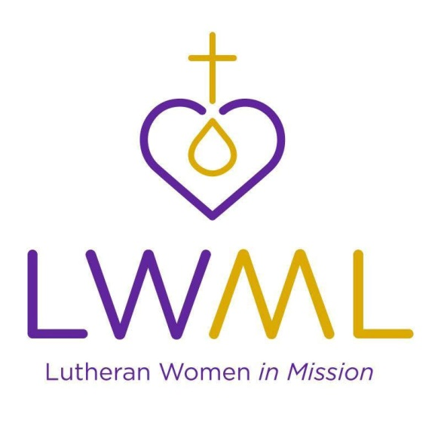

Mites Mission of the Month LWML National:
Teach Me Too – Preschoolers with Learning Needs – Lutheran Special Education Ministries: Lutheran Special Education Ministries (LSEM) has seen a growing desire for early intervention support of children with learning needs. In 1976, LSEM began serving children with special learning needs in the Detroit area and has since expanded programs and services to include a presence in Lutheran schools nationwide. Their pilot program is Let It Shine Academy at Bethany Lutheran Church, Austin Texas. The Teach Me Too program was designed to administer intervention strategies, address the unique needs of children with autism spectrum disorder and other needs such as hyperactivity issues, decreased or delayed social skills, developmental or speech delays, sensory integration difficulties, or other learning differences. As a resource for families, this program provides assessments, consultations, and materials to help children on an individual basis.
This grant will help fund Teach Me Too, expand the Let It Shine Academy – providing teacher training and offering scholarship finding for children whose families cannot afford the cost of the Let It Shine Program.

Contribute Mites through your weekly Peace offering envelope or deposit in the Mites Collection Box on the Events Counter in the Lobby.

