LWML Mites Mission of the Month
June
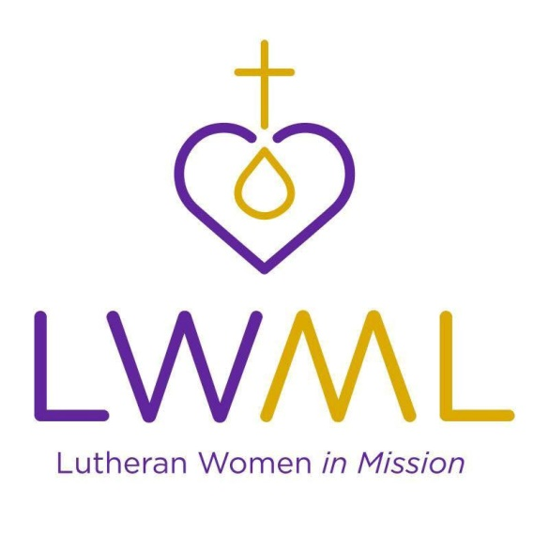

Mites Mission of the Month
(LWML National):
Sharing Jesus with People with Disabilities: Bethesda Lutheran Communities wants to enhance the lives of people with disabilities with services that share the Good News of Jesus. They operate programs throughout the US. They provide homes and support, promote awareness, and advocate for people with developmental and intellectual disabilities. Over 1,900 people at 300 program sites in 13 states are being served. Travel is essential in achieving this mission. They must rely on support of donors as these costs are not reimbursed by the states.
This grant will be used to support ministry consultant travel as they nourish relationships and grow their network to support people of all abilities with their faith journey.
Contribute Mites through your weekly Peace offering envelope or deposit in the Mites Collection Box on the Events Counter in the Lobby.

