LWML Mites Mission of the Month
July
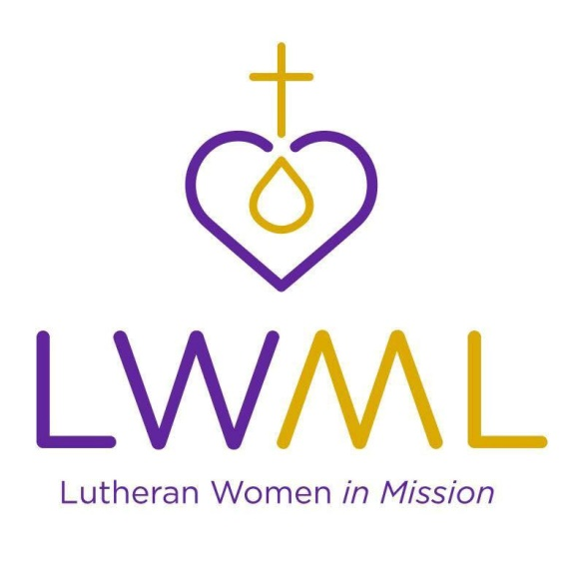

Mites Mission of the Month (NID District):
Post Abortion Crisis Hotline Expansion, Lutherans for Life: The Word of Hope Post-Abortion Crisis Hotline run by Lutherans for Life is the only Lutheran hotline program in the nation. LFL is seeking to partner with the NID LWML to aid in staff expansion and promotion of the hotline to churches in the district. Lutherans For Life will launch their promotion in stages on a district by district basis using targeted mailing, emails, district distribution of literature, etc.

This grant will help reach more hurting souls through additional staff hours and a full-time director.

Contribute Mites through your weekly Peace offering envelope or deposit in the Mites Collection Box on the Events Counter in the Lobby.

