LWML Mites Mission of the Month
September
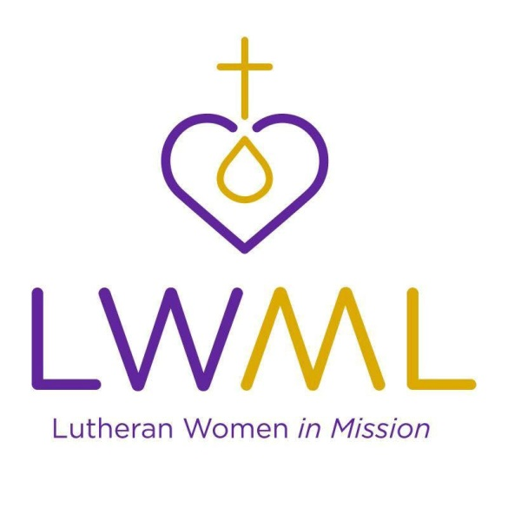

Mites Mission of the Month LWML National:
Water and Word for Rural Schools – Evangelical Lutheran Church, Kenya: In 2008, a Nebraskan travelling in East Africa saw the need for clean water and sought a way to help. Along with a man from Kenya, he devised a system of installing water harvesting equipment (rain gutters and tanks), filters, hand washing stations and clean water storage in schools in Kenya. In 2016, members of the LCMS from Nebraska took over the management of the project. They send teams every year to install rain gutters and tanks for storage. Hand washing stations and clean water “buckets” are placed in every classroom. They teach personal hygiene, handwashing and the importance of drinking only clean water. Students and staff are members of WASH clubs which are responsible for the clean water program.
This grant will help the Evangelical Lutheran Church in Kenya to extend their ministry of Word and Sacrament by expanding the clean water project for their schools and orphanages.
Contribute Mites through your weekly Peace offering envelope or deposit in the Mites Collection Box on the Events Counter in the Lobby.

