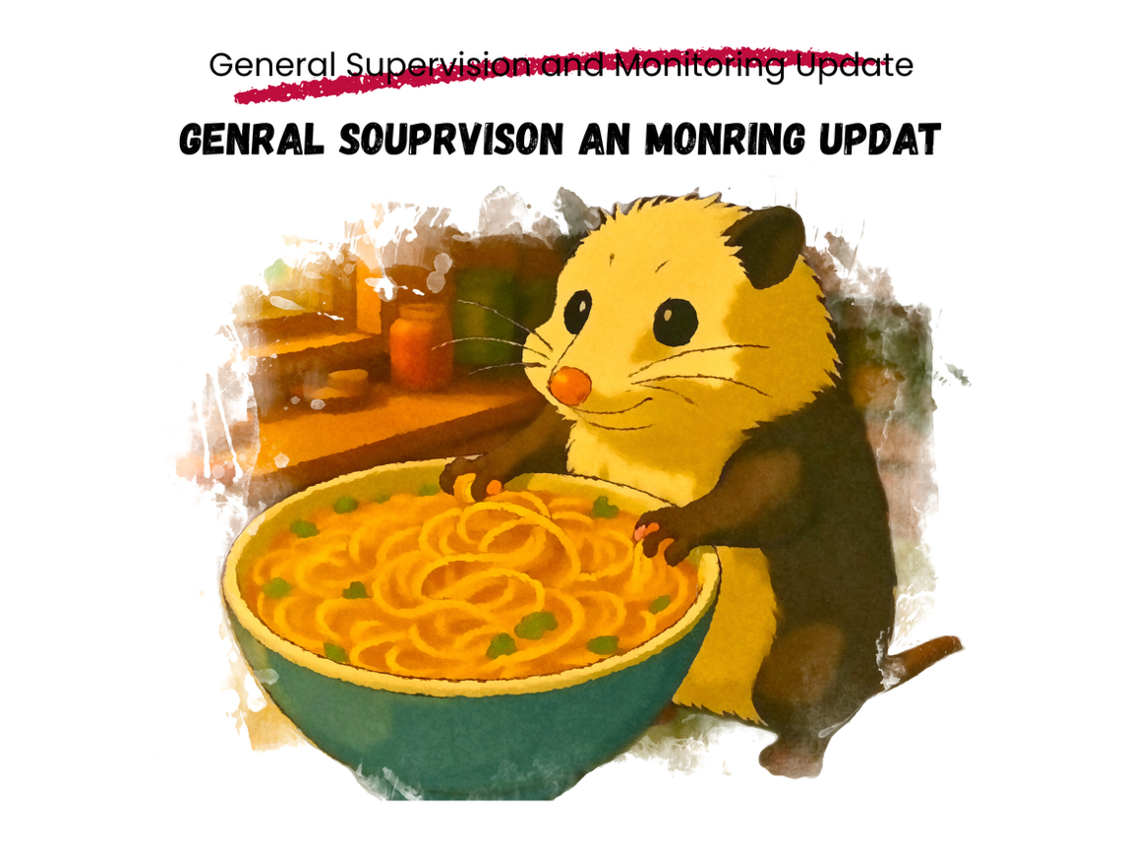
People often ask: How many children should our locality be serving?

There are (at least) two answers to this question… and nobody appreciates the lack of specificity of this first one: All of them. A locality should be identifying and serving all Part C eligible infants and toddlers. However, truth be told… nobody knows exactly how many all is.

For this reason we rely on statistics — global, national, state and local. How many infants do we think may have developmental delays or disabilities in any particular place? How many toddlers? How can we feel confident that we’re identifying and meeting the need?

As required by OSEP, U.S. states and territories set annual targets for two Part C child find indicators: C5 (birth-to-one) and C6 (birth-to-three). Targets can be adjusted over time, but states must show “meaningful” improvement over the course of a 6-year SPP/APR cycle.

- When Virginia began the current SPP/APR cycle (in federal fiscal year 2020 — or FFY20), the C5 target was set at 1.44% and the C6 target at 3.20%. The final targets (for FFY26) are 1.90% and 4.00%, respectively.

- As of this current federal fiscal year (FFY24), the C5 target stands at 1.83%, and the C6 target is 3.62% These are the figures one might use today when estimating local child count targets.

- For making an educated guess, a LEIS would need to know its birth-to-one and birth-to-three population figures — not always easy, as many local systems encompass more than one city or county.
- After years of obtaining population data from the Virginia Department of Juvenile Justice, the Part C Office has in recent years been redirected and now obtains the data for all Virginia cities and counties directly from the U.S. Census Bureau. The downloaded file isn’t pretty, and it takes time and effort to align all of the data with each of Virginia’s 40 local early intervention systems. That said, we somehow get it done.

- Landing on the population figures is the hard part. The calculations are simple:

  - For C5: Most recently available (annual) birth-to-one population x 1.83%.

    - As an example: From the most recent data available, ITC Possum Plains has a birth-to-one population of 3,451. 3451 x 1.83% = 63. To meet the state target, the one-day birth-to-one child count for ITC Possum Plains would be 63.

  - For C6: Most recently available (annual) birth-to-three population x 3.62.

    - As an example: The most recent data indicates that the ITC Possum Plains birth-to-three population is 11,982. 11982 x 3.62% = 434. To meet the state target, the one-day birth-to-three child count for ITC Possum Plains would be 434.

Remember: In Virginia (only), some 2-year-olds are served under Part B of IDEA through the Virginia school system. When calculating local child count percentages, these children are included in a locality’s birth-to-three child count.

So… if this first answer is all of them, you might now think the second answer is: We should be serving our calculated targets… and that’s not necessarily incorrect… but it’s not exactly 100% accurate, either. Do estimate your local targets — they can provide useful information! — but remember that meeting a calculated target does not mean all eligible children are receiving services.

Next ITCVA monthly monitoring community of practice: June 4 @ 3PM

Thanks to the 38 participants who were able to join us live for our first ITCVA monthly monitoring community of practice (MCOP) call in May. We look forward to sharing and engaging with you again soon!

As a reminder, MCOP calls are held on the first Wednesday of each month beginning at 3:00PM. Our next call will be held on June 4th. ITCVA MCOP calls are open to anyone who is interested in the topic(s) being covered. Calls will be recorded for those who are unable to attend. Please visit the Monitoring Community of Practice page of the ITCVA website for a list of upcoming topics, corresponding Microsoft Teams meeting links and session resources.

June 2025
Determination Reports (Copy 1 of 2)
Structured and Supervised Local Monitoring

July 2025
Initial SFy26 Budgets and Part C Expenditure Reporting

August 2025
POSM: Lessons Learned and the Path Forward

