

January 27, 2025

The Honorable Jason Perillo
Candidate for the 21st Senate District

Dear Representative Perillo:
It is with pleasure that I write to you on behalf of Friends of Connecticut Sportsmen to endorse your candidacy for Connecticut's 21st Senate District.
During your tenure in the House, you have given us your ear, been generous with your time and consistently advocated for science and evidence-based wildlife management and conservation practices. You’ve recognized that much of Connecticut’s wildlife management and habitat conservation activities are funded via hunting and fishing licenses, as well as outdoor sportsmen’s-related federal tax dollars returned to the State. Connecticut sportsmen are grateful for your steadfast commitment to preserving the rights of sportsmen to hunt, fish and shoot responsibly.
On behalf of more than 30,000 active sportsmen in Connecticut, we thank you for your commitment to our State and your willingness to serve in elected office. We wish you all the best in the upcoming election.
Sincerely,
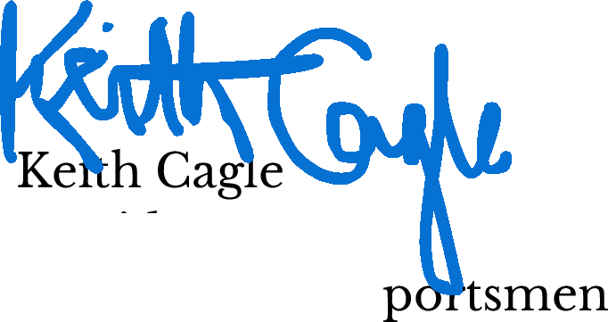

President Friends of CT S

