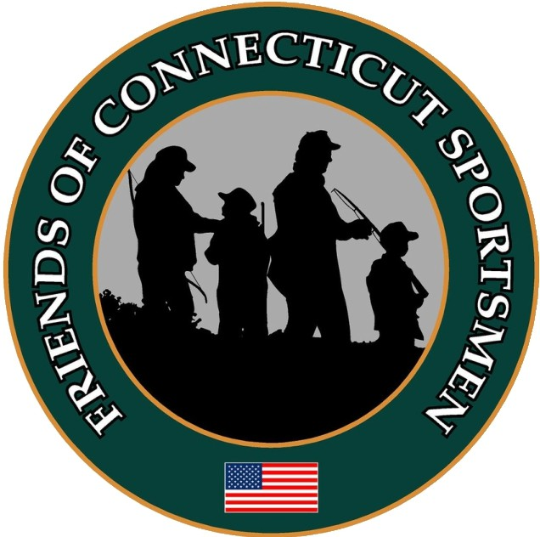

January 27, 2025

Robert Boris
Candidate for 40th House District
Groton, Connecticut

Dear Robert:
It is with pleasure that I write to you on behalf of Friends of Connecticut Sportsmen to endorse your candidacy for Connecticut's 40th House District.
Preserving hunting, fishing, and shooting sports in Connecticut requires effective wildlife management and habitat conservation, often funded by hunting and fishing licenses and related federal sales taxes that come back to the State. We appreciate your commitment to Connecticut sportsmen’s top priorities in the 2025 Regular Session of the Connecticut Legislature.
On behalf of more than 30,000 active sportsmen in Connecticut, we thank you for your willingness to serve in elected office. We wish you all the best in the upcoming election.
Sincerely,
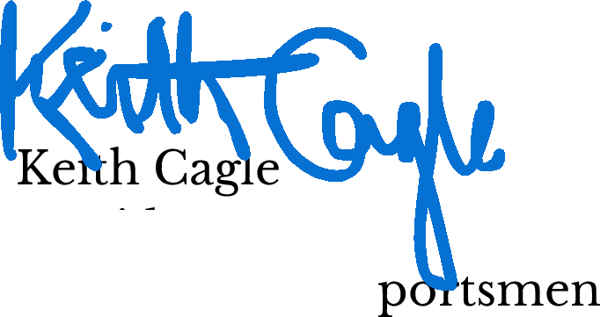

President Friends of CT S

