Women’s Rights are Human Rights!
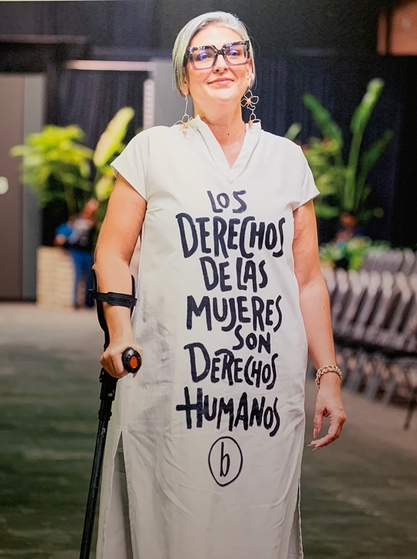
This year’s UN Commission on the Status of Women (CSW69) took place in New York City at the United Nations Headquarters in March 2025. The primary theme of revisiting Beijing +30 was an extraordinary opportunity to engage with the leaders of women’s movements from across the globe and across the decades.
For me, the most memorable session was held at the Harvard Club, with eight formidable veterans from the 1995 Fourth World Conference on Women, representing Tanzania, Namibia, Mexico, the Philippines, Trinidad and Tobago, and the United States. It was especially meaningful to hear how these strong women have continued to serve as parliamentarians, diplomats, professors, politicians, media professionals, and leaders of NGOs. In so doing, these amazing women inspire each of us to find ways to contribute to the goal of achieving women’s equality, whether in our local communities, our home countries, or internationally.
The need for role models also was emphasized in the session entitled Power4Girls, sponsored by Canada, UNICEF, and UN Women. This session was based on the sentiment that it is a “moral imperative that half of society gets a fighting chance” and that “the future belongs to adolescent girls.” An important message for experienced women’s rights advocates is their responsibility to inculcate a desire in girls to become leaders in the women’s equality movement.
Barriers to advancing women’s leadership figured prominently in several sessions. An insightful session sponsored by UN Women and the EU examined how the persistence of patriarchal social norms inhibits women’s participation in leadership and decision-making roles. Social norms — unwritten rules that guide behavior in certain contexts — include “women as caregivers” and “men as leaders.” Such norms can be internalized by both men and women, as well as reinforced by media portrayals. Valuable suggestions for moving beyond stereotypes and social norms at all levels include training, networking, and advocacy.
Another session continued this theme, by emphasizing the need to sustain women’s movements through infusions of seed grants at the grassroots level, along with long-term funding and alliances across movements and countries. The session concluded with the rallying cry “Don’t panic! Organize!”

