“The Prince William - Fauquier Voter”

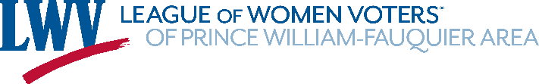
Summer 2025 Newsletter
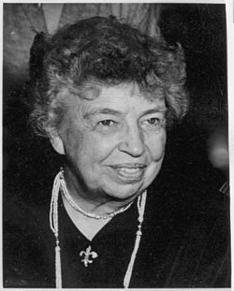
“Justice cannot be for one side alone, but must be for both.” Eleanor Roosevelt

President Pat Reilly’s Annual Report
In the past year, the League of Women Voters has undergone a national transformation. It centralizes many of the administrative functions of our chapters, which mostly affects officers’ jobs…treasurer and membership records. Most members will only notice this when paying dues, which now go to the US League and on its software and are renewed on a calendar-year basis rather than a fiscal year. The dues are split, with a greater percentage going to the U.S. and State Leagues and a smaller portion to local chapters. Donations to our chapter are more important than ever.

Where is all that national money going? The challenges to our mission: “To Defend Democracy and Empower Voters” have not been greater in the 105-year history of our organization. The U.S. League and the Virginia League have met threats to voting access with statements alerting the nation to a Constitutional Crisis, dozens of lawsuits on voter access and elections integrity and a new national campaign called Unite and Rise that gives all of us the goal of registering 8.5 million voters this year.

Here’s what we accomplished in the past year:
- participated in 90 events and contributed almost 2,000 hours. (that’s just the hours we registered). It does not include the hundreds of hours worked by our Board members in their various capacities.
- and educated voters—at high schools, community colleges, community events, libraries, senior residences and new citizenship ceremonies.
- created “Top Tens” for each county that tell people who the candidates are for Primaries and General elections, the important dates for voting and where to go to find other voter information.
- extended our reach and capacity through partnerships with groups in both counties for voter registration, candidate forums and debates and informational Webinars.
- helped the Arlington Chapter cover new citizen ceremonies and the Loudoun County Chapter with a joint 10th Congressional District Candidates Town Halls.
- continued to sponsor and support a coalition of Northern Virginia groups that has held a Vigil for Action every Saturday morning in Warrenton to bear witness to the murder of Black Americans in unjust circumstances. We celebrated the vigil’s fifth anniversary in June.
- partnered with the Delta Sigma Theta Sorority on the Martin Luther King, Jr. annual Oratorical Contest and presented each of the finalists with a book of Dr. King’s speeches.

In addition, during the General Assembly Session, State League members had a weekly opportunity to listen to dozens of issue leaders who aligned with our carefully studied and selected issue positions—gun safety, childcare, school funding, voter access, restoration of rights, budget allocation, and election integrity. Throughout the session, our Advocacy coordinator, Carol Noggle, alerted members to the work of their districts’ representatives.

Carol Noggle and Brenda Carswell worked on getting reentry information to former prisoners and their families, particularly on applying for restoration of voting rights. And our Land Use Study Group offered zoom sessions on what’s going on in Prince William County, led by our in-house expert Charlie Grimes. The Book Club met quarterly to discuss wonderful books that spurred lively discussions. Throughout the year, Communications Director, Carol Proven, alerted us to what we have to know and which opportunities are available in email bulletins. Our newsletter editor, Connie Gilman, puts out a quarterly report that invites each of us to contribute news and photos about what we’ve done. Our Volunteer Director Judy Hingle populated Signup Genius with opportunities for getting involved. We look forward to getting to know each other as we work together to register those 8.5 million potential voters!

From Co-president, Connie Gilman

It is my pleasure to introduce members to a recently new member of the LWV-PWFA. Kathleen is a lifelong member of the LWV and joined our league after relocating from California to Virginia. Kathleen was a delegate to the United Nations Commission on the Status of Women. Kathleen is also the Virginia State Leagues Secretary. Thank you, Kathleen for your dedication to the League!

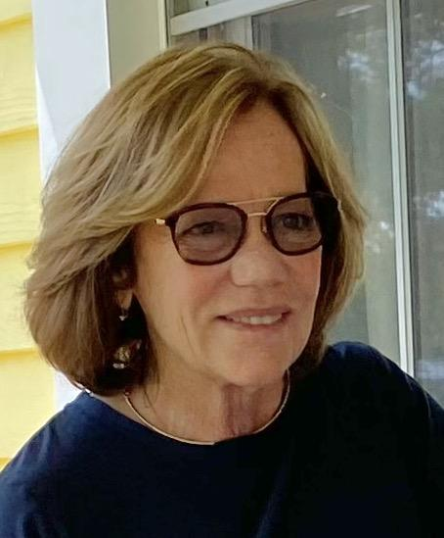
Kathleen Montgomery has a long history of working to advance women’s rights, both in her academic career and as a member of several human rights organizations. She has embraced the values of the League of Women Voters since childhood, when her parents taught her the importance of the League’s non-partisan guidance on important election issues. After retiring as Professor Emerita from the University of California, she sought opportunities to become more involved with the League at the local, state, and national levels. She served for five years on the Board of Directors of the League of Women Voters of Orange Coast (CA). In 2024, she moved to Virginia and was thrilled to join the League of Women Voters of Prince William-Fauquier Area (VA), helping with the strategic planning committee and voter registration efforts. Her roles with the state and national League of Women Voters include serving several years as a LWVUS delegate to the UN Commission on the Status of Women, as a panel moderator at the LWV National Convention, and as a representative of her local League to the State Convention.

Treasurer’s report:

Shari Oley reported that she, Pat Reilly, and Carol Proven served on the budget committee. Trish Freed also reviewed the draft budget. Since the National Capital Area League has been discontinued that fee will be deleted from the budget. The proposed budget was approved at the biennium meeting on May 18th.

To download and read the budget, click here.

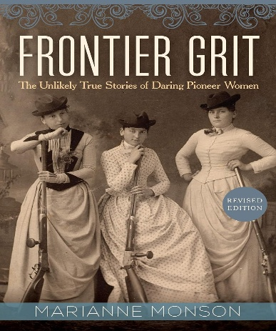
Up-coming Book Discussion

July 23rd, Wednesday 11:30, at Effingham Winery, please bring a savory to share! Wine available for purchase.
Frontier Grit, by Marianne Monson. This title covers the lives of 12 women who heard the call to be “influencers” during their time on the frontier of gold mining, dog sledding, voting rights, and helping native Americans.

LWV-PWFA (Public Service Announcement) PSA at Westminster at Lake Ridge.
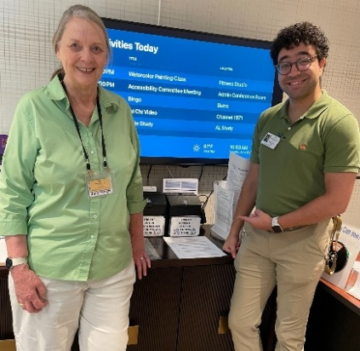
Judy Hingle has recorded an announcement on registering to vote in Virginia, changing your address with the Elections Office, and applying for absentee ballots to be broadcast on the closed-circuit television station for residents of Westminster at Lake Ridge. The community’s tech expert and events coordinator, Cameron Powell, shown here with Judy, will knit it together and add images. This is part of a voter education effort at Westminster , which is in Woodbridge. Voter registration forms, absentee ballot applications, and other voter information will be available at the community’s Resident Services Office. Residents can return forms to a locked box in the office. Judy or other League volunteers will take the forms to the Elections Office. Our League chapter will also hold registration events for residents and staff in September.
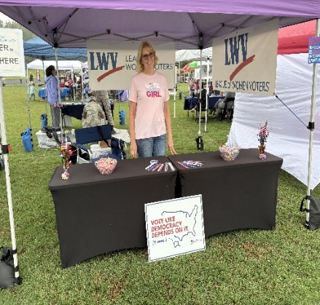
Warrenton Voter Registration
Ruthann Litchford representing our League at the Warrenton Town Limits Festival on Friday, June 27. Even though it rained, Ruthann was available to register voters and share all the good our League does.
Thanks, Ruthann!

Membership

Changes for renewing membership in the LWV-PWFA became effective as of February 1, 2025. Please note:
- There are no longer different types of membership. Per LWVUS, “Instead of a fixed dues rate, members choose their dues amount – “pay-what-you-can” – with a minimum of $20; however, the recommended rate is $75 per individual member”.
- All payments now need to go through LWVUS. They set up a portal that each member can go to change any of their contact information and such, and, if they want, to pay their dues and/or donate either directly to our league or to the Educational Fund.
- Please note – any renewal payments sent to Treasurer Shari Oley have to be mailed to LWVUS for them to process.
If you have set up an automatic recurring PayPal renewal, please remove it. When you go through the portal, there is an option there to set up an automatic renewal.
From now on, our league receives our percentage of member dues directly, so for example, if dues of $70 are paid, we receive only our 20% into our bank account. We no longer have the entire amount in our bank and then pay a single payment annually to both LWVUS and to the State League.

Information about who paid dues or made donations goes to the President, Roster Manager, and Membership, Pat Reilly, Carol Proven and Jane Touchet.
Our fiscal year has now changed to the calendar year.

Our retiring Advocacy Director, Carol Noggle, sent the following as her departing gift. She shared a list of the candidates who represent some of our members, running for office in November. Some of our current Delegates will have opponents, many who are new to Virginia politics. It will be important to get informed on the issues and think about holding debates. Once their goals for legislation, if elected, are shared, it will be important to publish and educate voters.

Currently, these are the candidates impacting our area:
19th House District: Del. Henson (D) has no opponent
20th HD: Del. Maldonado (D) has no opponent.
21st HD: Del. Thomas (D) has an opponent: Gorham (R)
22nd HD: Del. Lovejoy (R) has an opponent: Guzman (D)
23rd HD: Del. Candi King (D) has an opponent: James Tully (R)
24th HD: Del. Luke Torain (D) has no opponent
25th HD: Del. Brianna Sewell (D) has no opponent
30th HD: Del. Geary Higgins (R) has an opponent: John Chilton McAuliff
61st HD: Del. Webert (R) has an opponent: Jacob Bennington (D

“Women’s Rights are Human Rights, and
Human Rights are Women’s Rights.”

Report from the 69th United Nations Commission on the Status of Women
By Kathleen Montgomery, PWFA Member and delegate to the UN Commission
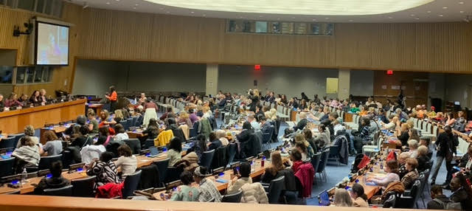

The 69th United Nations Commission on the Status of Women (CSW69) was held at UN Headquarters in New York City in March 2025. The CSW was established in 1946 by the newly formed UN to serve as the principal global inter-governmental body exclusively dedicated to the promotion of gender equality and women’s rights.
During CSW’s annual two-week session, representatives of UN Member States and Civil Society Organizations, including the League of Women Voters, gather to discuss progress and gaps in gender equality and women’s empowerment. This year’s CSW drew representatives from 186 UN Member States, half of whom were governmental ministers, and nearly 6,000 participants from Civil Society Organizations.

CSW69 was hailed as a particularly significant year because it coincides with the 30th anniversary of the Beijing Declaration and Platform for Action, adopted in 1995 by UN Member States at the Fourth World Conference on Women. The Beijing Declaration is still widely regarded as the most far-reaching policy document on gender equality. Many Leaguers may recall the moment at the 1995 meeting, when then-First Lady Hillary Rodham Clinton unequivocally declared, “Women’s Rights are Human Rights, and
Human Rights are Women’s Rights.”

I was fortunate to be selected again as a delegate to CSW and found this year’s theme of revisiting Beijing+30 to be an extraordinary opportunity to engage with the leaders of women’s movements from across the globe and across the decades.
An outstanding session showcased eight formidable veterans from the 1995 Fourth World Conference on Women, representing Tanzania, Namibia, Mexico, the Philippines, Trinidad and Tobago, and the United States. It was especially meaningful to hear how these strong women have continued to serve as parliamentarians, diplomats, professors, politicians, media professionals, and civil society leaders. In so
doing, these amazing women inspire each of us to find ways to contribute to the goal of achieving women’s equality, whether in our local communities, our home countries, or internationally.

Barriers to advancing women’s leadership figured prominently in several sessions. An insightful session sponsored by UN Women and the EU examined how the persistence of patriarchal social norms inhibits women’s participation in leadership and decision-making roles. Social norms — unwritten rules that guide behavior in certain contexts — include “women as caregivers” and “men as leaders.” Such norms can be internalized by both men and women, as well as reinforced by media portrayals. Valuable
suggestions for moving beyond stereotypes and social norms at all levels include training, networking, and advocacy.

Many sessions addressed the current backlash against human rights and women’s rights, along with a dampening of democratic values, seen in many countries, as well as in our own. Highlighting this the, the League of Women Voters of the United States organized an event entitled, Democracy at Risk: Reactions to Voter Decline Globally. The session included a panel drawn from countries with both high and low voter participation to explore barriers to civic engagement. One panelist began by emphasizing the four pillars of democracy — rights, participation, representation, and
rule of law — and defining democracy as “popular control over decision-making and decision-makers, and political equality in the exercise of that control.” Inter-related barriers include voter apathy and intimidation, registration hurdles, misinformation, voter suppression, polarized identity politics, media bias, and lack of trust in voting institutions. Some proposed solutions are making election day a national
holiday, greater voter education and unbiased voter information, and mandatory voting (used in some countries to improve voter turnout but at the risk of voter fatigue).
Many other sessions were devoted to this theme, including the following:
- “Resisting the Backlash and Shifting Paradigms Toward Gender Equality” sponsored by the Inter-Parliamentary Union and UN Women
- “Reflections and Resolve: Civil Society Pathways to Push Forward for Gender Equality” sponsored by UN Women and Regional Civil Society Committees for Beijing+30
- “Stepping Up, Standing By, and Speaking Out for Women’s Rights Movements” sponsored by the UK and Canada
- “Addressing the Backlash: Pushing Forward to Secure Sexual and Reproductive Health and Rights and Labor Rights” sponsored by Belgium, UN Women, and the UN Working Group Against Discrimination Against Women and Girls

Across CSW was heard the rallying cry “Don’t panic! Organize!”

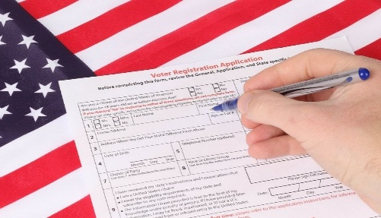
This Photo by Unknown Author is licensed under CC BY
Laura and Carol had such successful days registering high school voters! And they received this lovely thank you.
Well-done!

Date: 06/03/2025 11:28 AM EDT
Subject: OPHS Government Thank You/Announcement
Good morning,
Thank you for a wonderful year! It was great to work with all of you, and I am proud of all we did together - besides cool projects and lessons from the government team, we gave OP students time with lawyers and experts on preventing substance abuse and registered about 140 kids to vote!

Next year there will be a slight change. Zane Hurst will be the new government PLC lead! Congrats, Zane, and thank you for taking on this leadership role. You will lead us well.

While Zane will be in charge of team meetings and PLC leader communications, I will continue to be the point person for “So You're 18”, “Revive”, and voter registration next year. If you work with us on those programs, please email me in the fall to set them up and Cc Zane (HurstZ@PWCS.edu) to keep him in the loop.

Please let me know if you have any questions, and thank you again for your time and efforts.
Sincerely,
Lisa L. Petrovich

Osbourn Park High School
US & VA Government
8909 Euclid Avenue, Manassas, VA 20111
(703) 365-6500
PetrovLL@pwcs.edu
PWC Re-entry Program Update:
Carol Noggle

In addition to myself, Brenda Carswell is active in tracking the activities of the PWC Re-entry Program. The Department of Corrections provides re-entry resources
to inmates and individuals under community supervision. Re-entry starts upon the sentencing date that’s imposed by the court. Senior Re-entry Probation and Parole Officers help in getting identifications, housing, employment, substance abuse, and mental health resources to probationers. The Re-Entry Council meets every other month. It consists of members of community groups who come to share information on their resources.

Since 2011, the Re-entry Council has been involved with the community to establish supportive services for offenders being released to the community. In 2011, the Re-entry Council helped to develop and initiate Family Orientation (now known as Reentry Connections) events that are held in the community on a quarterly basis. Releasees and their families are encouraged to attend to learn of the vast array of services provided throughout the community. In addition to the typical state and local agencies and services, presenters include Parks and Recreation, Public Library, League of Women Voters, DMV, law enforcement, healthcare providers and Peer Support Specialists.
The presenters provide a rapid-fire overview of the services offered. After the presentations, participants are encouraged to visit the vendors to obtain more information pertaining to their specific needs and interests. Over the years, these events have assisted thousands of returning citizens and their families in engaging with available resources and assisting in successful reintegration. The Re-entry team also focuses on homelessness as these individuals typically have the highest needs. The team coordinates needed community services, provides food, clothing, personal care hygiene products, mentors and transportation to community residential programs, a hotel or local shelter.
​

The next Re-Entry Connections event is at 5:30 on July 17 at the Ferlazzo Building. The LWV-PWFA will set up a table with information on restoration of voting rights, materials for voter registration for those eligible, information on the November election (voting starts September 19), and information on the "Ban the Box" law regarding job applications.

Some good news! The recent recidivism rate was considered low, which is good. That could certainly mean that there are enough staff and groups that provided help regarding things like being prepared for employment interviews and getting good information on what jobs would be suitable for each person released. They said that, for this recent time period, of the 728 people released only 69 had to return to jail.

The next regular Jail Board meeting is on July 16th. The Board will meet at the Adult Detention Center in the Board Room at 6:00 PM. The meeting consists primarily of updates to the number of inmates, the status of the budget, and any special programs that they have. [There is usually just one sentence about the number of ICE arrests.]

​

Ban on Styrofoam, Article Submitted by Janet Gorn

RICHMOND, Va. (WAVY) — Virginia’s ban on Styrofoam is set to take effect July 1, four years after legislators approved its phase-out, with the reception getting mixed reviews despite what officials say is its harmful effect on the environment.
State lawmakers have wanted to see Virginia go foam-free, as the legislation bans single-use polystyrene — better known as Styrofoam. It includes plates, cups, containers and bowls.

For now, the law will only apply to businesses with 20 or more locations. Smaller businesses will have to comply in July 2026.
Alternatives listed by the Virginia Department of Environmental Quality include paper, plastic, bamboo or foil, which could cost the business owner more.
The VDEQ said Styrofoam takes 500 years to break down, and even then, it doesn’t break down fully. It can also be confused for food by animals, and it’s thought to be a possible carcinogen.
For more information, check out the VDEQ’s website.
Categories: Business, Local News, Video

  This Photo by Unknown Author is licensed under CC BY | From Saddlebags to Satellites  Janet Gorn,  Member Advocate  LWVUS Lobby Corp | 

Lobbying is an important part of our Democracy. To protect Americans’ rights LWV Members civic participation is imperative. To that end, what does the LWVUS do? The LWVUS actively tracks U.S. Congressional legislation, educating Congressional staff about pending legislation through nonpartisan, researched, and factual information. The LWVUS through its “Call to Action”, from Jessica Jones Capparell, Director of LWVUS Government Affairs, alerts and empowers state and local league leaders to engage in complementary national advocacy.
The LWVUS maintains a direct voice on Capitol Hill through its LWVUS Lobby Corps Member Advocates; the League’s “Boots on the Ground.” The Corps works under the direction of the corps LWVUS Advocacy team. Its task is to advocate in favor of specific LWVUS positions on pending legislation or resolutions, by requesting brief conversations with relevant Congressional members’ staff.
The Corps’ Mission is to:
- Educate Congressional staff about the impact of pending legislation,
- Increase the League’s influence and visibility on Capitol Hill,
- Build valuable relationships with Congressional Members,
- Promote and communicate the League’s priorities, and
- Empower state and local LWV leaders to engage in Federal advocacy.
The Corps Member Advocates are composed of League members who live within commuting distance of Capitol Hill (Maryland, Virginia, Washington DC), and state and local leagues approved by State Presidents. They are required to go through a training program and are briefed each time on a particular bill that is active on Capitol Hill, based on League study positions as selected by the LWVUS National Board whose portfolio is Advocacy. The Advocacy staff identifies the members of Congress who are supportive of the League’s positions or that are either unsure or are viable targets who may be persuaded, or may have useful information to share. The staff also prepares the Issue Background Memo and talking points.

Lobby Corps Member Advocates receive assignments to lobby select members of Congress. Some recent topics among others have been Medicaid Funding, For the People Act, the John Lewis Voting Rights Advancement Act, the Disclosure Act, the Equal Rights Amendment, DC Statehood, Affordable Care Act, climate change, the Keystone XL Pipeline, gun safety, and immigration.

Calendar of Events

We have a new interactive calendar of events on our website!
Check out our upcoming events for members and the public!
Date & Time & Description are available, and most events are held on Zoom, unless otherwise noted. Zoom info will be sent with SignUp Genius confirmation.

You can find the calendar on our website: www.princewilliamlwv.org/calendar-of-events/



League Meetings are open to all members!

Board of Directors Meeting, 3rd Tuesday of the month, 7:00-9:00 pm
(No Board Meeting in November and December)
General Meetings and Events notices are sent to the members. Watch for upcoming emails!

LWV-PWFA Website: Prince William – Fauquier Area League of Women Voters – Serving Voters of Prince William and Fauquier Counties

LWV-PWFA Email: lwvpwfa@gmail.com


Please send in ideas for the Fall 2025 Newsletter by September 23. Better yet, submit an article, ask some questions, share a joke!
Connie Gilman, Newsletter Chair, conniewg51@gmail.com

