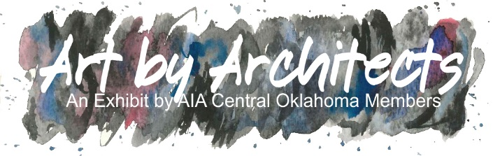

ENTRY FORM
AIA CENTRAL OKLAHOMA MEMBER INFORMATION
NAME:

COMPANY:

TYPE OF MEMBER:  AIA  ASSOCIATE AIA  ALLIED

PHONE NUMBER:

EMAIL ADDRESS:

ENTRY INFORMATION
ENTRY I- TITLE:

MEDIUM:

RETAIL VALUE: SIZE:

SHORT DESCRIPTION:

ENTRY II- TITLE:
MEDIUM:

RETAIL VALUE: SIZE:

SHORT DESCRIPTION:

ARTIST AGREEMENT:
I agree to grant AIA and IAO permission to reproduce artwork images for marketing purposes. In addition, I understand that if my artwork is for sale, the sale will be split, 40% to IAO and 60% to the artist.
SIGNATURE:

