2021 Architecture Tour Application
Deadline July 16, 2021

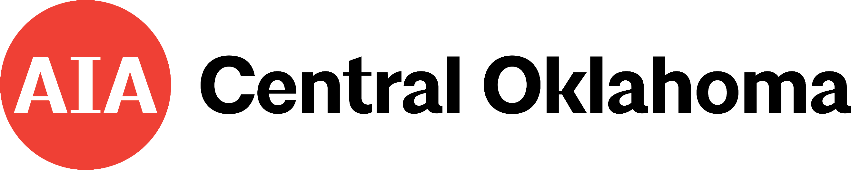

__________________________________________________________________________

2021 AIA Architecture Tour- Sunday, October 17 | 1:00 – 6:00 p.m.
__________________________________________________________________________

Architect Name:

Firm Name:

Firm Address:

Phone: Email: Cell Phone:

Project Name:

Project Address:

Project City, State, Zip:

Project Type:  Commercial  Residential
❑ New  Rehabilitation/Restoration

It is the goal of the 2021 Tour Committee to select a variety of residential, commercial and historic preservation projects for the tour.

Owner’s Name:

Owner’s Address:

Owner’s City, State, Zip:

Owner’s Email:

PROJECT TEAM INFORMATION:

As part of the tour application process, we are asking applicants to list subs, suppliers, contractors, interior designers, etc that were involved in the project. If your project is selected, AIA may solicit sponsorships from these companies.

Contractor:

Sub Contractors:

Suppliers:

Engineers:

Interior Designers:

Project application MUST include ALL the following to be considered:

❑ Completed Application
Owner and Architect agreements MUST be signed in order for this application to be valid and ALL Questions
must be answered.

❑ DropBox the following information:
- Two Exterior Photos and Two Interior Photos of the project (.jpg @300 dpi) These photographs WILL be used in promotion and media coverage for the tour and one or two of them will be used in the tour brochure.
- Firm Logo (.jpg)
- Electronic version (in word format) of the completed tour application (and signed form in PDF).

AIA Architecture Tour Rules:

 Eligibility and Authorship: Submissions must be designed by licensed Architects and /or firms holding a
Certificate of Authority with the Oklahoma Board of Architects. I certify that my firm holds a COA with the Board of Architects to practice Architecture in the State of Oklahoma. ___ (initial)

 Accuracy: Information submitted in this application will be used in Tour publications if the project is
selected; thoughtful and appropriate answers should be submitted at this time. I certify that the information
included in the application is correct and these details can be used in the tour brochure and media releases
if my project is selected. ___ (initial)

 Project Completion: Projects must be 100% complete by September 1, 2021. My project is / or will be
100% complete by September 1, 2021. ___ (initial)

 Project visits: Each project must be available for viewing by the selection committee. These site visits will
take place the weeks of August 2-6, 2021 . I agree to work with the committee and coordinate the site visit with the owner. ___ (initial)

 I understand that it is my responsibility to be the point of contact between the owner and AIA, upon
selection for the tour. ___ (initial)

 The Architect will be required to be present during the tour. In addition, the architect will be required to
supply all but two of the volunteers needed for the tour (on average that is 3-4 per shift). AIA will provide two additional volunteers per shift to assist the firm’s volunteers as well as sell tickets etc. The number of volunteers needed will be determined during a meeting with the owner, architect and AIA. I understand that if my project is selected and I am unable to provide the volunteers needed to staff my project there will be a $50 charge per volunteer not provided. ___ (initial)

❑ Owners and Architects: Architects, Owners and projects must be available for media coverage between
September 15 – October 17. Every attempt will be made to give at least 48 hours advance. Interior
and exterior photographs may be taken by the media for promotion of the tour. The architect is responsible
for coordinating these media visits with the owner(s). I agree to work with the owner in scheduling media
visits and I have made the owner aware that these visits can take place anytime between September 15 – October 17. ___ (initial)

 Shuttles: No shuttles will be used for the Tour. It is a self guided tour therefore adequate parking needs to
be available for tour participants. I certify that there is adequate parking for the guests on the 2021 AIA
Architecture Tour. ___ (initial)

❑ Sponsorship: The AIA Architecture Tour is a community awareness event for AIA Central Oklahoma as well
as a fundraising event for the chapter. No materials or representation may be displayed in the location
without paid sponsorship, except by the Owner and Architect for the project. ___ (initial)

 Multiple Submissions: A maximum of two locations may be submitted from any one firm or applicant.

 Entry Deadline: Application submissions must be drop boxed or emailed to the AIA Central Oklahoma office
by 5pm, Friday, July 16, 2021.

❑ Disqualification: I understand that the Tour Committee reserves the right to disqualify any selected Architect
and home if the above rules are not adhered to at any time. ___ (initial)

Architecture Tour Selection Criteria:

1. Completed Application and supplemental project information.

2. Illustrations that demonstrate or exemplify the following: design constraint solution, craftsmanship, innovative
use of materials, sustainable design, and / or relationship/collaboration between architect and owner.

3. Logistical feasibility for Tour, including but not limited to, location, route, parking and a safe environment for
tour goers.

4. The committee will give preference to residential locations but are also very interested in unique commercial
projects that the public isn’t able to just walk into everyday. The committee is also interested in historic
preservation projects.

ARCHITECT AGREEMENT:

The undersigned licensed architect acknowledges all information provided in this Application is true, and agrees to all of the above Architecture Tour Rules. The undersigned also agrees to respond in a timely manner to any requests from the Tour Committee or associated media coverage regarding information requests and / or site visits.

In addition, the Architect agrees to provide the volunteers need to staff this location. The Architect also agrees to be on hand during the tour hours to meet and greet the public and answer questions regarding the project.

Architect Name: Signature: ____________________________

Firm Name: Date: ________________________________

OWNER AGREEMENT:

The undersigned Owner acknowledges and agrees to all of the above Tour Rules. The undersigned Owner agrees to allow the above named Architect / Firm to submit his / her home or building for inclusion on the AIA Architecture Tour on October 17, 2021. The Owner also agrees to make the location available for media coverage with at least 48 hours notice between September 15 – October 17 (photographs – interior and exterior, and interviews) for the Tour. The Owner agrees to be present during the hours of the tour. The Owner further acknowledges that if in a gated community, or a secure building, their neighborhood association or the authorized party has given full authorization for this location to be on the Tour- written authorization is attached.

Owner Name: Signature: ____________________________

Date: ________________________________

Owner Name: Signature: ____________________________

Date: ________________________________

PROJECT WRITE UP:

Please provide us with a write up that will be used in the tour brochure and in other PR and marking materials. This write up should be no more than 250 words.

FIRM WRITE UP:

Please provide a short (150-200 word) write up about your firm that can be used in our marketing and PR efforts.

FINAL QUESTION:

Please tell us what is unique about your project and why you feel your project should be on the 2021 AIA Architecture Tour.

Questions, Please Contact AIA Central Oklahoma at 405-948-7174 or aiacoc@cox.net.

