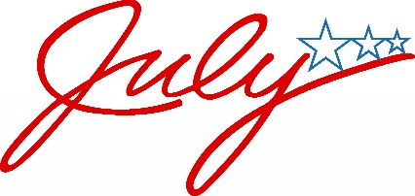
Boone county adult day center news 2019

One of the most recognizable symbols of America is our flag. When looking at the stars and stripes, most of us remember learning that the that red, white and blue were chosen as the colors to represent valor (red), liberty and purity (white), and justice and loyalty (blue).
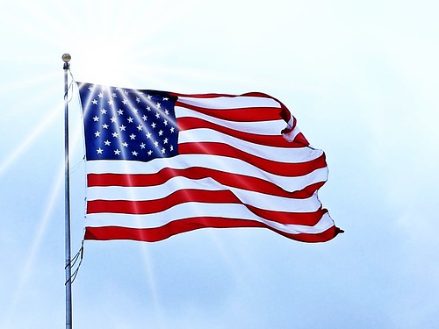
Flag etiquette, not often being taught in modern schools, tells us some important facts:
- When the American flag is flown at night it must be illuminated
- It should never be flown in bad weather;
- It can only be flown upside down to signal distress
- It must be raised quickly and lowered slowly
- No other flag can be placed above it.
- The flag should be flown during school days in or near every
school building.
It’s a myth that the flag must be burned if it touches the ground. The flag must be burned if it’s damaged and is no longer suitable for flying.
There have been 27 official versions of the American flag, each with a different number of stars. When Alaska and Hawaii became states 49 and 50, President Eisenhower received thousands of ideas for an updated flag. Robert G. Heft, a 17-year old high school student from Ohio, submitted his version that he created for a class project, and it was accepted and remains in use today. Can you believe that Robert got a B- on his project?
The Explore Harrison office presents the 7th Annual FIRE IN THE SKY on Thursday, July 4, 2019. This spectacular event will begin Thursday evening with all sorts of fun and activities for the whole family to enjoy and will lead into the fireworks celebration at dusk (approximately 9:30pm).
Ample parking will be available at the Harrison Junior High, Burlsworth Youth Center, and Lake Harrison Park. For more information contact Explore Harrison at 870.741.1789.
FREE General Admission

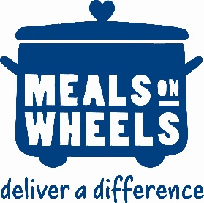
The Boone County Senior Activity and Wellness Center is available to provide home delivered meals to seniors in Boone County who cannot get out and get a hot meal during the week. Meals are delivered to seniors 60 or older Monday through Friday for a suggested donation of $3.00 per meal.
The Area Agency on Aging is an equal opportunity provider and employer.
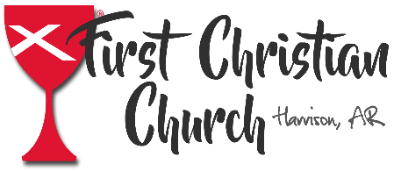
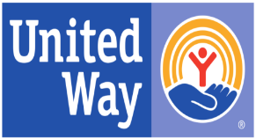
The Adult Day Center appreciates the United Way and the First Christian Church of Harrison for continuing to support the Adult Day Center program. The funds and donations received enhance the lives of seniors in our community.
_______________________________________________________________________________________
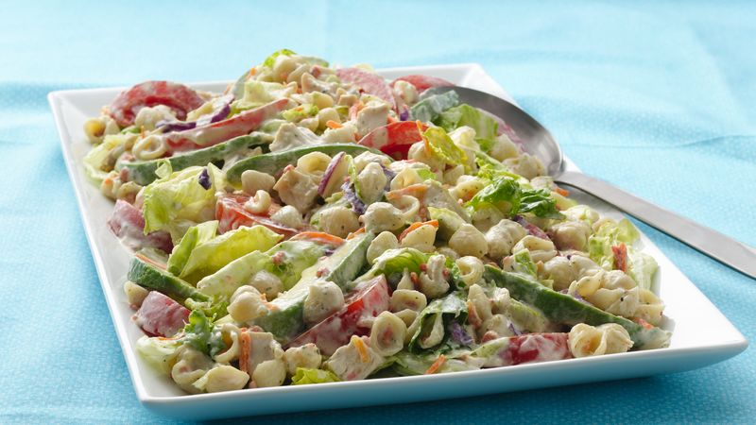
Easy California Chicken BLT Salad
Ingredients
1 Box Betty Crocker™ Suddenly Salad® ranch & bacon
pasta salad mix
1/2 cup mayonnaise
2 cups cut-up cooked chicken
1 large tomato, cut into wedges
1 avocado, pitted, peeled and cut into wedges
1 bag (12 oz) ready-to-eat salad mix (iceberg lettuce, romaine, red cabbage, carrots and radishes)

Steps, easy as 1-2-3:

1: Cook pasta as directed on box.

2: Drain pasta; rinse with cold water. Shake to drain well.
3: In large bowl, stir together seasoning mix and mayonnaise. Stir in drained pasta and remaining ingredients. Refrigerate at least 1 hour before serving. Cover and refrigerate any remaining salad.
Things Happening in July:
- The ADC is Closed Wednesday July 4th for the Independence Day Holiday

- The Boone County Senior Center will host a reception Wednesday July 3rd at 12:00 honoring those in our community who have served in the armed forces. Cake and punch will be served. Open to the community, free of charge.

The Boone County Adult Day Center
Welcomes Clients

Monday – Friday, 7:30 am to 4:30 pm
Boone County Adult Day Center is an equal opportunity provider/employer.

