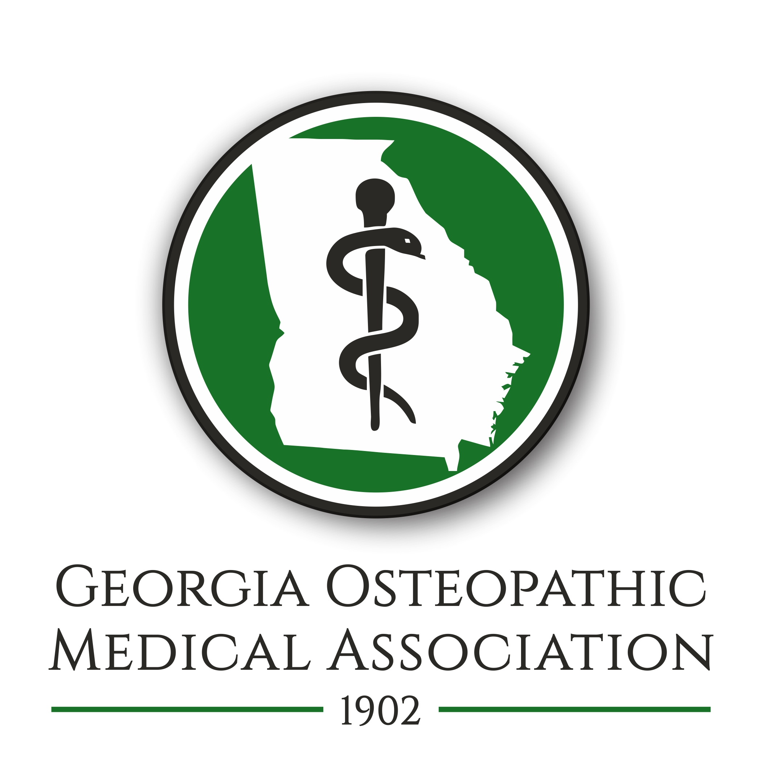
GOMA
2133 Lawrenceville-Suwanee Rd
Suite 12-347
Suwanee, GA
www.goma.org
770.403.6894
Fax: 678.225.7579
gomaosteo@aol.com

Besides the clinical skills and the academic knowledge that I gathered during those years, I heard many stories about sentinel events and dynamic leaders of Osteopathic medicine here in Georgia. Some of those stories were dramatic in discrimination that D.O.s suffered in the early years. Those troubles made the profession more unified. A majority of the D.O.s in the state belonged to GOMA, and hence there was always a strong bond between the doctors. Everyone knew the spouse and the children of each D.O. in the state. And of course, the D.O.s helped support each other’s practices by referring patients to each other.
In 1996, the year prior to my first installation as President of GOMA, this organization spearheaded legislation that forced hospitals to treat Osteopathic Board certification equally with Allopathic Board Certification. A hospital not that far from here was famous for discriminating against doctors with Osteopathic board certification. Now, that same hospital has an Osteopathic residency. To some of us in this room, it brings on a small smile and a shake of the head knowing how far things have come.
When the early planning for an osteopathic medical school was happening here in Georgia, it was this osteopathic community, many who were members of GOMA, who led this from becoming just an idea to an actual school. I sat on that committee, and I distinctly remember some of the challenges, but also the victories including Gwinnett County giving us the greatest support in trying to create an osteopathic medical school. Then, later, PCOM coming down to scout the possible locations. Every time I come back to this campus, I think about those evening meetings that started this great school.
When D.O.s come together, great things happen. When we work together, barriers are broken down and schools are built up.
HMOs, PPOs, PHOs, ACOs are just a few of the abbreviations of forces that have worked against our unity. Those forces along with more general acceptance of D.O.s have slowly acted to distance D.O.s from each other. I think that is a shame. I’m not sure what the next battle will be, but I certainly want our profession to be unified and ready for when it comes. I wouldn’t be surprised if GOMA will be speaking out for employed physician rights in the not too distant future.
For now, I look forward to leading GOMA for the next year. The organization was started in 1902. I hope to allow it to blossom in 2019. We will be restarting newsletters except no longer in the paper mailing as done in years past but rather in the digital form. We will continue to have an active Facebook page as we have done over the past year. We will start to expand into other Social Medias. But probably more important than going big, is GOMA going small. We will be having small personal gatherings across the state so that D.O.s and their spouses can socialize.
GOMA will continue to work to prevent discrimination against D.O.s (yes, there still are some prejudices). GOMA will continue to make ourselves known with the state legislatures and work alongside with other professional organizations to keep physicians as the leaders in healthcare.

GOMA will help support the American Osteopathic Association. Our delegates to the AOA’s House of Delegates have historically contributed important proposals that help define our profession. And closer to home, GOMA will support PCOM’s Georgia campuses – both this one, and the rapidly rising PCOM South Georgia in Moultrie, Georgia which will matriculate its first class in the Fall of 2019.
Of course, GOMA will continue to provide high quality CME. Some of it will be in person like this conference. Some of it will be web based learning like we did in February 2018 to help our members get opioid training. We hope to continue to partner with other organizations to provide high quality CME.
In closing, I appreciate this opportunity. I am honored to become the President of the Georgia Osteopathic Medical Association. I remember my predecessors who broke down barriers as well as shared their knowledge and clinical skills. Now it is time to look forward to a bright future. It is time for GOMA bring all the D.O.s in the state together to work for our common good. No other organization will speak for the D.O.s. It is time for us to help each other. The Osteopathic profession brought us to this day. Please join me by becoming an active member of GOMA. You will make strong friendships by doing this, and you will make bonds that will help your career. Thank you for your support as I take on this task of being president of your organization.

