Spring Insight Application Guidance
For SEO London’s Partner Firms
 | Bank of America Merrill Lynch | Barclays | Citi | Goldman Sachs | HSBC
Online Application |  |  |  |  | 
Deadline | 04-Jan-18 | TBC | 12-Jan-18 | 03-Jan-18 | 14-Jan-18
Duration | 1 week | 1 week | TBC | 2 weeks | 4 days
CV |  |  |  |  | 
Motivational Questions | 
Cover Letter |  |  |  | 
Numerical Test |  |  | 
Situational Judgement Test / Business Scenario |  |  |  |  | 
Verbal Reasoning Test
Video Interactive Assessments/Video Interview |  |  |  |  | 
Flag SEO Candidate |  |  |  |  | 

General Guidance
- Online Applications
If you are interested in spring programmes with any of our sponsor firms, you will have to make direct applications to each of them via their individual websites. As an SEO candidate, we would like to provide you with support through this process. After the First Year Fast Track event in November, SEO London will be discussing strong applications with partner firms who they will prioritise for their Spring Programmes.
- Cover Letter
Where necessary, write a strong and relevant cover letter. This is an opportunity to highlight particular strengths on your CV, and a chance to explain to the recruiter why you should be considered for a place.
Numerical and Logical Tests, Interviews, and Assessment Centres
Once you have applied to these firms and begin their individual assessment processes, we are able to provide you with numerous resources to help you prepare and practice fo interviews and assessments. Once you are invited to complete any of these assessments, please do contact us to let us know and we will provide you with the resources to prepare.
- Flag that you’re an SEO Candidate
When applying to each of our partner firms, it is important to flag that you are an SEO Candidate by following the firm-specific instructions below. In all cases you should include on your CV “2017 SEO Candidate)
Firm-Specific Guidance
Please find below guidance on the following firms:
1) Bank of America Merrill Lynch
2) Citi
3) Goldman Sachs
4) HSBC
5) Barclays (Coming soon)

Barclays is yet to open but we will keep you updated

Bank of America Merrill Lynch
Application deadline: 04/01/2018
https://campus.bankofamerica.com/careers/spring-insights-program-emea.html

Flag that you are an SEO Candidate
Application Step 9 out of 11- How did you hear about us?

What prompted you to apply to Bank of America? We would encourage you to select SEO 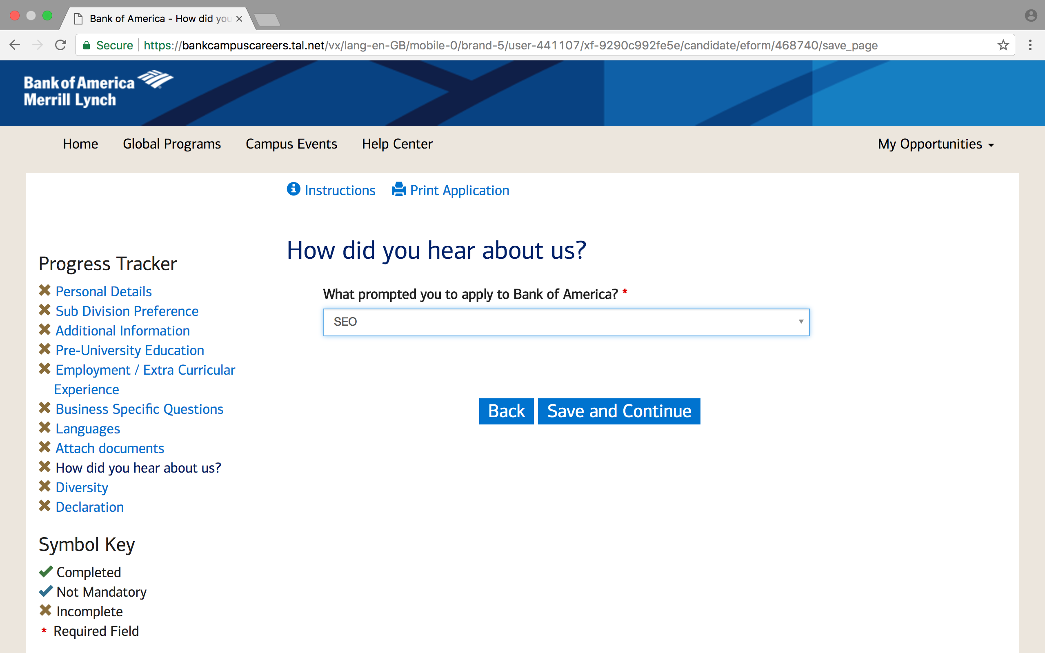

Opportunities by division:
- Audit
- Global Corporate & Investment Banking
- Wholesale Credit
- Global Markets & Global Research
- Global Transaction Services
- Corporate Treasury
- Technology
- Risk (Compliance and Market Risk)

Questions:
Please detail why you have chosen to apply to the Financial services Industry and specifically why the Insight Week at Bank of America Merrill Lynch? Also in your own words, describe the function of your first divisional preference (300 words)

Tips: Make sure you read the Job Description and Programme Overview on their website so you know what to expect from the Bank of America Merrill Lynch Spring Week; what aspects appeal to you and your learning style. Speak also to students at your university that may have done a Spring Week (or even summer internship) at the firm.
When answering this question, think carefully how your skill set matches what is required in the demanding industry of investment banking.
Upload CV
Once you have completed your application to BAML, you MUST notify SEO London by completing this survey here.

Barclays
Application deadline: Please note, the below is based on last year’s process. SEO London will recirculate guidance for Barclays as soon as you can apply.

https://joinus.barclays/emea/application-and-selection-spring-insights/

The application is in stages, you will be requested to complete your personal details and upload your CV. You will then be invited to sit an interactive video assessment.

Opportunities by division:
- Spring Analyst: Front Office – Banking and Markets
- Spring Analyst: Functions
- Spring Analyst: Technology
- Spring Analyst: Barclays UK

Flag that you are an SEO Candidate
Application Step 5 out of 6
Source Type?*
Please indicate how you heard about this job – Event/Job Fair
*Event/Job Fair – Select “SEO”

Note on online assessment:
All candidates will be asked to complete some online testing where they will be asked to answer some multiple choice questions as well as pre-record some answers via webcam. They will have approximately 2-3 minutes to prepare their answer for the webcam questions and 3 minutes to record it.
In terms of the types of questions, they will be fairly straightforward and will focus on scenarios that the candidate could experience during the Spring Programme. The testing will assess the types of skills that the candidate has as well as their understanding of the Barclays values.
Please be reminded of Barclays’ purpose and values: https://www.home.barclays/about-barclays/barclays-values.html
Once you have completed your application to Barclays, you MUST notify SEO London by completing this survey here.

Citi
Application deadline: 12/01/2018

https://citi.avature.net/careers/ProjectDetail/London-London-City-of-United-Kingdom-2018-EMEA-Spring-Insight-1st-Year-Programme-London-United-Kingdom/5081

Upload CV

Flag that you are an SEO Candidate
Application Questions (3) page
Source?*
What led you to this opportunity with Citi? – Put “Diversity Event”
ALL SEO Candidates applying to Citi should have a line of their CV that says “2017 SEO Candidate”
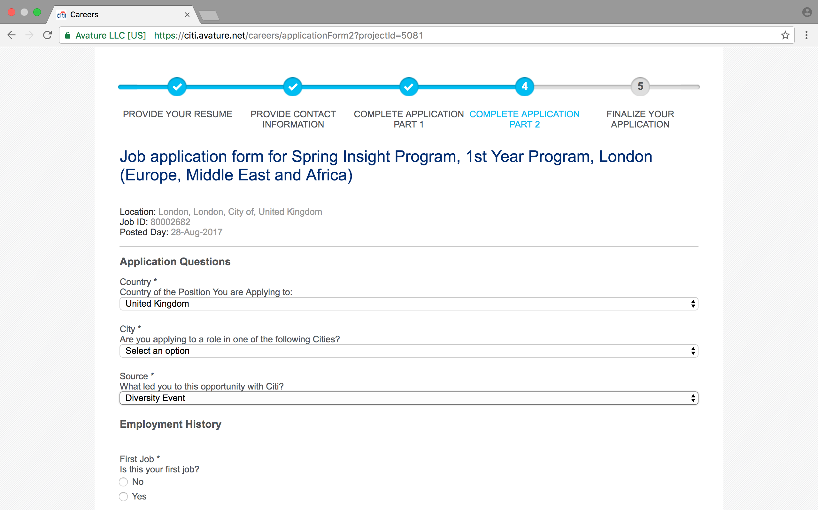

Opportunities by division:
- Corporate Banking
- Investment Banking
- Markets and Securities Services
- Capital Markets Origination
- Private Banking
- Treasury and Trade Solutions (TTS)
- Technology

Cover Letter - Be sure to provide examples of the qualities you would bring to Citi and describe your motivations for applying. Please see the end of this document for ideal Cover Letter format and structure

Address to use for Cover Letter:

Citi Graduate Recruitment
25 Canada Square
Canary Wharf
E14 5LB

Once you have completed your application to Citi, you MUST notify SEO London by completing this survey here

Goldman Sachs
Application deadline: 03/01/2018

http://www.goldmansachs.com/careers/students-and-graduates/our-programs/emea-programs/division-spring-internships.html

Flag that you are an SEO Candidate
Source/Affiliation page
Are you a member of any of these programs or partnerships? You may select all that apply – Put “SEO”
Did you attend or interview at any of the following conferences? Put “SEO”
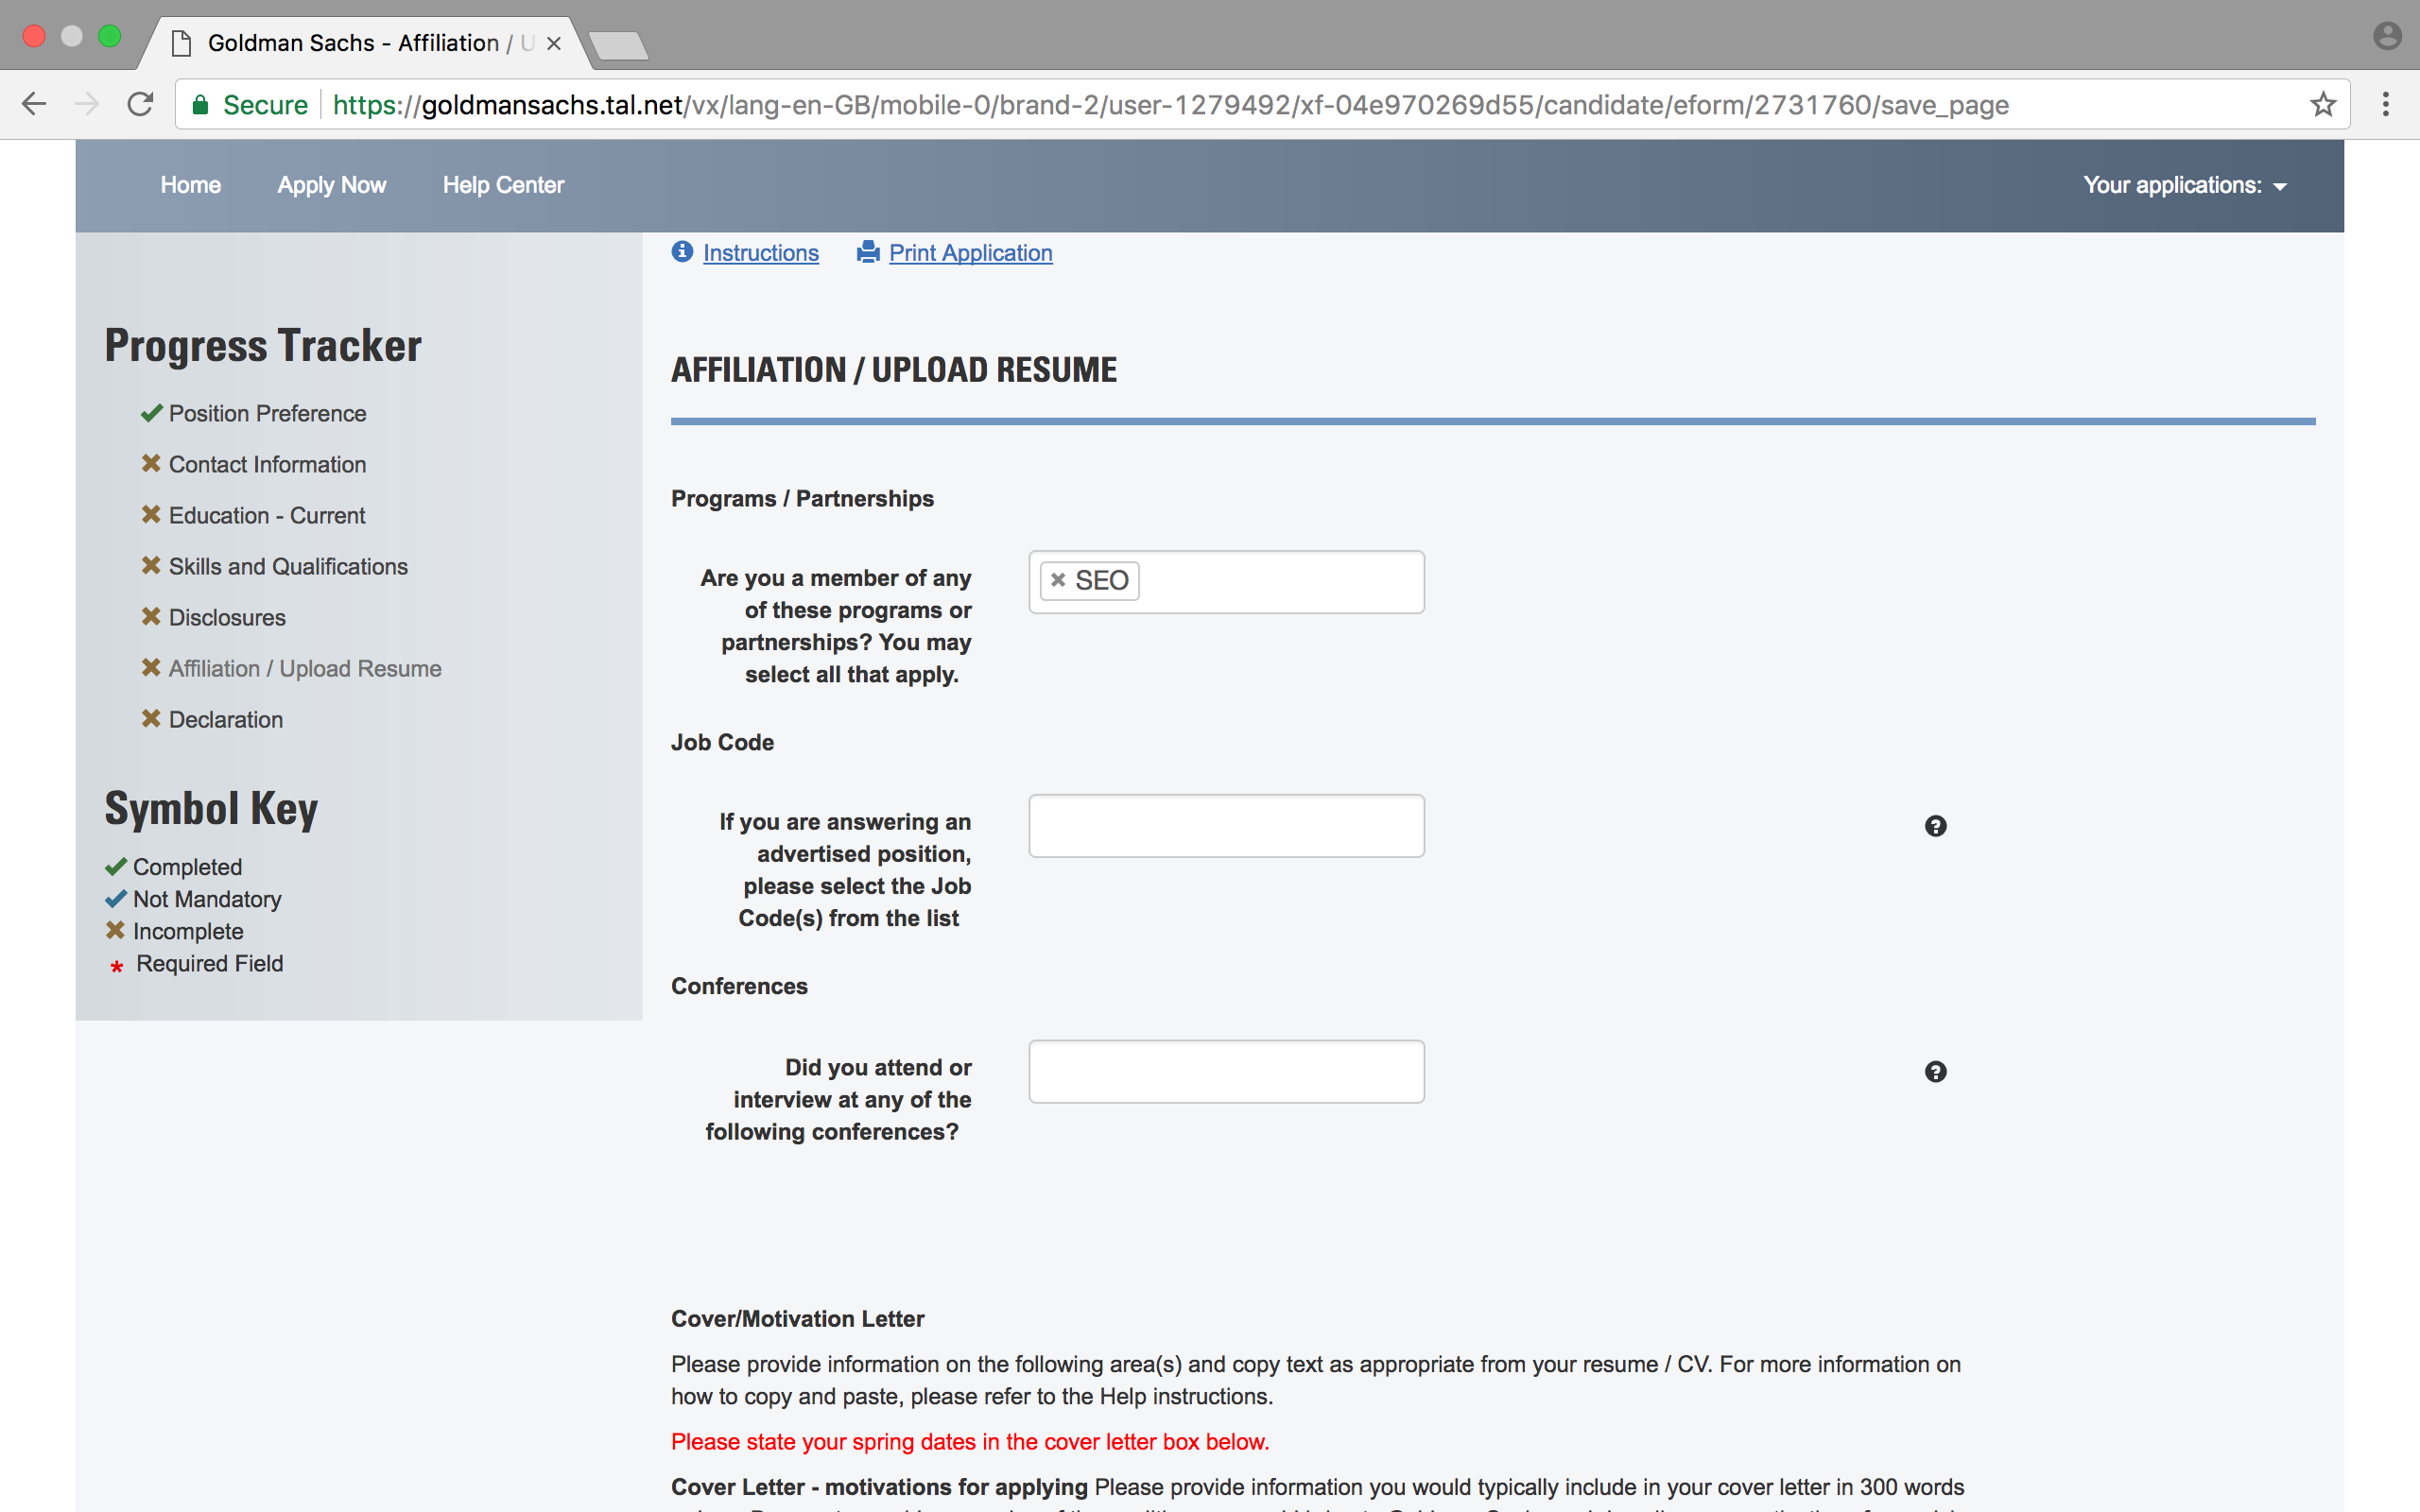

Opportunities by division:
- Finance
- Global Investment Research
- Economics, Commodities & Strategy
- Equity Research
- General
- Investment Banking/Corporate Finance
- Investment Management
- Goldman Sachs Asset Management
- Private Wealth Management
- General
- Operations
- Risk
- Securities
- Investing
- Sales and Trading
- General
- Engineering

Cover Letter - motivations for applying (300 words or less). Be sure to provide examples of the qualities you would bring to Goldman Sachs and describe your motivations for applying. If you are applying to more than one division, please discuss your motivations for applying to each. Please see the end of this document for ideal Cover Letter format and structure. For Goldman Sachs, do not worry about putting an address and making it look like a letter as you will have to complete a text box.

Upload CV
Upload Academic Transcripts
Once you have completed your application to Goldman Sachs, you MUST notify SEO London by completing this survey here

HSBC
Application deadline: 14/01/2018
http://www.hsbc.com/careers/students-and-graduates/programmes/spring-insight-programmes
Flag that you are an SEO Candidate
Registration page
How did you hear about us? Please select your main influence in applying to HSBC – Choose “SEO”
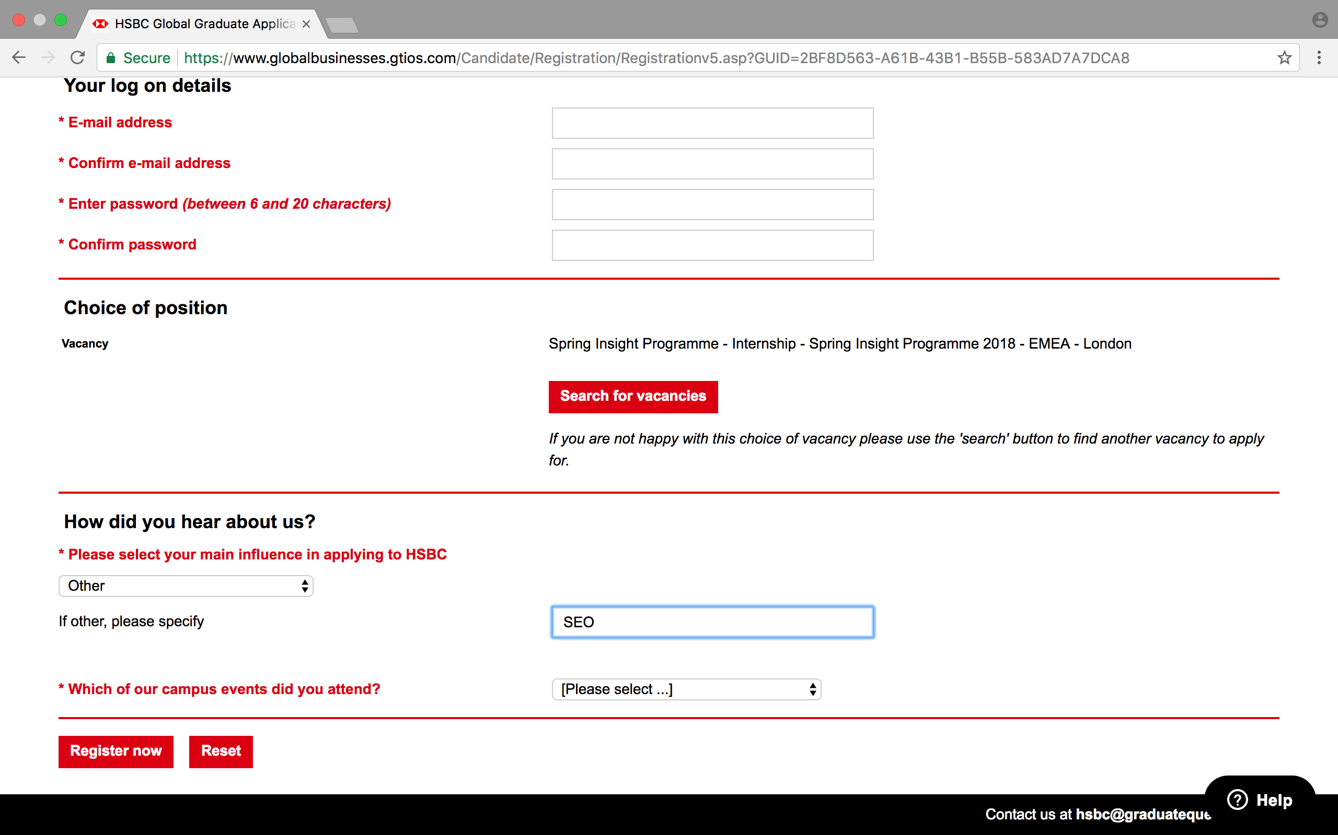
Opportunities by division:
- Global Banking and Markets

Recruitment Process
- Stage 1 – Online Application: Collecting eligibility data and candidate profile data only
- Stage 2 – Online Immersive Assessment: Fully immersive video based assessment
- Stage 3 – Online GBM Case Study: Continued realistic job preview with interactive case study assessment. Job simulation
- Stage 4 – Assessment Centre: Face to face business interaction and assessment

Upload CV
- Throughout HSBC’s application and interview process they are assessing whether candidates are a good fit for the firm and take their values very seriously – it is important that you try to demonstrate you understand their values and have demonstrated them in the past. They are constantly assessing if you meet their “values” assessment – PLEASE READ THEIR VALUES HERE (YOU WILL BE QUESTIONED ON THEM DURING INTERVIEW AND ASSESSMENT CENTRES): http://www.hsbc.com/citizenship/our-values
Stage 2: Online Immersive Assessment

- The online immersive assessment process is similar to a situational judgement test. You will be played a series of videos and will be asked a series of questions. The assessment should take between 45-60 minutes and you are advised to watch all the videos so you can make an informed decision.
- There will also be a number of Maths questions that you will be required to complete too.
- If you are successful with this stage, you will be invited to the Case Study which will be another interactive case study.

- Once you have completed your application to HSBC, you MUST notify SEO London by completing this here.

PLEASE KEEP COVER LETTER TO ONE PAGE AND DELETE THIS HEADER BEFORE SUBMITTING!

Your name
Your Address
Your Address
Current Date
Graduate Recruitment
NAME OF FIRM
THEIR ADDRESS (SEE DOCUMENT)
THEIR ADDRESS (SEE DOCUMENT)

Dear Sir/Madam,

Re: NAME OF SPRING PROGRAMME YOU ARE APPLYING FOR
[Paragraph 1 – Introduce yourself]
Something along the lines of “I am writing to apply for a position on your 2018 Spring Insight Programme for [insert Division if necessary]...”]. I am currently in the {name year} of an undergraduate degree in {subject} at the university of {name uni}.]

You can then start with why you are interested in undertaking a Spring Insight within investment banking and then why that particular firm. The below is suggested structure only. Remember to personalise – the same directions are given to all SEO candidates!

[Paragraph 2 - Why are you interested in doing a Spring Programme in the Division you are applying for]
You are not expected to have a lot of experience but they will be expecting to see strong motivation for wanting to explore the investment banking. You need to be very clear about what specifically attracts you to working in this division.
For client facing divisions show some understanding of how this business helps clients. Please read each firm’s website before you start the relevant application. There will be information about what the different areas do

[Paragraph 3 – What makes you a great candidate for investment banking and in particular this division]
This can either be linked into Paragraph 2 or a separate paragraph.
You need to be able to link your strengths and interests with the specific skills and experiences that prove you would be a strong candidate for investment banking. This industry is extremely client focused so any examples of building strong relationships, strong analytical skills, entrepreneurial skills and leadership skills should be flagged. In addition, you should flag anything that demonstrates your genuine passion for the industry – have you been involved in and/or won any trading games? Have you had any professional experience? What did you learn? Have you founded anything innovative? Have you been following any deals in the market? (particularly if you are interested in IBD (e.g. M&A transactions, IPOs or bond issues – you should choose deals that the relevant bank has been on) Ensure you are able to articulate, through examples of your activities/interests/achievements/experiences, how you are a good fit for the business and someone who has researched it thoroughly. You should be passionate about the industry and what it does.

[Paragraph 4: Why the firm]
You need to research each of the firms. Know what makes them special, what their strengths are. Please research any awards they have been nominated for. Banks are recognised for their market position – be sure to use these links

http://www.globalcapital.com/data/all-league-tables

https://data.bloomberglp.com/professional/sites/10/Bloomberg-League-Global-Equity.pdf
Bloomberg’s global equity offerings database consists of nearly 87,000 deals (with approximately
43,000 IPOs and over 43,000 additional offerings)

https://data.bloomberglp.com/professional/sites/4/Bloomberg-League-Global-Capital-Market.pdf
The Bloomberg Capital Markets Tables represent the top arrangers, bookrunners and advisors across a broad array of deal types including loans, bonds, equity and M&A transactions; according to Bloomberg standards.

https://data.bloomberglp.com/professional/sites/10/Bloomberg-League-Global-Fixed-Income.pdf

FT league tables: see links below there is a lot of good data here and many of our partner firms feature on these league tables (by fees and deal value)
http://markets.ft.com/investmentBanking/bankingLeaders.asp
http://markets.ft.com/investmentBanking/tablesAndTrends.asp

I would suggest for every firm you read a RECENT INVESTOR REPORT AS THIS WILL PROVIDE YOU AN UNDERSTANDING OF OUTLOOK FOR THE FIRM AND WILL DEMONSTRATE YOU ACTIVELY FOLLOW THE COMPANY.

In answering some of the above you might want to mention specific clients or deals (that demonstrate you are aware of their presence in key industries) or rankings (that do the same). You should also check the company’s website as they often put high profile and landmark deals on their website

[Close: Thank you...]
Thank you for considering my application and I look forward to hearing from you. xxxxxxxxxxxxxx xxxxxxxxxxxxxxxxxxxxxxxxxxxxxxxxxxxxxxxxxxxxxxxxxxxxxxxxxxxxxxxxxxx

Yours sincerely,

Your name

