WHS Principal’s Leadership Committee
GRILL DAY
Wednesday
October 18th
During WEB
Item | Price
Grilled Angus Hamburger | $3.00
Grilled Angus Cheeseburger | $3.00
Harvest Fresh Veggie Burger | $3.00
Harvest Fresh Veggie Cheeseburger | $3.00
Chargrilled Hot Dog | $2.00
Cheese Dog | $2.00
Chips | $1.00
Ice Cold Drinks & Bottled Water | $1.00

Proceeds from Grill Day Support
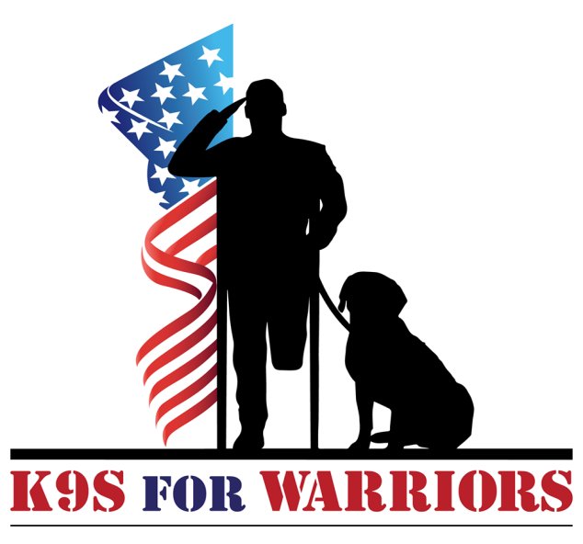
K9S For WARRIORS is a tax-exempt 501(C)(3) nonprofit organization dedicated to providing service canines to our warriors suffering from PTSD.

