 Race Weekend: Saturday, December 6th
Rules for Prototype Races
- There is a $150 race fee per day for members participating in the Prototype Race. Late registration yields higher fees.
- There is a $350 track support fee per day.
- Drivers must attend the Mandatory Drivers Meeting
- Drivers must have a transponder to participate in any race.
Rules for Sports Car Races
- There is a $150 race fee per day for members participating in the Sports Car Race. Late registration yields higher fees.
- Drivers must attend the Mandatory Drivers Meeting
- Drivers must have a transponder and digital radio to participate in any race.
Rules for Open Sessions
- The session is for club members who are not racing. No guest drivers. Passengers ok.
- Point-bys are required for passing.
- If a mechanic or instructor needs to take a car participating in our races out during this session, they are limited to 3 laps.

Track Configuration: Charleston Peak North Course
2.76 Miles
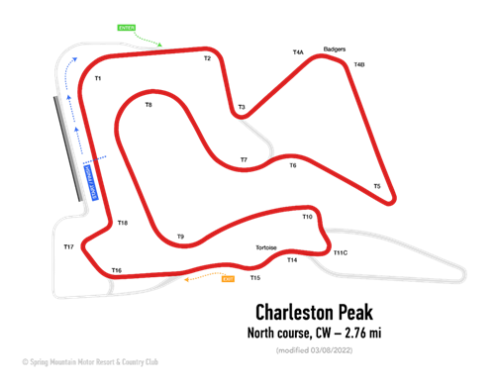

*Schedule is Subject to Change*

Begins | Ends | Duration | On Track | Session
7:00am | 9:00am | 120 | Race Day Registration / Tech Inspection-Sports Cars / Non-Racers Track Sign-In | Race Fees Increase after 9:00am
8:00am | 8:20am | 20 | Sports Cars | Open Sessions
8:25am | 8:45am | 20 | See description in notes | Open Sessions
8:50am | 9:10am | 20 | SM Radical Cup | Open Sessions
9:15am | 9:25am | 10 | Track Maintenance
9:25am | 10:05am | 40 | Sports Cars | Qualifying
10:10am | 10:20am | 10 | Track Maintenance
10:20am | 11:00am | 40 | SM Radical Cup | Qualifying
11:05am | 11:20am | 15 | Track Maintenance
11:10am | 11:20am | 10 | Sports Cars | Pre-Grid / 10 Min Board
11:20am | 11:30am | 10 | Sports Cars | Grid Departs with Pace Car
11:30am | 12:00pm | 30 | Sports Cars | Race #2
12:05pm | 12:25pm | 20 | Sports Cars | Podium
12:00pm | 1:30pm | 90 | Lunch Opens | Clubhouse
1:30pm | 1:40pm | 10 | SM Radical Cup | Pre-Grid / 10 Min Board
1:40pm | 1:50pm | 10 | SM Radical Cup | Grid Departs with Pace Car
1:50pm | 2:20pm | 30 | SM Radical Cup | Race #2
2:25pm | 2:45pm | 20 | SM Radical Cup Podium | Podium
2:25pm | 2:35pm | 10 | Track Maintenance
3:00pm | 4:00pm | 60 | See description in notes | Open Sessions
4:00pm | 8:00pm |  | Clubhouse is open from 4pm-8pm with our Winter menu available. | Clubhouse closes at 8pm

