 Race Weekend: Friday, December 5th
Begins | Ends | Duration | On Track | Session
7:00am | 9:00am | 120 | Race Day Registration / Tech Inspection-Sports Cars / Non-Racers Track Sign-In | Race Fees Increase after 9:00am
8:00am | 8:20am | 20 | Sports Car Racers Mandatory Driver’s Meeting | Driver’s Lounge
8:00am | 8:20am | 20 | See description in notes | Open Sessions
8:25am | 8:45am | 20 | SM Radical Cup | Open Sessions
8:50am | 9:30am | 40 | Sports Cars | Open Sessions
9:10am | 9:30am | 20 | Radical Racers Mandatory Driver’s Meeting | Driver’s Lounge
9:35am | 9:55am | 20 | See description in notes | Open Sessions
10:00am | 10:20am | 20 | SM Radical Cup | Open Sessions
10:25am | 10:35am | 10 | Track Maintenance
10:35am | 11:15am | 40 | Sports Cars | Qualifying
11:20am | 11:30am | 10 | Track Maintenance
11:30am | 12:10am | 40 | SM Radical Cup | Qualifying
12:00pm | 1:30pm | 90 | Lunch Opens | Clubhouse
1:15pm | 1:25pm | 10 | Sports Cars | Pre-Grid / 10 Min Board
1:25pm | 1:35pm | 10 | Sports Cars | Grid Departs with Pace Car
1:35pm | 2:05pm | 30 | Sports Cars | Race #1
2:10pm | 2:20pm | 10 | Track Maintenance
2:20pm | 2:40pm | 20 | See description in notes | Open Sessions
2:45pm | 2:55pm | 10 | Track Maintenance
2:55pm | 3:05pm | 10 | SM Radical Cup | Pre-Grid / 10 Min Board
3:05pm | 3:15pm | 10 | SM Radical Cup | Grid Departs with Pace Car
3:15pm | 3:45pm | 30 | SM Radical Cup | Race #1
4:00pm | 9:00pm |  | Clubhouse & Bar Open at 4pm for Cocktails and Appetizers; Dinner will be available from 6pm-8pm; the Clubhouse closes at 9pm.
Rules for Prototype Races
- There is a $150 race fee per day for members participating in the Prototype Race. Late registration yields higher fees.
- There is a $350 track support fee per day.
- Drivers must attend the Mandatory Drivers Meeting
- Drivers must have a transponder to participate in any race.
Rules for Sports Car Races
- There is a $150 race fee per day for members participating in the Sports Car Race. Late registration yields higher fees.
- Drivers must attend the Mandatory Drivers Meeting
- Drivers must have a transponder and digital radio to participate in any race.
Rules for Open Sessions
- The session is for club members who are not racing. No guest drivers, Passengers ok.
- Point-bys are required for passing.
- If a mechanic or instructor needs to take a car participating in our races out during this session, they are limited to 3 laps.

Track Configuration: Charleston Peak North Course
2.76 Miles
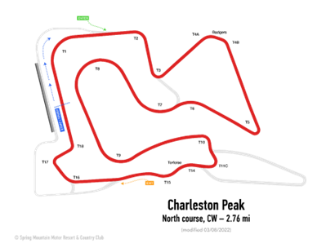

*Schedule is Subject to Change*

