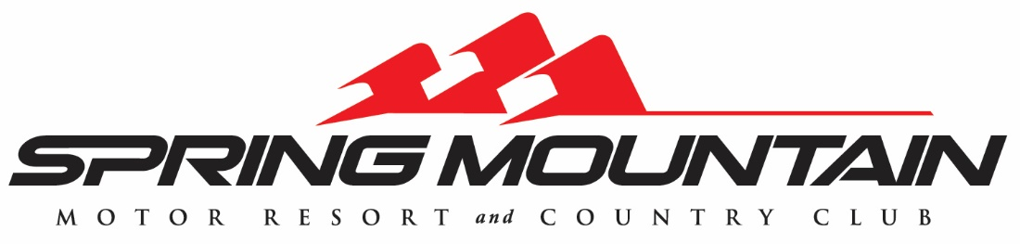
Final Race Weekend Buffet
Cold:
Classic Caesar Salad
romaine hearts, caesar dressing, parmigiano reggiano, croutons
Roasted Heritage Beets
saffron vinaigrette, crumbled goat cheese, honey, pistachios
Charcuterie Board
imported and domestic meats and cheeses, grilled bread, jams and nuts
Sushi Boat
assorted rolls, nigiri, sashimi, wasabi, soy sauce and pickled ginger

Entrees/Starch/Vegetable:
Spicy Rigatoni
calabrian chili, vodka, san marzano tomatoes
Smoked Chicken
oak wood, house-made rub
Prime Rib
horseradish crème, au jus, dinner rolls
Mahi Mahi
mango salsa
Grilled Asparagus
Whipped Potatoes

Dessert:
Rolled Ice Cream Station
Churro Lady

