
Open Track Day, Thursday, December 4th

Begins | Ends | Duration | On Track
8:00am |  |  | Sign-Ins Begin
9:00am | 9:45am | 45 Min | Sports Cars Open Track
9:45am | 10:30am | 45 Min | Formulas/Prototypes Open Track
10:30am | 11:15am | 45 Min | Sports Cars Open Track
11:15am | 12:00pm | 45 Min | Formulas/Prototypes Open Track
12:00pm | 1:00pm | 60 Min | TRACK CLOSED. Lunch is served in the Clubhouse
1:00pm | 1:45pm | 45 Min | Sports Cars Open Track
1:30pm | 3:30pm | 2 Hours | Guests and Spouses details to come
1:45pm | 2:30pm | 45 Min | Formulas/Prototypes Open Track
2:30pm | 3:15pm | 45 Min | Sports Cars Open Track
3:15pm | 4:00pm | 45 Min | Formulas/Prototypes Open Track
4:00pm | 8:00pm |  | Clubhouse is open from 4-8pm with our Winter menu available

Track Configuration: Charleston Peak North Course 2.76 Miles

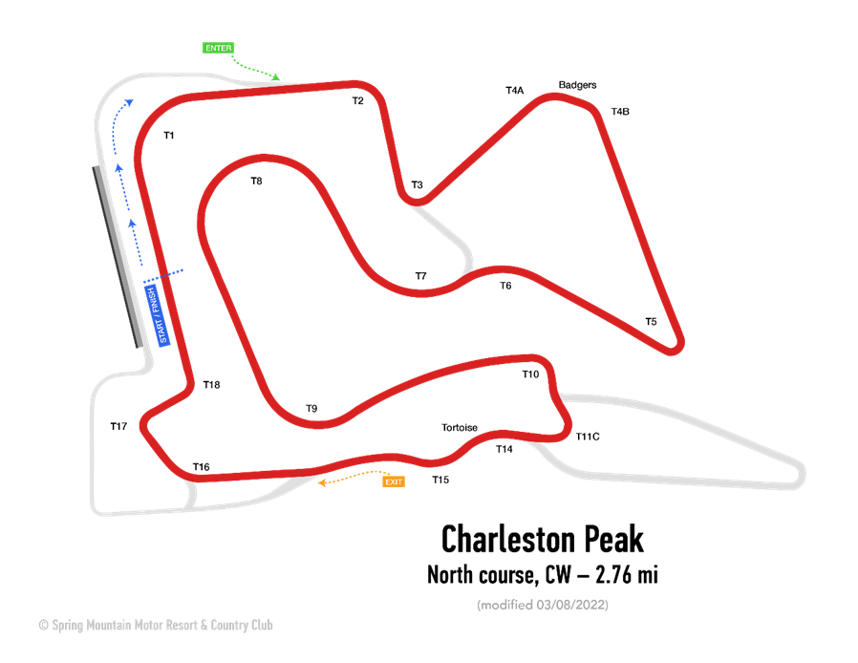
*Schedule is Subject to Change*

