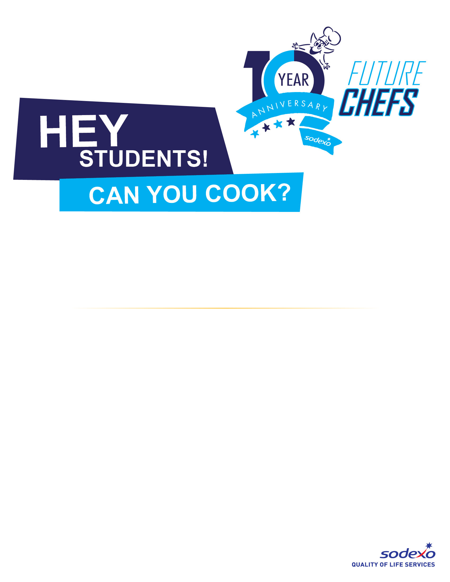

**PICK UP YOUR ENTRY FORM**

They’re available in the Cafeteria and in the Main Office!

Turn them in to the Cafeteria or Main Office by January 31,2020.

The Lucky recipes will be announced the week of February 3,2020

1-2 lucky recipes from each School District will be chosen as finalists to compete in our contest with Cambrian, Los Gatos, Saratoga and Union School Districts, at Union Middle School on March 11,2020.

As a bonus, the winner of this event will be entered in a Future Chefs National Competition for some great prizes!

**We’re looking for your favorite SCHOOL Lunch meal - reimagined!**

Calling all **“FUTURE CHEFS”** for our   
Culinary Competition