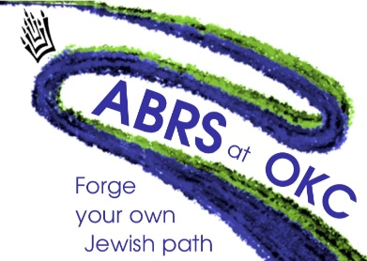
The Alvin Browdy Religious School
at Ohr Kodesh Congregation
Tuition and Programs
Tuition for 5780 / 2019-2020
Register at http://ohrkodesh.wix.com/abrs/register!
Registration will be complete when we receive a deposit of $250 per child. Deposits are non-refundable. Please make checks payable to Ohr Kodesh Congregation. Siblings receive a 10% discount!
 | Members By May 31st | Non-Members By May 31st | Members June 1st or later | Non-Members June 1st or later
Pre-K & K (S only) | $990.00 | $1090.00 | $1090.00 | $1190.00
1-2 (S & W) | $1660.00 | $1865.00 | $1760.00 | $1965.00
3-7 (S & W) | $1930.00 | $2265.00 | $2030.00 | $2365.00
* All rates are subject to adjustment upon the adoption of Ohr Kodesh Congregation’s budget expected by the Board of Directors by May 1, 2019. Each family will also be subject to a $50 security fee, dependent on the budget committee’s approval in May
Tuition is due in full by December 31st. No refunds will be given after 12/31/19. To request a more extended payment plan, please contact Ellen Feldman at efeldman@ohrkodesh.org.
ALL CHILDREN ARE ENTITLED TO A JEWISH EDUCATION. Need-Based Scholarships are available for families who request it. Email Leah Miller (LMiller@ohrkodesh.org) for more information.
What is Included in Tuition?
COHORT LEARNING. These classes are taught using primarily a project-based approach using a spiral curriculum that has been developed by Cantor Hinda Labovitz tailored for the ABRS.
HIGH TEACHER-TO-STUDENT RATIO. The ratio of teachers and aides to students in our school is approximately 1:5.
OK-CLUB (Wednesdays 3:15 PM – 4:15 PM). Many of our students arrive earlier than 4:15 PM, either dropped off by parents or by bus from their public schools. Starting at 3:15 PM on Wednesdays, we provide a supervised space. All students receive a healthy snack when they arrive on Wednesdays (usually pretzels, carrots, and hummus).
T’FILAH EDUCATION. Our classroom Hebrew program focuses on proficiency in prayer-based language. Each Sunday we meet as a whole school in the Cohen Chapel for a weekday shacharit service so our students can put what they have learned into real practice.
HEBREW LAB. Students in 1st through 7th grades meet weekly for small-group Hebrew learning, and are divided by level rather than grade. Our Hebrew program is designed so that students may work at their own pace and actualize their potential for linguistic development.
HEBREW TUTORING- 3rd to 7th grade. Each student in the 3rd to 7th grades at ABRS has an opportunity for additional Hebrew study per week to be arranged with a tutor hired by ABRS either by Skype or in person. Families can choose how this time is used: to bolster modern Hebrew skills, to work on decoding, or to reinforce our classroom curriculum. Included in tuition.

For all inquiries, please contact Leah Miller, ABRS Assistant Principal at LMiller@ohrkodesh.org or call (240) 450-3497.

