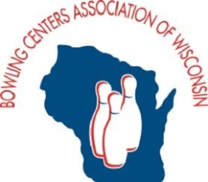
Wisconsin Vintage Alleys Tour Recap
By Yvonne Bennett, Executive Director

For our members who are bars & taverns; supper clubs & pizzerias . . . BCAW is continuing our outreach to find ways to help you too. As smaller “centers” with between two and eight lanes, bowling is not your core revenue source but it is an important element of your overall business. And for so many, the allure of “vintage” resonates with your local community and others who love bowling.

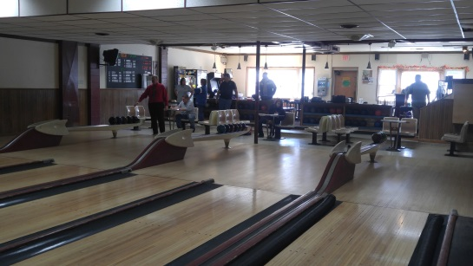
BCAW hosted what is believed to be the first ever tour of vintage bowling alleys on October 31st. The event was a big success in terms of providing opportunities for four of our members to showcase their business. All were excited with the concept and welcomed our group during our stop to bowl as part of the scheduled 11 hour journey through Jefferson & Dodge counties.
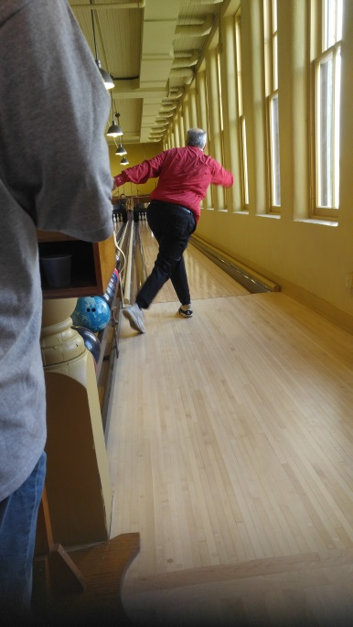

You may have recently seen some of the buzz throughout social media as well as print newspapers throughout the state. We had coverage recently in the Milwaukee Journal Sentinel as well as front page coverage in the Sunday (11/5/17) Wisconsin State Journal and La Crosse Tribune to include their online versions.

Links to news articles:

Milwaukee Journal Sentinel

Wisconsin State Journal

La Crosse Tribune

I anticipate BCAW offering more Wisconsin Vintage Alleys Tours around the state in 2018. As with our event last month, we will feature small centers (six lanes or fewer) that are BCAW members and represent small community centric experiences featuring vintage era bowling.

