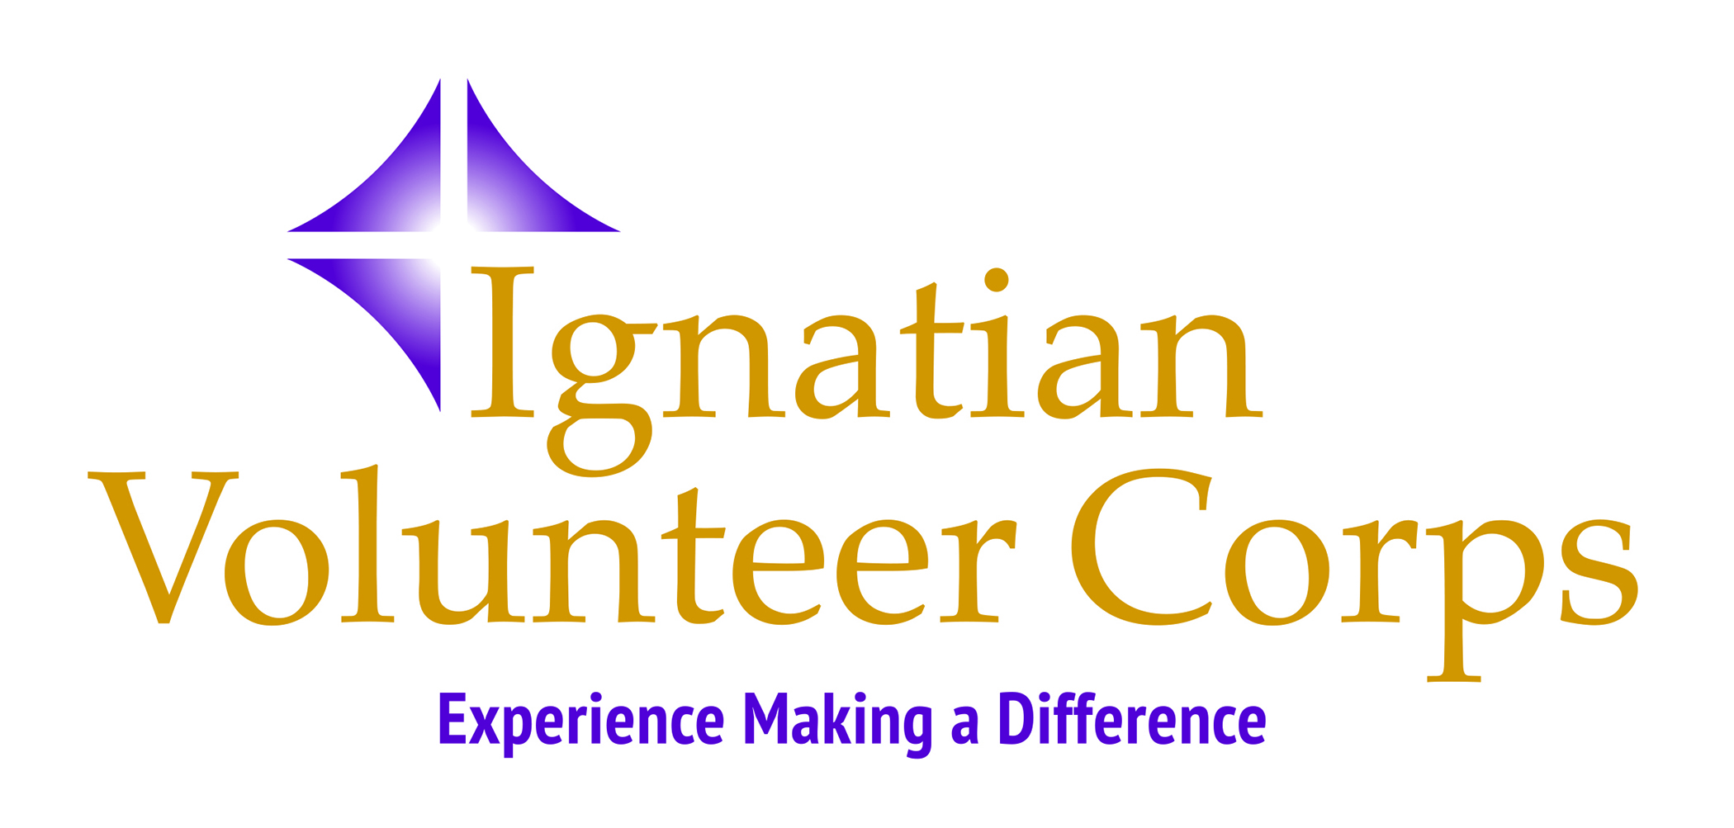

Program Manager – IVC New England (Part-time)
Position Summary
IVC New England, a regional office of the Ignatian Volunteer Corps, is seeking a Program Manager who will collaborate with its IVC New England Director and other staff members to manage operations of the organization. This is a part-time position (i.e., 20 - 25 hours per week) with flexible hours. IVC New England encompasses Boston, Worcester, Providence, and surrounding communities.
The IVC Program Manager will have four major areas of responsibility:
- Recruitment of volunteers and partner agencies for IVC New England, which includes:
- Establishing and nurturing relationships in parishes and community, civic and senior groups in the region
- Developing and disseminating recruitment materials
- Working with the IVC NE Director on the development and execution of a strategic recruitment plan
- Organizing and assisting IVC representation at volunteer fairs, parishes, diocesan functions, and with local networking groups
- Assisting prospective service corps members through the IVC application process
- Promotion of IVC in the New England region, which includes:
- Maintaining the database list of volunteers, reflectors, IVC alumni, and friends of IVC to whom we send appeals and event invitations
- Working with our Jesuit institutional partners and providing stories of alumni who are IVC volunteers for their publications
- Placing ads, announcements, and articles about the IVC program in area church bulletins, newspapers, magazines, and online publications
- Maintaining social media accounts for the IVC region, including Facebook, Linked In, and the IVC webpage
- Assisting IVC NE Director and staff with event promotions
- Management of program logistics during the IVC year, which includes:
- Contacting IVC monthly meeting and retreat sites to schedule meeting dates, plan room set-ups, and arrange for technology needs; assisting, as needed, with food and name tag organizing
- Onboarding and welcoming new IVC members, including the collection of safety training and criminal background records and MOUs
- Preparing copies of materials for monthly meetings, retreats, and orientations
- Aiding the Advancement/Program Assistant, as needed, with planning, ordering, and organizing hospitality items at monthly meetings and retreats
- Assisting the IVC NE Director, as needed, with the maintenance of rosters of regional council members, reflectors, volunteers, and partner agency sites and keeping attendance of service corps members at monthly meetings
- Assisting with the record keeping of registration for fundraising and friend-raising gatherings and organizing mailings for event invitations
- Assisting the IVC Director with program support and development which includes:
- Providing back-up coverage for the IVC NE Director and staff, as needed
- Assisting IVC NE Director, staff, and Regional Council members with the overall support and development of the IVC program in the New England Region
- Attending bi-monthly Regional Council meetings
- Participating in national all-staff meetings when required
- Assisting IVC NE Director, as needed, with site visits to partner agencies with the goal of strengthening our relationship with those partner agencies and lending support to volunteers assigned to those agencies
- Aiding Advancement/Program Assistant in implementing targeted fundraising efforts
- Possible eventual event planning responsibilities
- Additional assignments as mutually agreed with the IVC Director
Qualifications:
We are looking for a motivated self-starter who can communicate the IVC mission enthusiastically and effectively among prospective service corps members, potential nonprofit agency partners and other diverse constituencies.
The successful candidate should:
- Be able to set goals and work independently and possess excellent interpersonal skills in one-on-one and small group settings as well as in front of larger audiences
- Have a commitment to the IVC mission, embracing its values and ideals; sensitivity to vulnerable populations; respect for cultural differences and feel comfortable working with faith-based communities (a familiarity with Jesuit or Ignatian Spirituality, institutions or programs would be beneficial)
- Be familiar and comfortable with Microsoft products (Excel, Word, Outlook, and PowerPoint), Google Drive, and video conferencing (communications and social media marketing experience would be helpful in this position)
- Be detail-oriented, flexible, and have a sense of humor, with an ability to adjust to ever-changing realities and engage with a variety of personalities
Additional Details: The Program Manager will work out of her/his home. S/he must have a private work area in her/his home where records can be stored securely, and video calls can be conducted professionally. Driver’s license and use of personal vehicle required. Spanish fluency is a plus. Travel is required in own car (mileage will be reimbursed). The IVC Program Manager reports directly to the IVC Director. Occasional weekend and evening work may be necessary. Residency in the IVC New England program area is required.
To apply, please send a letter of interest and cv/resume via email to:
Dave Hinchen, IVC New England Director – dhinchen@ivcusa.org

