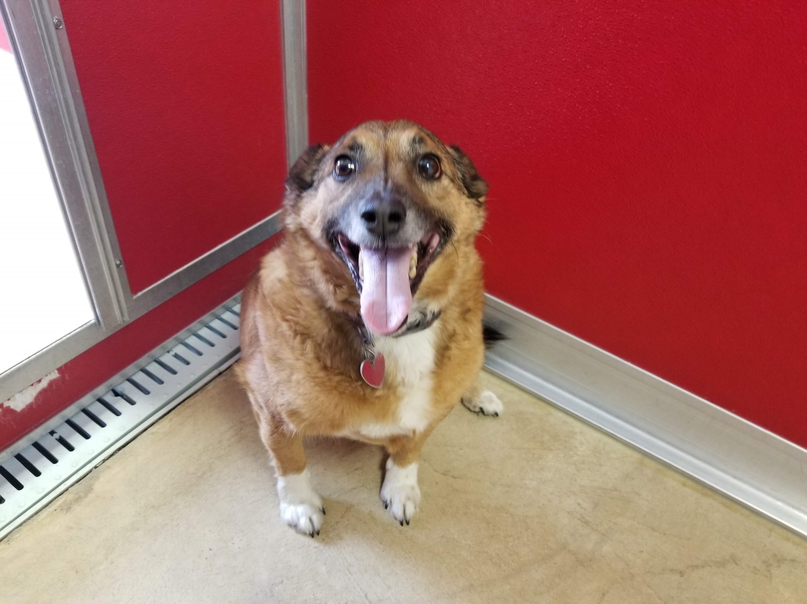
My name is Buddy. I am a 6-year-old Jack Russel/ Heller mix. I’m a bit overweight but I do love to walk. I’m a real guys guy. I love to hang out and watch TV with my human. My last owner had to give me up for medical reasons and while it did take me a minute to warm up to new people but now that I have all I want are belly rubs. Please call to meet me today!
Kaydee Barker 970-520-2804
Jamie Helmut 970-466-7387
Andi Walter 970-520-8996

