Dear Area Business Owner, October 7, 2022
My name is Celeste Delgado-Pelton. I am the Department Chair for Liberal Arts at Northeastern Junior College and the Chairwoman for Northeastern Nation – the diversity group for our campus. Our job is to schedule events throughout the year that promote diversity, equity, and inclusion on campus and in our community in a positive way through education, outreach, and celebrations of diversity.
On November 29th from 3:30 to 7:00 pm we will be hosting the Hanging of the Greens: An International Holiday Market. This is one of two events held on our campus each year that celebrates our International Students. This year for the Hanging of the Greens we are trying to replicate a European Christmas Market. I have included a few pictures for reference. I also learned quite a bit about European Christmas Markets through google searches.
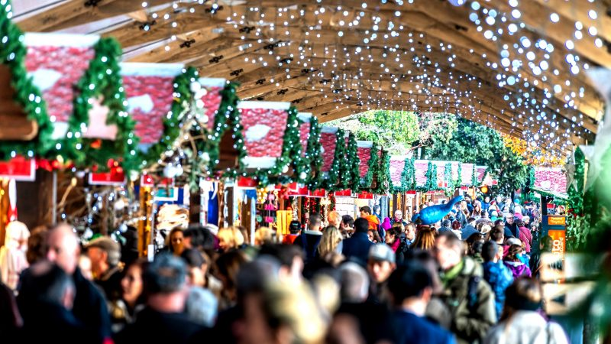
NJC will have between 5 and 10 booths of our own at the Holiday Market, but we are hoping to add lots of booths from area businesses – like yours!
We are not charging businesses anything to participate in this event – we just want you to come and join us! We will hang Christmas lights throughout ES French Hall (where the event will take place) and provide an 8-foot table for you. (If you have a display you would prefer to use – just let me know.) What we would ask is that you decorate your table. At a minimum – a dollar store plastic tablecloth. Anything above and beyond that is fantastic! We would ask that you bring enough product to fill your table (you can bring more if you want).
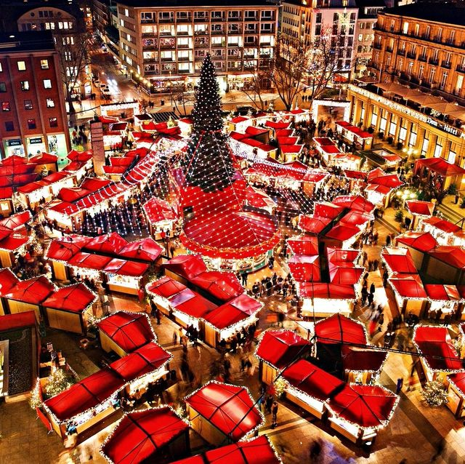
Depending on what products you sell, we would encourage you to bring at least some items that have an international or holiday theme.
We will promote this event to our 124 staff members, as well as the community. We will also widely promote this event among the entire student body. With that in mind, you might consider bringing items at varying price points. For example, feel free to bring a $300 piece of Polish pottery, but maybe also bring a $20 bracelet.
You will need to bring your own cash box and/or square for card purchases. Please know that many of our students use digital wallets like Venmo or Apple Pay. Our ability not to charge for booth space is, in part, because we won’t be collecting any money as a college.
We will be setting up all day Monday, November 28th and Tuesday, November 29th prior to the 3:30 start time. If you would like to come tour ES French Hall and get a feel for the building ahead of time, please just let me know.
We think this will be a fantastic event and a lot of fun for everyone involved! There will be some live music and hot international drinks. We have already confirmed a few food vendors that will make this event delicious as well!
I know this is a busy time of year as you head into the Christmas shopping season, but I hope you will consider joining us for this fun event as we celebrate our International Students and the 19 different countries they represent at Northeastern this year!
If you would like to reserve a booth/table space or if you have any questions, please contact one of the following two people:
Celeste Delgado-Pelton celeste.delgado@njc.edu or 970 521-6754
Rebeka Laible Rebeka.laible@njc.edu or 970 521-6671
Thank you so much for considering being a part of this great event!
Respectfully,

Celeste Delgado-Pelton

