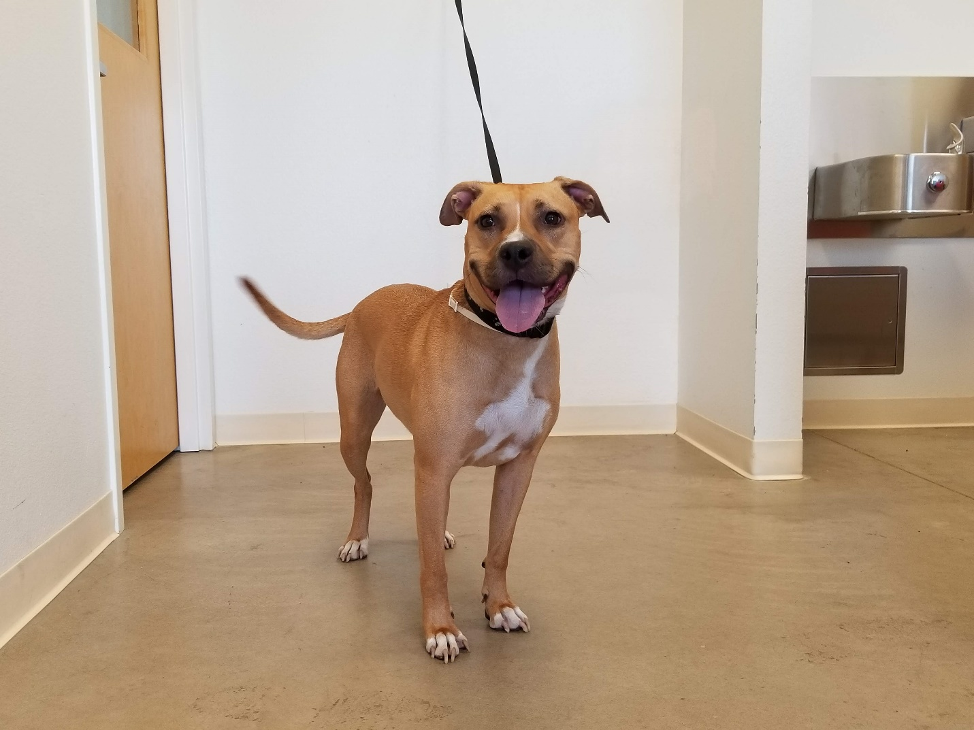

My name is Ruby Roo! I am 2 ½ years old and a big cuddler. I firmly believe I am a lap dog and I give the best hugs. I was adopted out 6 months ago but we just learned that my owner was very very sick and he had to bring me back. I don’t do well with other dogs but I will make an amazing companion for someone and I am waiting patiently for my new family. Call to schedule a time to meet me!
Kaydee Barker 970-520-2804
Jamie Helmut 970-466-7387
John Johnson 970-520-8996

