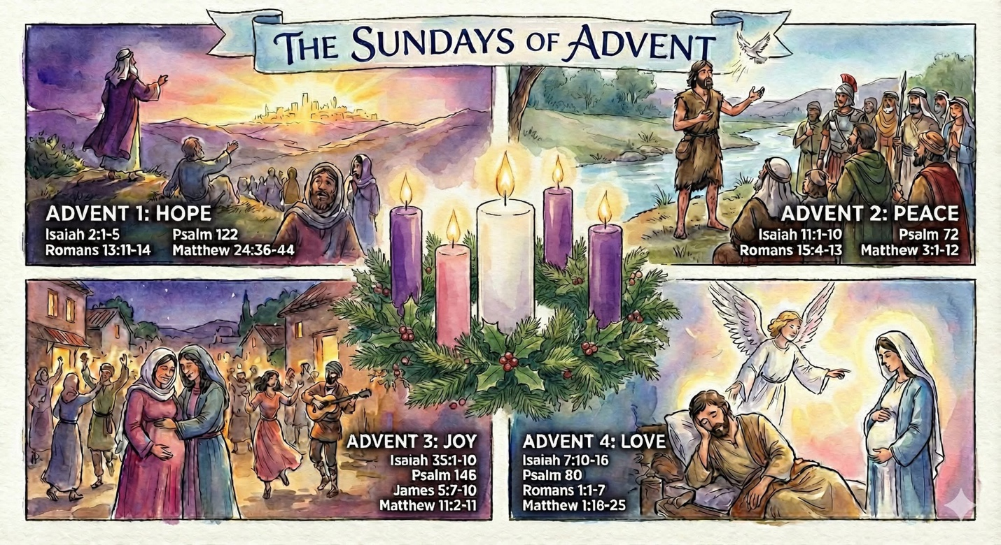

CANDLELIGHTING AT HOME

- Reflect on the theme over the course of the day
- Read one of the readings
- Pray as you light the candles

Week 1: Hope  “I hope…”  - What do you hope for today  - Invite God’s hope for parts of your life where hoping is difficult  - What action of yours gives hope to people in your life  - Imagine what God hopes for you | Week 2: Peace  “More peace…”  - Imagine more peace in the world  - A good walking prayer inspired by St Francis of Assisi: “Make me a channel of your peace”  - Pray for specific people and places  - Pray for peace
Week 3: Joy  “More joy…”  - What would it look like for you to live with more joy  - What action of yours brings – joy for you, joy for people you know, joy for people you don’t know | Week 4: Love  “I love…”  - Who do you love and who loves you  - Send love – as a prayer, a card, a call, in person  - Offer gratitude for the love that is in your life

