St John the Evangelist Anglican Church
Diocese of Ottawa


Last Sunday after Pentecost: The Reign of Christ

November 21st, 2021 at 10.15 am

_______________________________________________________________________________
Prelude
Processional Hymn 379 Rejoice, the Lord is King

The Gathering of the Community
Dear friends, we gather this day on the traditional territory of the Algonquin Nation.
May we always dwell on this land with respect and peace.

The grace of our Lord Jesus Christ, and the love of God, and the communion
of the Holy Spirit, be with you all.
And also with you.
Almighty God,
to you all hearts are open, all desires known, and from you no secrets are hidden. Cleanse the thoughts of our hearts by the inspiration
of your Holy Spirit, that we may perfectly love you, and worthily magnify your holy name; through Christ our Lord. Amen.
The Collect of the Day
Let us pray.
Silence is kept.
Almighty and everlasting God, whose will it is to restore all things in your well-beloved Son, our Lord and King, grant that the peoples of the earth, now divided and enslaved by sin, may be freed and brought together under his gentle and loving rule; who lives and reigns with you and the Holy Spirit,
one God, now and for ever. Amen.

The First Reading Daniel 7:9-10, 13-14
As I watched, thrones were set in place, and an Ancient One took his throne;
his clothing was white as snow, and the hair of his head like pure wool; his throne was fiery flames, and its wheels were burning fire. A stream of fire issued and flowed out from his presence. A thousand thousand served him, and ten thousand times ten thousand stood attending him. The court sat in judgement, and the books were opened. As I watched in the night visions,
I saw one like a human being coming with the clouds of heaven. And he came to the Ancient One and was presented before him. To him was given dominion and glory and kingship, that all peoples, nations, and languages should serve him. His dominion is an everlasting dominion that shall not pass away, and his kingship is one that shall never be destroyed.

Hear what the Spirit is saying to the Church.
Thanks be to God.
Psalm 93
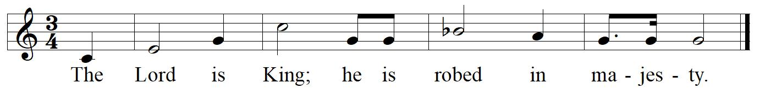
The Lord is King; he has put on splendid apparel;
the Lord has put on his apparel
and girded himself with strength.
He has made the whole world so sure that it cannot be moved;
Ever since the world began, your throne has been established;
you are from everlasting.
The waters have lifted up, O Lord,
the waters have lifted up their voice;
the waters have lifted up their pounding waves.
Mightier than the sound of many waters,
mightier than the breakers of the sea,
mightier is the Lord who dwells on high.
Your testimonies are very sure,
and holiness adorns your house, O Lord,
for ever and for evermore.

The Second Reading Revelation 1:4b-8
Grace to you and peace from him who is and who was and who is to come, and from the seven spirits who are before his throne, and from Jesus Christ, the faithful witness, the firstborn of the dead, and the ruler of the kings of the earth. To him who loves us and freed us from our sins by his blood, and made us to be a kingdom, priests serving his God and Father, to him be glory and dominion forever and ever. Amen. Look! He is coming with the clouds; every eye will see him, even those who pierced him; and on his account all the tribes of the earth will wail. So it is to be. Amen. “I am the Alpha and the Omega,” says the Lord God, who is and who was and who is to come, the Almighty.
Hear what the Spirit is saying to the Church.
Thanks be to God.
Gradual Hymn 383 Jesus Shall Reign Where'er the Sun
The Gospel John 18:33-37
The Lord be with you.
And also with you.
The Holy Gospel of our Lord Jesus Christ according to John.
Glory to you, Lord Jesus Christ.
Then Pilate entered the headquarters again, summoned Jesus, and asked him, “Are you the King of the Jews?” Jesus answered, “Do you ask this on your own, or did others tell you about me?” Pilate replied, “I am not a Jew, am I? Your own nation and the chief priests have handed you over to me. What have you done?” Jesus answered, “My kingdom is not from this world. If my kingdom were from this world, my followers would be fighting to keep me from being handed over to the Jews. But as it is, my kingdom is not from here.” Pilate asked him, “So you are a king?” Jesus answered, “You say that I am a king. For this I was born, and for this I came into the world, to testify to the truth. Everyone who belongs to the truth listens to my voice.”
The Gospel of Christ.
Praise to you, Lord Jesus Christ.
Homily
Anthem Leaning on the Everlasting Arms (arr. Eric Nielson)
Sandra Allan, cello | Heidi Gruber Lagacé, flute
The Prayers of the People
The Peace
The peace of the Lord be always with you.
And also with you.
Offertory Hymn 375 At the Name of Jesus
The Prayer over the Gifts
Eternal God, by your grace you have raised us up and enthroned us with Christ in the heavenly realms. Receive all we offer you this day, and lead us in those good works for which you have created us. We ask this in the name of Jesus Christ the Lord. Amen.
The Celebration of the Eucharist
The Lord is here.
God’s Spirit is with us.
Lift up your hearts.
We lift them to the Lord.
Let us give thanks to the Lord our God.
It is right to give thanks and praise.
It is always right to give you thanks, God our Creator, loving and faithful, holy and strong. You made us and the whole universe, and filled your world with life.
You sent your Son to live among us, Jesus our Saviour, Mary's child. He suffered on the cross; he died to save us from our sins; he rose in glory from the dead.
You send your Spirit to bring new life to the world, and clothe us with power from on high.
And so we join the angels to celebrate and sing:
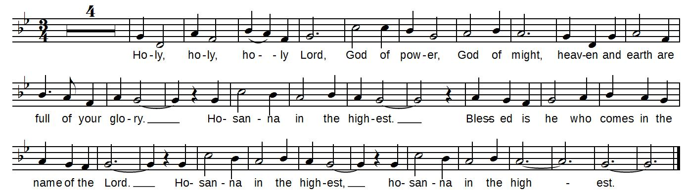
On the night before he died, Jesus shared a meal with his friends. He took the bread, and thanked you. He broke it, and gave it to them, saying: Take and eat; this is my body, given for you. Do this to remember me.
After the meal, Jesus took the cup of wine. He thanked you, and gave it to them, saying: Drink this, all of you. This is my blood, the new promise of God's unfailing love. Do this to remember me.
Great is the mystery of faith:
Christ has died. Christ is risen. Christ will come again.
Loving God, as we bring this bread and wine, and remember his death and resurrection, send your Holy Spirit, that we who share these gifts may be fed by Christ's body and his blood.
Pour your Spirit on us that we may love one another, work for the healing of the earth, and share the good news of Jesus, as we wait for his coming in glory.
For honour and praise belong to you, Creator, with Jesus your Son, and the Holy Spirit: one God, for ever and ever. Amen.
The Lord’s Prayer
As our Saviour taught us, let us pray:
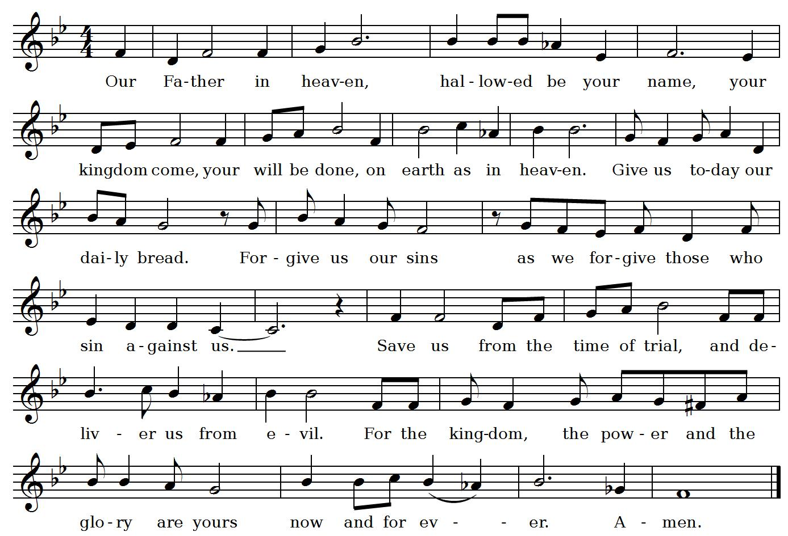
The Breaking of the Bread
Silence is kept.
“I am the bread which has come down from heaven,” says the Lord.
Give us this bread for ever.
“I am the vine, you are the branches.”
May we dwell in him, as he lives in us.
The gifts of God for the people of God.
Thanks be to God.
Communion
Please request a gluten-free wafer if required or a blessing if desired.

Prayer after Communion
Let us pray.
Silence is kept.
Almighty God, you have made us a royal priesthood in the kingdom of your Son our Saviour Jesus Christ. Make known his victory through us, we pray, that all the world may see his light. We ask this in the name of Jesus Christ the Lord. Amen.

Announcements
Doxology
Glory to God,
whose power, working in us, can do infinitely more than we can ask or imagine. Glory to God from generation to generation, in the church and in Christ Jesus, for ever and ever. Amen.
Blessing
Recessional Hymn 322 All Hail the Power of Jesus’ Name
Dismissal
Go in the peace of Christ.
Thanks be to God.
Postlude

__________________________________________________________________________________
Presider & Preacher The Reverend Gary van der Meer
Organist Dr Gordon Johnston
Crucifer & Server Rebecca Gregg, Jill Moll
Readers Gaston Michaud, Alex Bissett
Cantor Wayne Teal
Intercessor Ann Chaplin
Communion Assistants Mary Clark, Wendy McCutcheon
Sidespeople Michelle Smulders, Ian Myles
Tower Bell Jo Cassie
Altar Guild Brian Cameron, Margot Cameron
Audio Tech Sherrie Dagg
Registrar Laura Doehring
Children’s Ministry Margot Cameron
__________________________________________________________________________________
Liturgy: ‘A New Zealand Prayer Book - He Karakia Mihinare o Aotearoa’ and is used with permission.
Liturgy: The Book of Alternative Services ©1985 by the General Synod of the Anglican Church of Canada. Used with permission. Readings: New Revised Standard Version Bible (NRSV) Anglicized Edition, ©1989, 1995, Division of Christian Education of the National Council of the Churches of Christ in the United States of America. Psalm Music: ©2001 Gordon Johnston.
__________________________________________________________________________________
We thank you for your patience and cooperation as we learn to worship in these unusual times. If you missed the collection plate you can always connect at anytime to St John’s online giving site:

Donations
Did you know that this Order of Service is available online? Next time you are here, you can help care for the environment by following along from your phone or tablet. See our website:

www.stjohnsottawa.com/worship/service-bulletins

