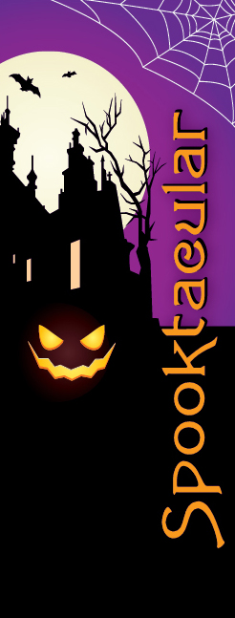

**Victor is looking for your most creative Halloween display!**

|  |  |
| --- | --- |
| **Spooktacular Victor**  **Pumpkin People, Scarecrows and Ghosts!** | |
| **Free** | **For $50** |
| A lamp post in the Village of Victor assigned to  your business/organization | A lamp post in the Village of Victor assigned to  your business/organization |
| You create your own display | A character created by an artist or school group! |
| A sign with your business logo on your display | A sign with your business logo on your display |

|  |  |
| --- | --- |
| **Official Rules**  **All displays must contain a Pumpkin Person, Scarecrow or Ghost** (see pictures for inspiration!) | |
| Creation of your display can take place on:  **Friday, October 12th between 12pm and 6pm**  **Saturday, October 13th between 8am and 11am** | All displays must remain up through **10/31**  It is the responsibility of the business/organization to  remove the display on **November 1st** |
| Displays must be in good taste and created to withstand the weather.  We reserve the right to request that any display depicting controversial, social, or political situations be removed. | |
| **Prizes will be awarded on October 22nd!** | |

|  |  |  |  |  |  |
| --- | --- | --- | --- | --- | --- |
| **Business / Organization Name:** | | |  | | |
| **Title of Display:** | |  | | | |
| **Contact Name:** | |  | | | |
| **Address:** |  | | | | |
| **Phone:** |  | | | **Email Address:** |  |

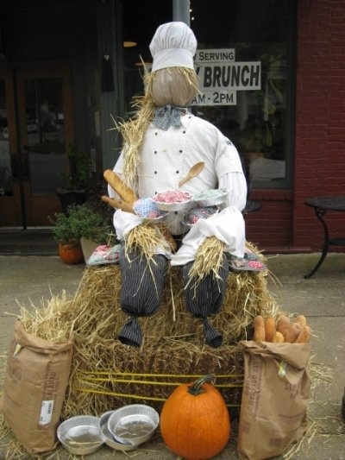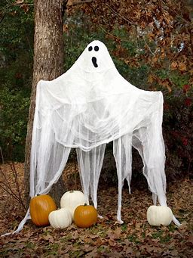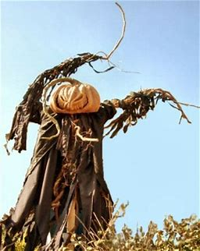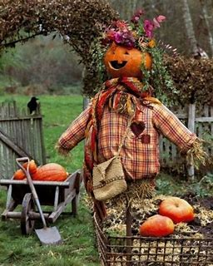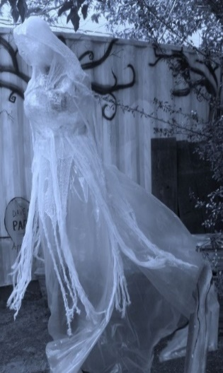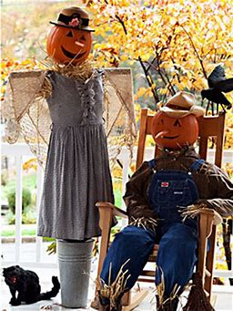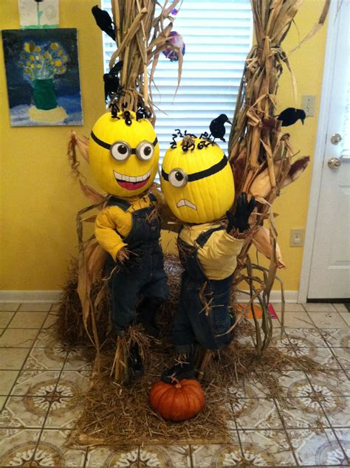

Completed entry forms and payment must be received by:

Victor LDC by **Monday, October 1, 2018**, 85 East Main Street, Victor, New York 14564