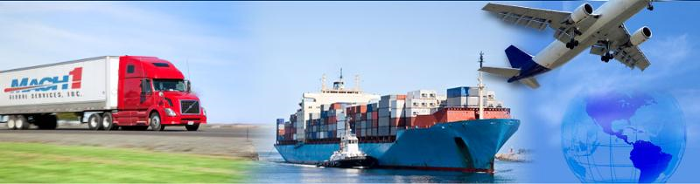

Good Morning Exporting Entrepreneurs,

Exporting is a great way to expand your market base, stay competitive when your competitors are already exporting, protect your company against domestic market swings in business cycles, sell extra inventory that isn’t selling in your domestic market and increase profits!

Small Business Grant opportunity for your company: take advantage of the South Dakota’s STEP (State Trade Expansion Program) Grant. The STEP Grant is still available for YOU to use in assisting your company to further promote its exporting program**.**

**The STEP Grant opportunity funds MUST be used by September 29, 2017.**

STEP Grants provide financial awards to state and territory governments to assist small businesses with export development. This program's mission is to increase the number of U.S. Small Business exporters and increase their export sales.

**STEP financial support helps U.S. small businesses:**

* Learn how to export
* Participate in foreign trade missions and trade shows
* Obtain services to support foreign market entry
* Develop websites to attract foreign buyers
* Design international marketing products or campaigns

The state of South Dakota will use STEP Program award funds to support export development for Eligible Small Business Concerns (ESBCs) through a governor-led trade mission to Canada, attendance at domestic trade shows with the International Buyer Program trade shows, participation in U.S. Department of Commerce services, and offering translation services. STEP will also facilitate export training for ESBCs through seminars and courses, and will provide financial assistance for foreign market sales trips.

**For further information as to how these dollars can be used by YOUR South Dakota business to further expand its export sales, please refer to the above attachment.**

Sincerely,

Rock Nelson  - International Marketing Director of the Sioux Falls Development Foundation and Sioux Falls Area Chamber of Commerce, Director of South Dakota's International Trade Center, S.B.A. Certified in Export and Trade Counseling, Certified Global Business Professional

#1 West Weather Lane, Suite #400

Sioux Falls, South Dakota, 57104

Telephone/Fax: (605)-338-3424

Cell Phone: (605)-941-6696

E-mail: [rock@siouxfalls.com](mailto:rock@siouxfalls.com)

Website: [www.internationalportinfo.com](http://www.internationalportinfo.com)   [www.usd.edu/sbdc](http://www.usd.edu/sbdc)

*** Any information provided by South Dakota’s “International Trade Center”, its Director or its staff is purely an informational, educational service to its clients and other interested parties.  When making business decisions based on this or any information, it is important to verify the accuracy and timeliness of the information with the appropriate government or private entities.***