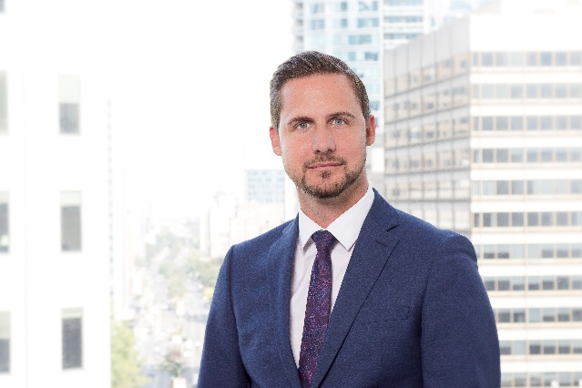
MARC bEAUCHAMP
pRESIDENT AND CEO

The cai global group
615 René-Lévesque Boulevard West Suite 1120
Montreal, Quebec, Canada, H3B 1P5
T: 514.982.0095, ext. 224
C: 450.973.6212
E: m.beauchamp@caiglobal.com

Marc Beauchamp joined the CAI Global Group in 2005 as a Consultant responsible for numerous investment project mandates, and in 2017 was nominated President and CEO.
During his tenure with CAI, Mr. Beauchamp focused extensively on CAI’s site selection methodology including the development of the firm’s data analytics group. Marc has become a recognized expert in the industry and has worked on numerous large-scale projects on behalf of a multitude of clients such as Bridgestone, Agropur, Cascades, Ericsson and more. During this time, Marc also spearheaded and refined the development of CAI’s project diagnostic service offering which assists companies of all sizes today with their investment project decision making. Marc is also recognized for leading numerous positioning strategies for communities and agencies of all sizes.
As President & CEO, Mr. Beauchamp oversees and ensures the successful execution of all of CAI’s consulting services and files. He regularly participates as an expert speaker and panelist for numerous industry stakeholders, sits on various boards and committees, and collaborates on the organization of several key FDI related Forums in Canada.

About CAI Global
The CAI Global Group is a location advisory firm with over 35 years of experience offering expertise in site selection, incentive negotiation and capital investment strategies for the retention, expansion, and attraction of investment projects for multinational, national and domestic companies. For its public-sector clients, CAI offers economic development strategies based on the in-depth knowledge and hands-on experience of what domestic and foreign investors are looking for.

