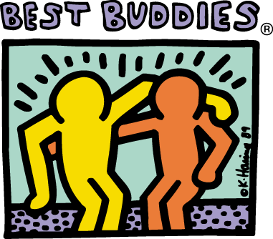  WE NEED THE FAIRFIELD COMMUNITY TO BE CITIZENS MATCHES FOR THE ADULTS WITH IDD IN OUR COMMUNITY!!  Program Overview  The Best Buddies Citizens program matches adults with IDD (intellectual and developmental disabilities) in one-to-one friendships with adults without IDD from the community. By spending time with one another, the lives of both individuals are enhanced through a mutually-enriching friendship. The citizens program is essential in providing social opportunities for adults with IDD, who are often isolated and have little opportunity to interact with their adult peers. The matches are made between two individuals based on age, personality and interests, as well as proximity.  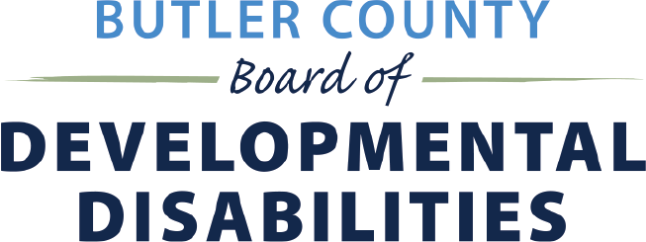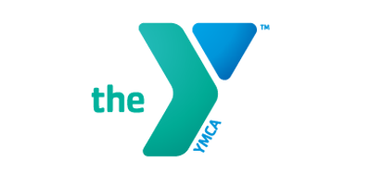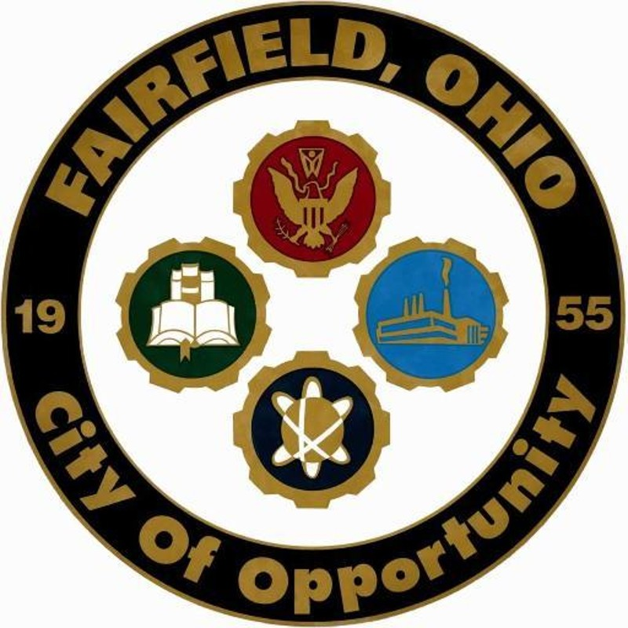 | In partnership with Fairfield YMCA, City of Fairfield and Butler County Board of Developmental Disabilities  ────  Best Buddies is the world’s largest organization dedicated to ending the social, physical and economic isolation of people with IDD  For more information contact:  Jenny Mann, jamann@butlerdd.org  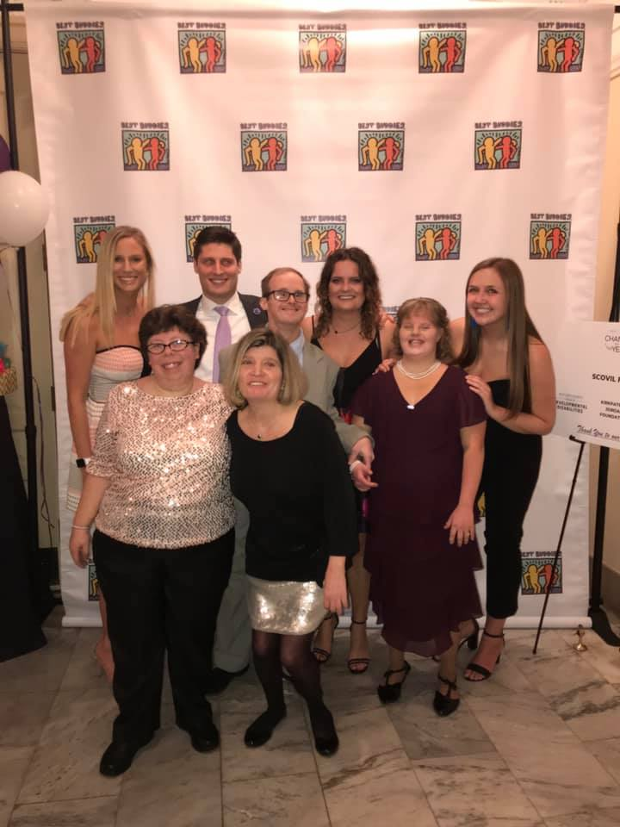  Brittany Theilman, BTheilman@fairfield-city.org  ────  Web Address  Dates and Times

