Peace Community Church
Oberlin, Ohio
When Oberlin was founded in 1833, the idea was that it would be a one church town. Citizens would worship and work together for the greater glory of God. But that ideal began to founder when the Episcopal Church was founded in 1855, and then First Baptist Church (FBC) in 1866.
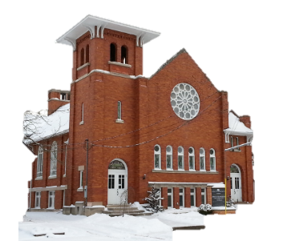
The great Oberlin evangelist and abolitionist, Charles G. Finney, said “O, Lord, thou knowest, we don’t want a Baptist Church in Oberlin. But Lord, if thou seest it is best to have one, if thou canst, we pray thee to bless it.” In spite of Finney’s apprehension, and perhaps opposition from other members of the community, the early FBC saints forged on. One of the founding families, the Brainards, were travelling several miles to LaGrange to attend church. The first prayer meetings in Oberlin took place in the home of Mary Fulton. Andrew and Emily Edwards were among those gathered there, and they were still in attendance 25 years later (they were among the three remaining constituent members).
Later, after the congregation was established, they were meeting in an upper room in the New Carpenter’s block on West College Street, which is now the block of stores facing Tappan Square. The members who were there found significance in the location: “the Upper Room.” Once the new Church had been built, about where Oberlin College’s Allen Memorial Art Museum is now, the congregation started growing. During the first year, 71 members were received (18 by baptism,) and by end of the second year, there were 119 members.
The College bought the church property in 1915 and a lot across Lorain Street from the original location was given to the congregation. The church that was dedicated in 1917 is still in use today.
One early longtime member who should be remembered for his faithfulness and dedication to this congregation is Charles P. Edwards, a nephew of Andrew and Emily. He was in attendance by the 1880’s; he served as the superintendent of Sunday Schools and was on the building committee when the new church was built. He had several children, including Alma (later Frost) and Mae (later Chesbro), who were still active members in the 1970’s and 80’s.
Presently, FBC, called Peace Community Church (PCC) since the name changed in 2000, is a small but very active church where members deeply care for one another while also working for peace and justice in the community and world. The church's peace and justice ministry is evidenced in educational programs, in networking and building community through Community Peace Potlucks and other events. The church supports the Baptist Peace Fellowship of North America, Family Promise of Lorain County (a homeless ministry), Plant with Purpose (an environmental ministry), Alliance of Baptists, Association of Welcoming and Affirming Baptists, and other organizations. PCC has a rich music ministry in addition to a strong campus ministry with Oberlin College students. Many of the students mentored have become clergy or other kinds of church leaders over the decades. For the past 38 years PCC has been wisely and ably led by Co-pastors Mary and Steve Hammond whose gifts of ministry have enriched not only the congregation but the Oberlin community and beyond.

