Reporting Direct Retail Pounds in P2
1. Log in to P2. Next to the “shop” button on the green bar, select “Agency Pickups” and click “New Pickup.”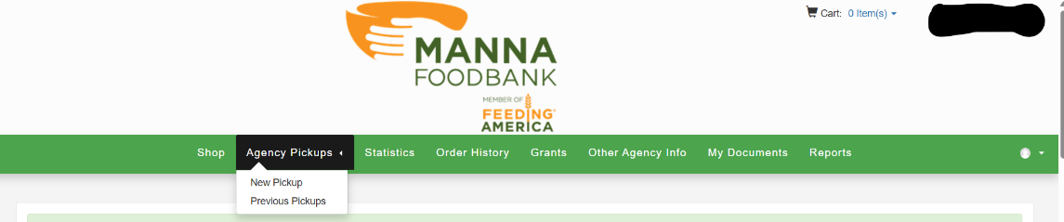
2. Select the store for which you want to report the weight. If you don't see the store you want to report, please notify the Commodities and Direct Retail Manager.
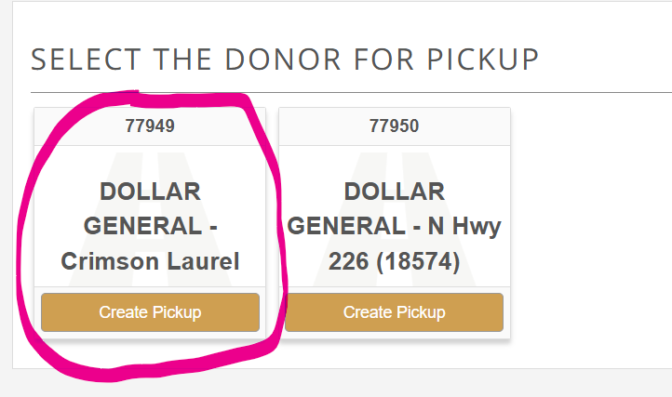
3. Enter the weight for each product category, then click “save.” If you’re not sure which category is most appropriate, use your best judgment or contact the Commodities and Direct Retail Manager with any questions.
