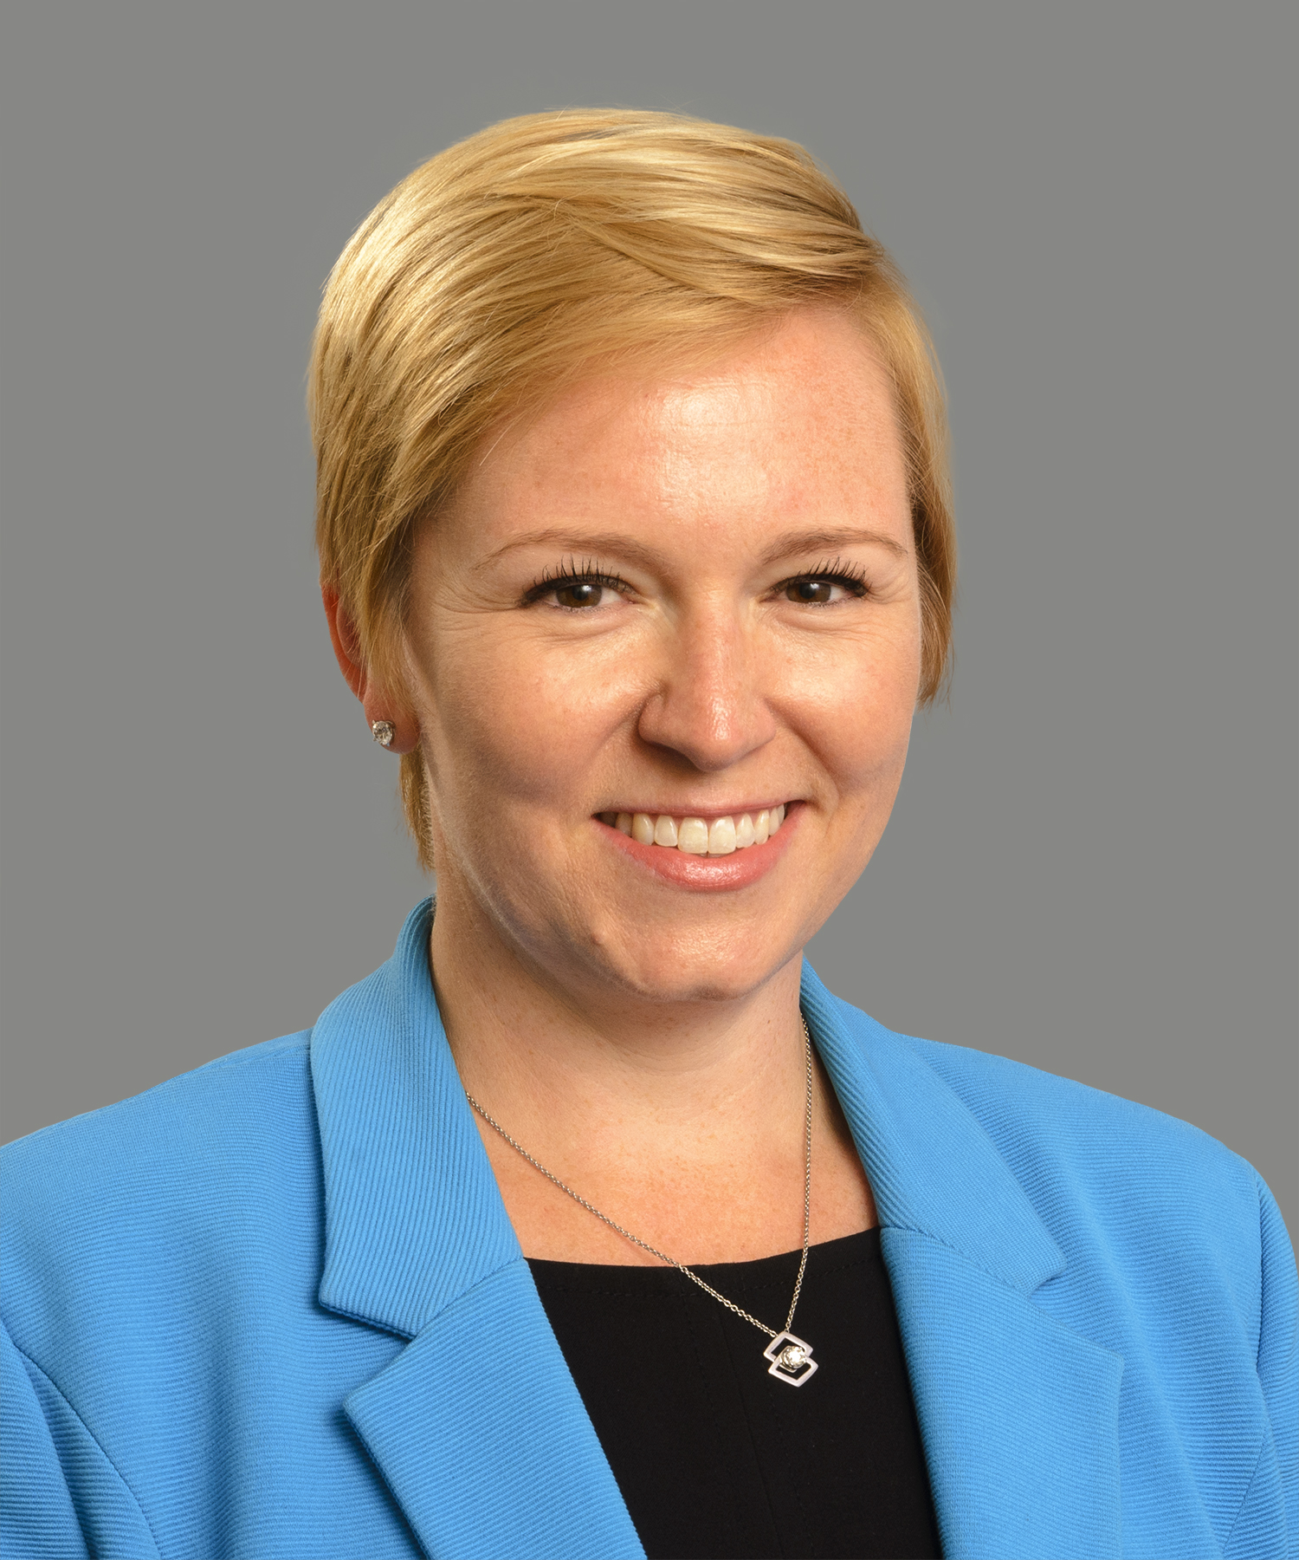
Heather Brilliant, CFA
Heather serves as Chief Executive Officer and President for Diamond Hill Capital Management, an independent active asset manager based in Columbus, OH, with significant employee ownership and $30.6 billion in assets under management as of March 31, 2021. Diamond Hill provides valuation-driven investment management services across a range of asset classes. Heather joined the firm in 2019 bringing more than 20 years of domestic and international investment industry experience to the role.

Previously, Heather served as Chief Executive Officer, Americas with First State Investments. Prior to that role, she spent nearly 14 years with Morningstar where she served as Global Head of Equity & Credit Research before advancing to Chief Executive Officer, Morningstar Australasia. Earlier in her career, she held several roles analyzing both credit and equity at firms including Bank of America and Driehaus Capital Management.

Heather is a long-standing member of the CFA Institute, a global credentialing organization for the investment industry. She served on the board of the CFA Institute from 2013 to 2020 and was chair of the board from 2018 to 2019. As chair she provided leadership and governance to a board of 15 senior investment management executives. She is also a member of the CFA Society of Columbus.

She is on the board of Future Ready Columbus, a nonprofit collective impact organization whose goal is to ensure that 100% of Franklin County children demonstrate readiness for kindergarten by 2030. She is a member of the Columbus Partnership, a nonprofit, membership-based organization of more than 70 CEOs from Columbus’ leading businesses and institutions focused on improving the economic vitality of the Columbus Region, and YPO (Young President’s Organization), a global leadership community of chief executives that are committed to lifelong learning and idea exchange.

Heather is on the executive committee of the Ohio chapter of the International Women’s Forum (IWF), an invitation-only membership organization made up of more than 7,000 diverse and accomplished women from 33 nations. IWF’s mission is to support women leaders and build better leadership across careers, continents and cultures by connecting accomplished women both locally and globally.

She is a frequent speaker at industry conferences and is a volunteer teacher for Rock the Street, Wall Street, a nonprofit organization that aims to spark interest in finance among high school girls. Heather was recently named a 2021 Women WELDing the Way® honoree by Women for Economic and Leadership Development (WELD) for supporting the leadership development of other women and women-owned businesses in the community.

Heather earned her MBA from the University of Chicago Booth School of Business and has a degree in economics from Northwestern University.

