REGISTRATION FORM
This form could be photocopied for use by additional registrants.
REGISTRATION & FEES PAID IN FULL MUST BE RECEIVED BY
September 5, 2020

Registrations will NOT be accepted at the door.
“Please Print”

NAME:_____________________________________

ADDRESS:__________________________________

____________________________________________

CITY:_______________________________________

STATE:__________________ZIP:_______________

E-MAIL ADDRESS:
____________________________________________

EMERGENCY #: (____)__________________

Course Fees: $825.00

(Lecture & PowerPoint Presentations)

includes Text Book & Study Guide

MAKE MONEY ORDER or
FACILITY CHECK “only”
(FULL PAYMENT)

“PAYABLE TO AL SPATH”

SEND REGISTRATION FORM AND FEES TO
Al Spath Jr.
27 Montview Road
Edison, N.J. 08837

AL SPATH
27Montview Road
Edison, N.J 08837

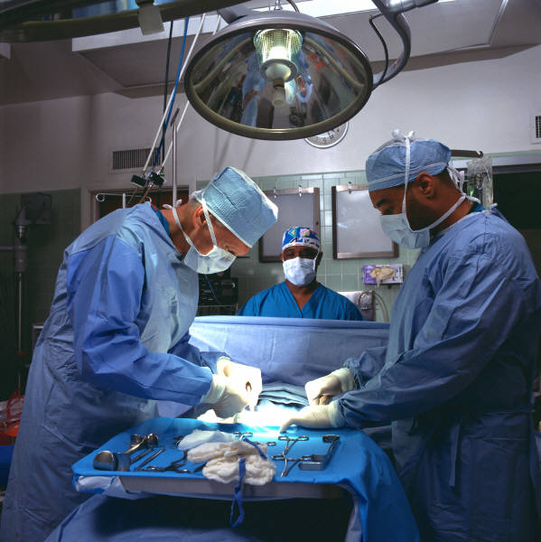

STERILE PROCESSING LEARNING CENTER’S

“CENTRAL SERVICE COURSE”
Starts
August 22, 2020

Saturdays, 8:00AM to 1:30PM

At

Figueroa Medical & Associates LLC
107 Stuyvesant Ave, Lyndhurst, NJ 07071

Course Outline

This course is an overview of the basics of Sterile Processing that will assist in:
- Preparation for Certification
(CBSPD & IAHCSMM)
- Orientation for new employees & Managers
- Refresher course

Lecture Topics
- Introduction to Central Service
- Language of Medicine
- Infection Control
- Surgical Instrumentation
- Preparation and Packaging
- Methods of Sterilization
- Materials Management

Length of Course 5 weeks

8:00 AM to 1:30 PM

Dates: 8/22/, 8/29,
9/5, 9/12 & 9/19

REMINDER
REGISTRATION DEADLINE

For any questions,
please contact Al Spath at
(732) 225-7585 “directly” or
e-mail ALS0215@AOL.COM.

Cancellation Policy
Registrations may be cancelled up to 3 days before the course & monies less $50.00 processing fees will be refunded

“Fundamentals of Central Service”

If you are looking for a new career that helps others and are up for a challenge, then the Sterile Processing field is the place for you. This course will prepare students for entry level employment in the sterile processing field and for the National Certification Exam (CBSPD or IAHCSMM).

This course also serves as a refresher course for existing technicians or new managers.

This five (5) week course introduces students to the scientific principles and basics of Central Service. This is a combined lecture and power point presentation.

You will acquire the knowledge, skills and understanding which are needed to perform the job responsibilities in hospitals, surgical centers, clinics, dental offices and veterinary offices, which play a vital role in these facilities.

Upon completion of this program, you will be better prepared to enter this exciting and rewarding career.

Course Requirement
- GED or High school diploma
- Able to read & write English

“NOTE”
All staff performing sterile processing activities in NJ is required to be certified.

Al Spath Jr, MPA, BA

CHL, CRCST& SME

IAHCSMM Instructor & Sterile Processing Consultant
Directions
From Route 3 West to Park Ave, turn left onto Park Avenue, turn left on Stuyvesant Ave (office is on the right about ¼ mile)

From Route 3 East, take ramp right for 21 North (Lyndhurst/Rutherford), bear left & at the light turn right onto Stuyvesant Ave (office is on the right about ¼ mile)

Note: Please bring your own refreshments and/or snacks, none is available on-site

