2020 YWCA 21 Day Challenge – Content compiled by UH Rainbow Center for Child Health & Policy

Every 10 years, the US Census Bureau counts everyone living in the United States. This count guides the annual distribution of $675 Billion in federal funding that supports health care, education, emergency services, safety net programs and more. Census data also determine how many seats each state receives in the US House of Representatives, and are used to draw boundaries for federal, state, and local legislative districts.
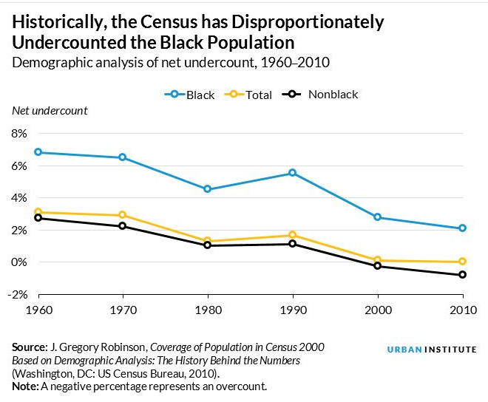
The 2010 Census missed over 1.5 million African Americans, Latinos, and Native Americans, but over-counted the total population of white people by about 36,000 (due to mostly to duplicate counts of affluent whites owning multiple homes).

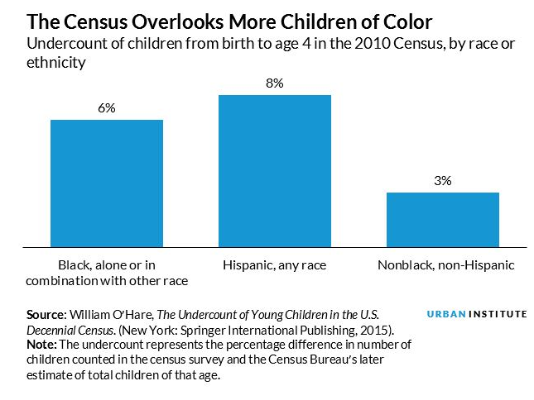
These undercounts have deep and lasting impacts because resources and representation are distributed according to a community’s population, not its need. An undercounted community is likely underfunded and underrepresented. The historical undercount of minority and low-income neighborhoods creates a disproportionate impact on those who could benefit most from well-funded federal programs and a stronger political voice.

Nationwide, the 2010 Census missed over 2 million children - including about 1 million children under age 5. Any undercount of children is a significant concern because census data guides funding for important federal programs like public insurance, housing assistance, and programs like the Supplemental Nutrition Assistance Program (SNAP), National School Lunch Program, and Temporary Assistance for Needy Families (TANF). The effect is amplified for Black and Hispanic children, who are more frequently missed on the Census and therefore at higher risk to be negatively impacted when programs are underfunded.

10 years is most of a childhood – if missed on the Census, a child is basically invisible to any policy decisions for their entire childhood.

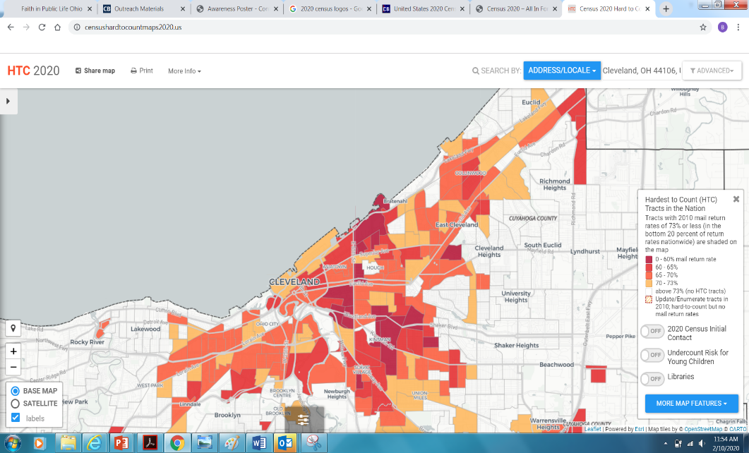
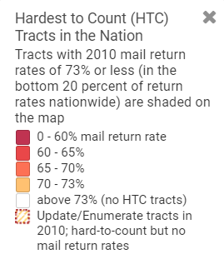
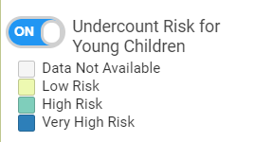

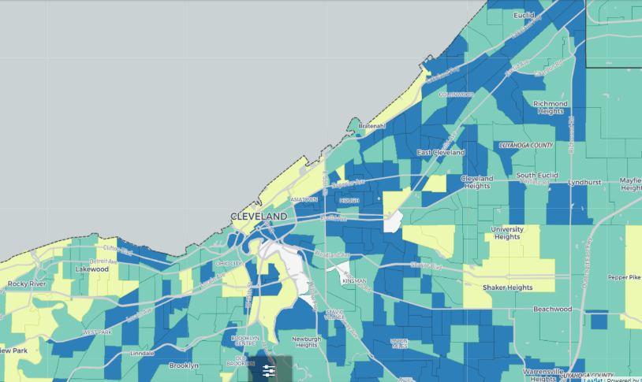
Many children live in communities that are hard to count, especially children under age 5 and those who split time between two homes, or live with another family or relative. 3 in 4 Cleveland children live in “hard-to-count” communities, and Cleveland is projected to have the second-highest undercount of young children in the nation. (Source: US Census Bureau)
Source: censushardtocountmaps2020.us
Source: censushardtocountmaps2020.us

The 2020 Census can be completed online, via phone, or by mail and will shape our communities for the next decade. Many factors may contribute to an undercount of minorities – anyone with limited internet access, a language barrier, transient residential history, multi-family household, or mistrust of the government may be reluctant to respond. Raising awareness about the census is important to ensure a fair, accurate, and complete count that will help provide Ohio children with the programs and resources necessary for a healthy and successful future.

What you can do:
- Take your census as soon as your household receives the invitation in the mail so the Census Bureau can focus on “Hard to Count” areas.
- Advocate for others to participate in the 2020 Census.
- To learn more, explore:
  - US Census Bureau: www.2020census.gov
  - How to take the US Census online (9 min instructional video): https://www.youtube.com/watch?v=3vVLnZTPx-U

Additional options for short imbedded video:
2 min: https://youtu.be/oXZAe8XYeNQ
30 sec: https://www.youtube.com/watch?v=wLFjPTogMIs
Everybody counts (30 sec): https://www.youtube.com/watch?v=uKOGPsaWMTo

Additional references:
2020census.gov
prospect.org/economy/insidious-way-underrepresent-minorities/
censushardtocountmaps2020.us - Center for Urban Research, City University of New York,

https://thegrio.com/2012/05/24/2010-census-undercount-could-spell-disaster-for-blacks-latinos/ (htt)

