Episcopal Church Women
Diocese of Virginia
ECW Spring Meeting May 11, 2019
12:30 – 3:30 p.m.

Circles of Ashland and the Mission to Reduce and Resolve Poverty
- News from the United Nations Commission on Status of Women
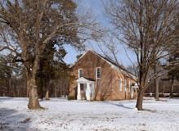
- Refreshments
- Holy Eucharist

The Fork Episcopal Church, 12566 Old Ridge Road, Doswell, VA
Please return this form with a $25.00 Registration Fee. Make check payable to: ECW Diocese of Virginia. Mail to: Pat Baughman, Treasurer, 1815 Genther Lane, Fredericksburg, VA 22401 by May 3, 2019.

Name: Home Church Phone: Email: Street Address: City State: Zip:

For more information, contact Cindy Helton (540-373-6382) or cindyhelton505@gmail.com

