
19th Annual Flounder Tournament Marketing Opportunities

Captains Meeting – Pre-Tournamant Gathering for all participants | Friday, June 26 | Yacht Club in Ocean Pines
The Tournament is held on Saturday June 27 at the Ocean Pines Swim and Racquet Club.

Presenting Sponsorship $6,000 – Enjoy speaking opportunity at the events.

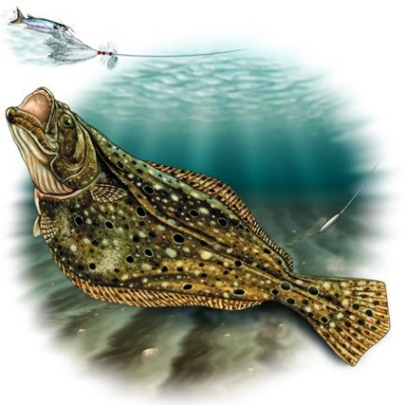
Additional benefits include
- Sponsorship of the Captain's Meeting (One reserved table of 10)
- Speaking opportunity at both facets of the Tournament
- Logo will be prominently featured on the iconic Tournament T-shirt
- Logo on large prize checks
- Multiple photo opportunities at the Tournament Weigh in
- Eight registrations for the Flounder Tournament
- Extensive professional media promotion by iHeart Radio and WMDT
- Full Page ad in the annual business directory (printed in January)
- Logo included on registration information and weekly newsletters
- 3 Facebook Live Spotlights
- Facebook mentions (tag) in event related Chamber posts.
- Company name and Logo (with link to your website) on Chamber event website noted as the Master Event Sponsor
Admiral Sponsor $3,000 – Company's logo will be featured throughout this iconic tournament. Your logo will be prominently featured on the iconic Tournament T-shirt and a vendor table at the Captain’s meeting. In addition, ½ page ad in the annual business directory (printed in January), professional media promotion by iHeart Radio and WMDT, 2 Facebook Live Spotlights, digital advertising (webpage, social media, email), one reserved table of 10 at the Captain’s Meeting and EIGHT tournament entries.
Captain Sponsor $1500 - Company's logo will be prominently displayed throughout this iconic tournament and your logo will be prominently featured on the iconic Tournament T-shirt and a vendor table at the Captain’s meeting. In addition, ¼ page ad in the annual business directory (printed in January), digital advertising (webpage, social media, email), 6 reserved seats at the Captain’s Meeting and SIX tournament entries.
Naming rights to the Calcutta $1000 – 2 available. Company's logo will be prominently displayed throughout this iconic tournament and logo on Calcutta presentation checks and a vendor table throughout the Tournament weigh in. In addition, digital advertising (webpage, social media, email) and FOUR tournament entries.
First Mate $500 – Company's logo will be prominently displayed throughout this iconic tournament and offers 2 exclusive email broadcasts to our 10,000 followers and subscribers, 2 Facebook Live video spotlights and TWO tournament entries.
Bosun $300 – Company's logo will be displayed throughout this iconic tournament. In addition, digital advertising (webpage, social media, email) and ONE tournament entry.

To secure these opportunities, please contact Amity.Aldrich@WorcesterCountyChamber.org or 410.599.5086

