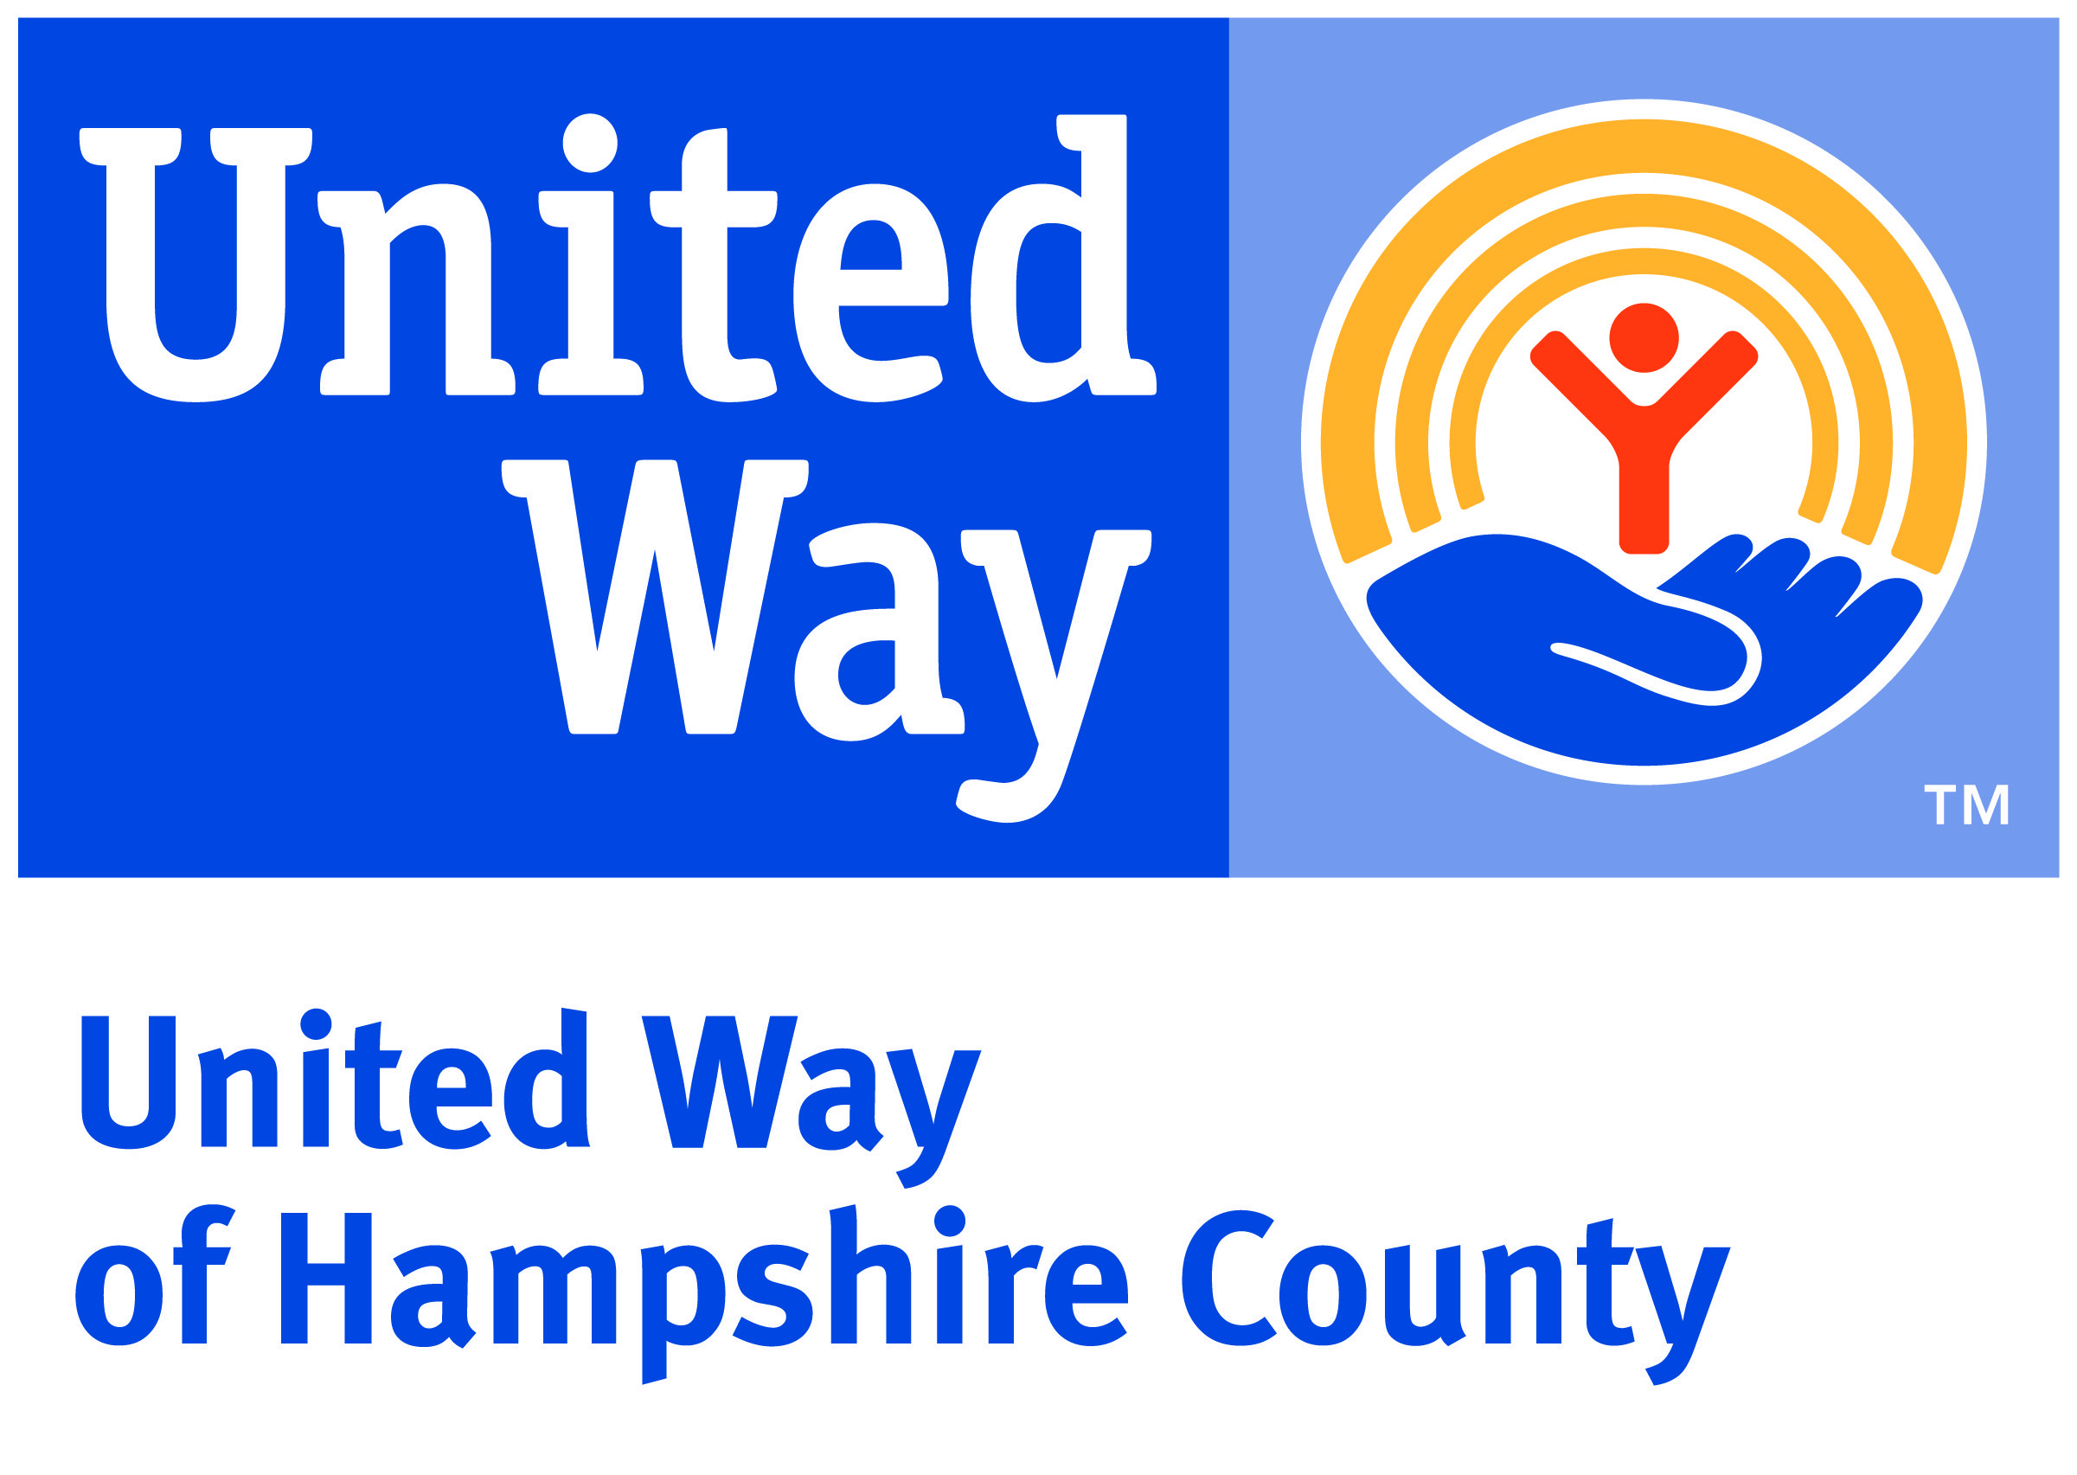

Donor Relations Manager

Regular / Full-Time + Benefits

Are you ready to help build a powerful campaign and culture of philanthropy to help your neighbors? If you are a donor centric development professional this may be your dream job.

United Way of Hampshire County (UWHC) seeks an experienced professional who wants to forge a strong major donor program. We are located in beautiful Northampton, a small college town in Western Massachusetts. Our mission is to assure that everyone in Hampshire County lives fulfilling lives. Our county is a highly desirable place to live, but we still face many challenges.

If you are committed to using your know-how to make a difference in Hampshire County, please apply! Partnering closely with the Executive Director, you will be responsible for raising more than $500,000 annually through individual donors and professional groups. You will serve as the lead relationship manager for individuals and private foundations, building and managing strategic plans for each individual. Organizational skills and knowledge of donor databases are a must. You will:
- Develop strong, year-round relationships with donors, volunteers, and corporate partners to drive revenue results;
- Grow the Planned Gifts program to support strategic initiatives;
- Analyze donor data to inform strategy development and goal achievement.

Who you are:
- A Relationship-builder: You demonstrate a strong ability to build and maintain relationships with diverse groups and focus on superior donor engagement and customer service.
- Results-driven: You meet and exceed fundraising goals. You strategize, develop action plans, and relentlessly create thoughtful opportunities to engage people with our mission and work.
- Action-oriented: You’re not satisfied with the status quo. You’re constantly thinking about how to optimize your work and increase our fundraising capability. You’re adept at knowing how to prioritize tasks and your time most effectively to achieve goals.
- Flexible and Collaborative: You leverage your talents and expertise to collaboratively find solutions to challenges and emerging needs. You’re able and willing to shift focus at a moment’s notice—you are okay with a degree of the unknown in our business.
- Passionate: You’re mission aligned and bring joy to your work and the organization, knowing your work supports a mission of helping all of Hampshire County’s families thrive.
- Interested and a learner: You want to learn about what motivates our donors and business partners, and what inspires them to be so generous. You welcome feedback and are open to learning how to improve in your role.

Essential Functions

Donor Cultivation
- Participate in all aspects of the gift cycle – initiate contacts with potential leadership and major gift donors, develop appropriate cultivation strategies, move potential donors in an appropriate and timely fashion toward fund creation, and maintain stewardship contact with donors.
- Work collaboratively with colleagues, volunteer leadership, and professional advisors (attorneys, wealth advisors, accountants, and trust officers) to cultivate and expand current giving by planned gift donors.
- Oversee process of establishing new funds by assisting donors in selecting charitable giving products that complement and enhance donors’ charitable goals.

Foster a Culture of Philanthropy
- Plan, implement, and evaluate donor cultivation and stewardship events such as small gatherings, luncheons, cocktails, and educational sessions to build partnerships with donors.
- Plan, implement, and evaluate professional advisor educational outreach events to continually update and guide professional advisors in the charitable and planned giving arena.
- Work with the entire UWHC staff and board to strengthen relationships throughout our region.
- Participate regularly in community activities and events to enhance the image and position of UWHC. Activities include speaking to groups, participating in civic engagement, and overall immersion in the community by networking to foster the culture of philanthropy.

Education
Bachelor’s degree in relevant major required with 3-5 years minimum professional leadership experience in the field of fundraising. Certified Fund Raising Executive (CFRE) designation preferred.

Required Skills and Experience
- 3-5 years relevant experience (fundraising, donor relations, account management).
- High level of proficiency in major gifts, estate planning, planned giving vehicles, and project fundraising. Also demonstrate the ability to identify opportunities, relationships, and partnerships for new/increased revenue generation; must be able to work collaboratively throughout the organization to successfully bring those opportunities to fruition.
- Proficiency in both written and verbal presentations, as well as the ability to interact with senior management, board of directors, donors, and community influencers.
- Demonstrate strategic thinking and capacity to see both the big picture and the detailed steps needed to achieve organizational goals.
- Customer-focused, and strong customer service and interpersonal skills.
- Comfortable public speaker and able to represent UWHC to large and small groups.
- Data-driven, innovative, and results-oriented.
- Volunteer management experience strongly desired.
- Must be a self-starter and team player, with a positive outlook and ability to manage ambiguity and change, proficient in identifying solutions, and opportunities.
- Strong organizational skills, with a proven ability to manage deadlines in a fast-paced setting.
- Ability to prioritize and handle multiple projects simultaneously, exercise discretion, and the ability to work independently with limited supervision.
- Proficiency in Microsoft applications (especially Word, Excel and Outlook). CRM donor database software experience desirable.
- Valid driver’s license, verifiable auto insurance, and use of a personal vehicle required.
Supervisory Responsibility
None

Work Environment
This job operates in a professional office environment. This role routinely uses standard office equipment such as computers, phones, photocopiers, filing cabinets, and fax machines.

Why choose United Way of Hampshire County?
Advancing the common good is about helping one person at a time, and creating community level change that benefits everybody. We all win when a child succeeds in school, when families are financially stable, and when people are healthy.

We have a staff of 5 dedicated employees to help us achieve our goals and fulfill our mission: To improve people’s lives by mobilizing the caring power of our community.

To support the great work of our employees, we offer a competitive salary and a robust benefits package including health and dental insurance, a 403 (b) plan, life insurance, generous vacation and holiday pay and paid sick time off.

Additionally, United Way of Hampshire County offers:
- Convenient downtown location with free parking
- Professional development
- A great team of top-notch professionals that share your passion for strengthening our community

We start reviewing and interviewing in mid-May 2019, and will continue the search until we fill the position. Submit a cover letter and resume to info@uwhampshire.org, using the subject line, “Application for Donor Relations Manager.” For a complete job description and to learn more about United Way of Hampshire County, go to www.uwhampshire/career-opportunties

The United Way of Hampshire County is committed to providing a diverse and inclusive work environment. We are an equal opportunity employer and all qualified applicants will receive consideration for employment without regard to race, color, religion, sex, sexual orientation, gender identity or expression, national origin, disability status, protected veteran status, or any other protected status as required by applicable law.

