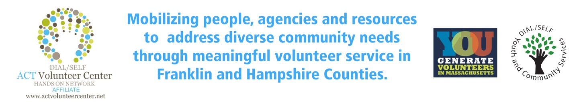
ACT* VOLUNTEER CENTER NEWSLETTER
(ACT is a program of Dial/Self Youth and Community Services)
MAY, 2020
Nonprofit Considerations for Starting a Virtual Volunteering Program – Points of Light
In light of the global ramifications of COVID-19, many nonprofits are offering alternatives to volunteering in-person to support the needs of the individuals they serve. Everyday citizens are looking for ways to support their local communities, and virtual volunteering, as well as DIY volunteer projects and remote opportunities, allows people of all ages to get involved from the comfort of their own homes. Virtual volunteering is an easy and time-efficient way to give back at your own pace. In addition, it offers volunteers a way to give back to causes greater than themselves. If virtual volunteering is something your organization is thinking about doing to help keep your mission moving forward, below are several things to consider before you move forward:
- Benefits of virtual volunteering for an organization, institution, or cause, virtual volunteering often provides:
• The opportunity to complete more tasks that need to be done
• The ability to access more volunteers with varying backgrounds and skill sets
• An outside-the-box opportunity to attract new sponsors and activate corporate partners’ remote employees
• Is highly replicable and scalable: virtual volunteer opportunities are very flexible and can the same great idea can be used for multiple applications
• More traction on your website, social media, email, and more
• An easier way to access more data for your organization (e.g. website tracking, email captures, volunteer hours)
2. Example virtual volunteer roles/tasks:
• Data entry/research projects
• Tutoring/mentoring
• Marketing, communication and social media support (e.g. website, publications)
• Editing or writing proposals, press releases, newsletter articles, web pages, etc.
• DIY Projects with step by step instructions Visit here to find for virtual volunteering opportunities and organizations to partner with.
3. Assess IT needs and requirements. Before getting started, make sure you check with your IT team to see if you have the right tools/systems in place to take your program online. If not, reach out to your funders, other nonprofits who are doing this work successfully, board members and/or skill-based volunteers for support. For instance, how will your capture the information of potential volunteers? To see an example of a COVID-19 volunteer interest form visit the Jewish United Fund.
4. Volunteer management is key. Managing volunteers is no small task, but with a little effort on your part, you can develop a virtual volunteer program that’s effective, engaging, and exceptionally fulfilling for everyone involved. To do so, you’ll need a way to manage volunteers in a comprehensive way. If you have the resources, volunteer management software can help you take care of logistics, leaving you time to focus on what really matters—the volunteers! If not, work with your team to modify your current volunteer management process or ask a board member or skill-based volunteer for support. Check out these volunteer management tools nonprofits are currently using.
5. Develop clear role descriptions/update training materials A clear role description is the corner stone of a good volunteer program. It makes sure that you as the organizer and all the potential volunteers are on the same page, ensuring that you can all reach your shared goal. It is also important to update your training materials to ensure it translates and is understandable for virtual volunteers – considering the various ways people learn.
6. Be available. Create opportunities to offer support to your volunteers or to answer any of their questions (e.g. virtual office hours). This is also a good way to get new ideas, approaches and feedback from volunteers helping to support your work.
7. Communicate. Communicate. Communicate. Because you cannot see volunteers in-person, it is important to keep them up-to-date with the latest news from your organization, via newsletters, emails, texts and social media channels. A lot can happen in 24 hours as we’ve previously seen. This means priorities might pivot at short notice, so try to keep your volunteers informed as much as possible. Communicating also ensures your volunteers feel connected to your mission and the work you all are doing!
8. Engage your volunteers. During times like these, people are feeling more isolated than ever. Providing a space for volunteers and your employees to engage in a safe, and inclusive environment will be essential to your virtual programming success. With various companies like Zoom or Slack, you have numerous platforms available to engage your volunteers. Try hosting an online lunch-and-learn to discuss potential volunteer opportunities, share video stories from your volunteers on social media, or just host an online happy hour to bring everyone together to celebrate all their amazing work.
9. Manage volunteer stress. Volunteering at a time of disaster can be stressful and challenging for everyone involved, even on a simple task. Be mindful of these stresses and try to ensure that volunteers are not pushing themselves too hard or taking on more than they can do.
10. Document all your hard work. Throughout this process you will learn a lot from your research, other nonprofit professionals, your volunteers, and more. Don’t let all your hard work be in vain – make sure you take the necessary time to document everything in case you or someone you work with needs to access it in the future.
11. Share best practices with the greater nonprofit network. If during all your amazing hard work and research, you come away with some possible learnings you would like to share – do so! One thing we can all agree on is that during times of disaster, we learn the importance of community and how much we are all in this together.

