ACTIVE INITIATIVES  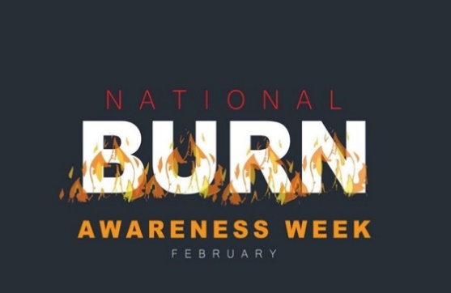  ACHIEVEMENTS  FIRE INVESTIGATION CLASS  Fire Investigator Danny Irions conducted a fire investigation class at Kendrick High School for Forensic students. They analyzed fire activity in wooden structures under the guidance of our fire investigators. Kendrick High School’s forensic class put their fire investigation skills to the test! Students built small houses and set them on fire to study fire patterns and determine the origin of the fire—just like real fire investigators. This hands-on experience is a great way to inspire the next generation of fire science professionals!  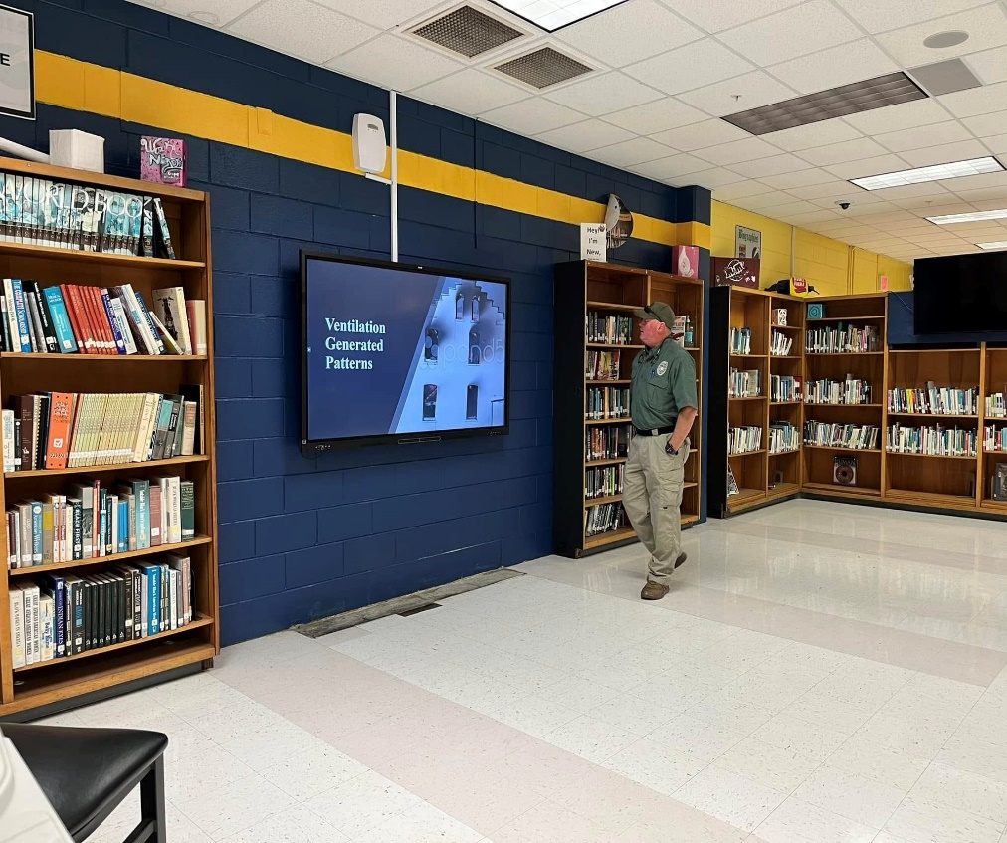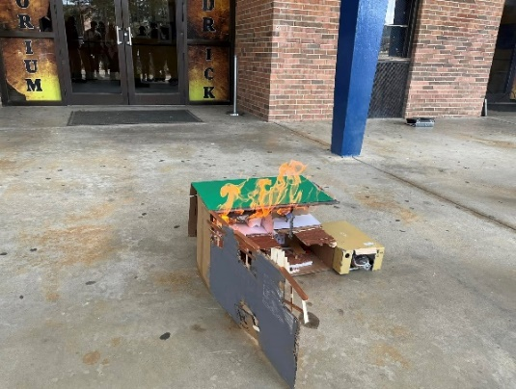  CRR FIRE SAFETY EVENTS  During the month of February 2025 Columbus Fire and EMS conducted various fire truck displays, station tours and career day events. These events promoted fire safety awareness as well as prevention.  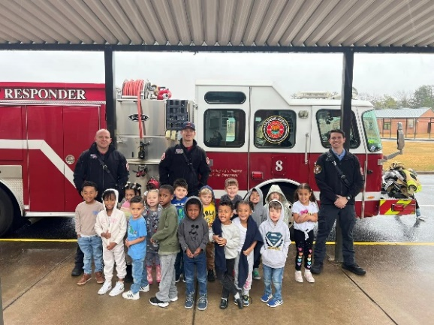 |  | 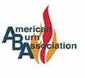  BURN PREVENTION TIPS  February 2nd -8th marks National Burn Awareness  Week. The American Burn Association has provided  CFEMS with some preventive measures of bodily  burn injuries in the home that could also cause house fires. TIPS: USE A TIMER: Avoid overcooking by forgetting what’s on the stove and leaving food unattended while cooking. DON’T FORGET: Blow out candles when you leave the room or go to bed. LIMIT CORDS: Don’t overload your outlets. Keep cords safe and out of reach. Contact ABA for more information.  COLUMBUS CORRECT CARE  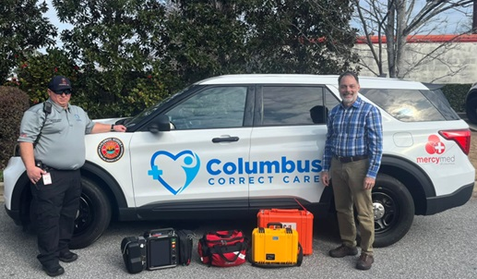  On February 3rd, Columbus Fire and EMS successfully launched their new Mobile Integrated Healthcare unit. The unit consists of a Firemedic Jonathan Lauglin (left), and a Nurse Practitioner Kelly Smith (right) from MercyMed focused on care for high utilizers of the EMS system. Thanks to all that made this initiative possible.  CADET GRADUATION CEREMONY  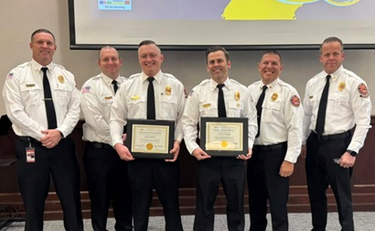  Columbus Fire and Emergency Medical Services, Congratulates, Captain James Barnes and Captain Clayton Moore for completing the city’s Leadership Development Program. This program introduces students from various departments to include the functionality of each department with an emphasis on leadership.

